Concordia University

Department of Computer Science

and Software Engineering

Software Process

SOEN 341/4 S --- 2016



Final Report

Team: The Force

|  |  |
| --- | --- |
| Team information | |
| Name | SID |
| Stefano Pace | 27454716 |
| Julian Ippolito | 27419112 |
| Adam Arcaro | 27459157 |
| Joey Tedeschi | 27513062 |
| Georges Mathieu | 26863477 |
| Hasan Ahmed | 27546467 |
| Marc-Andre Dragon | 27721579 |
| Jordan Stern | 27400144 |
| George Theophanous | 27400578 |
| Olivier Cameron-Chevrier | 27228805 |

Table of Contents

1 - Project Description 5

2 - Goals and Constraints 6

2.1 - Functional Requirements 6

2.1.1 - Use Case Diagrams 8

2.1.2 - Use Cases 10

2.2 - Domain Model 23

2.3 - Constraints and Qualities 26

3 - Constraints and Qualities 27

3.1 – Human Resources 27

3.2 – Technical Resources 32

4 – Scoping 33

5 – Solution Sketch 34

5.1 – Architecture 34

5.2 – Technologies in Use 35

5.2.1 – Programming Languages: 35

5.2.2 – Libraries/Frameworks: 36

5.2.3 – Relational Database Management Systems: 36

5.2.4 – Web Server 37

5.2.5 – Integrated Development Environments (IDE) / Editors: 37

5.2.6 – Collaboration Software: 37

6 – Plan 39

6.1 – Activities 39

6.2 – Artifacts 40

6.3 - Project Estimates 43

6.4 – Activities Assignments 45

6.5 – Schedule 46

6.6 – Risk 47

7 - Prototype 48

8 – Introduction 51

9 – Architecture Design 52

9.1 – Architecture Diagram 53

9.1.1 – Logical View 53

9.1.2 – Development View 55

9.1.3 – Physical View 58

9.1.4 – Process View 59

9.1.5 – Scenarios 64

9.2 – Subsystem Interfaces Specifications 67

9.2.1 – IstudentInfo 67

9.2.2 – IScheduler 69

9.2.3 – ICourse 72

10 – Detailed Design 75

10.1 – Detailed Design Diagram 75

10.1.1 – User Subsystem 75

10.1.2 – Course Subsystem 77

10.1.3 – Scheduler Subsystem 78

10.2 – Unit Descriptions 79

10.2.1 – User Subsystem Unit Descriptions 79

10.2.2 – Course Subsystem Unit Descriptions 82

10.2.3 – Scheduler Subsystem Unit Descriptions 84

11 – Dynamic Design Scenarios 86

12 – Estimation 94

12.1 – Revised Project Estimates 94

12.2 – Revised Schedule & Gantt Chart 98

13 – Rapid Prototyping and Risk 102

13.1 – Prototype 102

13.2 – Previously Identified Risks 106

13.3 – Newly Identified Risks 107

14 – Introduction 108

15 – Testing Report 109

15.1 – Test Coverage 109

15.1.1 – Tested Items 109

15.1.2 - Untested Items of Interest 115

15.2 - Test Cases 116

15.2.1 - Unit Testing 117

15.2.2 - Requirements Testing 123

15.2.3 - Stress Testing 132

15.2.4 - Security Testing 133

16 - System Delivery 137

16.1 - Installation Manual 137

16.2 - User’s Manual 142

16.2.1 - Getting Started 142

16.2.2 - Creating an Account 142

16.2.3 - Login 144

16.2.4 - Logout 144

16.2.5 - View/Edit Profile 145

16.2.6 - Reset Password 146

16.2.7 - Add Course Manually 146

16.2.8 - Change Course Section 148

16.2.9 - Remove Course 149

16.2.10 – Schedule Generataion 149

16.2.11 - Add Student (Administrator) 150

16.2.12 – Remove Student (Administrator) 150

17 - Final Cost Estimate 152

17.1 - Revised Project Estimate 152

17.2 - Final Schedule & Gantt Chart 155

**Part A: Project Scope and Plan**

1 - Project Description

Concordia University's current course enrolment system does not provide students with all their possible scheduling options for their respective courses. In a program such as Software Engineering where sections are limited and professors must be engineers, it can prove difficult for a student to create a desirable schedule. The Force is a web based application that allows students to choose from a list of generated course schedules based on their desired courses.

The Force has a simple interface where users are prompted to enter their desired courses along with certain criteria, such as requesting to have no classes on Mondays or to not finish later than 5PM. Next, all schedule options that satisfy the inputted information are displayed. The student is first verified by the system for eligibility in the indicated courses, based on prerequisites, co-requisites, and program restrictions. Users can also choose to add and remove courses manually from their schedules.

This project is documented through five deliverables, each of which describes progress in the creation of this application:

* Deliverable 0: Overview and general system description
* Deliverable 1: Project requirements and plan of action
* Deliverable 2: Description of system architecture and design
* Deliverable 3: Implementation and testing of refined system prototype
* Deliverable 4: Concluding system implementation and final report

2 - Goals and Constraints

2.1 - Functional Requirements

1. Interface - Login Page

1. Display brief message describing function of application
2. Display fields for login credentials
3. Login button leads to section 2

2. System - Login Page

1. Verify credentials from login page
   1. If credentials are valid, proceed to section 3
   2. If credentials are invalid, return to section 1 and display message for invalid information

3. Interface - Course Page

1. List of saved schedules (initially empty)
2. List of desired courses (initially empty)
3. Button for adding course
   1. List all courses & sections as checklist for user to select from
   2. When course is added, add to schedule
4. Button for removing course next to each course in schedule
5. Button for generating schedules based on predetermined Concordia Course Sequence
6. Additional criteria section for requesting days off and requesting earliest/latest course times

4. System - Course Page

1. Verify student eligibility for added course
   1. Check course prerequisites and verify if student has them completed
   2. Check course co-requisites and prompt the user to add the co-requisite course to list automatically.
   3. Check program restrictions (such as necessary credits) for course
   4. Verify course vacancy for added course
2. If all conditions are met, add course to schedule
3. If any of these conditions are not met, display message to user explaining why they cannot enroll in this course
4. If at least one course schedule can be generated, proceed to section 5. Otherwise, display message informing user that there are no possible schedules with the selected courses and criteria.

5. Interface - Course Scheduling Page

1. Display generated schedules based on course sequence and criteria
2. Beside each generated schedule:
   1. List sections enrolled
   2. Button for downloading schedule as PDF

6. System - Course Scheduling Page

1. If user creates schedule, store generated schedule in profile for future logins

7. System - Logout

1. If user logs out using logout button, save session information and logout user
2. If user closes window, save session information and logout user

8. Interface - Reset Password

1. Display field for account email
2. Reset button sends password reset email

9. System - Reset Password

1. Verify if account email is valid
2. If valid, send temporary password to email address
3. If invalid, display message saying that account does not exist

10. Interface - View profile

1. Can be viewed any time after logging in
2. Display general student information

11. System - View profile

1. Change stored information if user changes information

2.1.1 - Use Case Diagrams

Figure: General User UCD

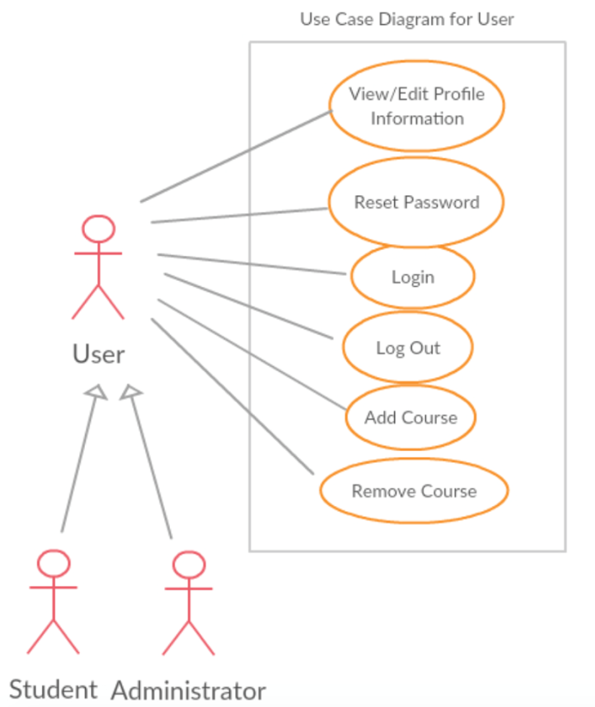

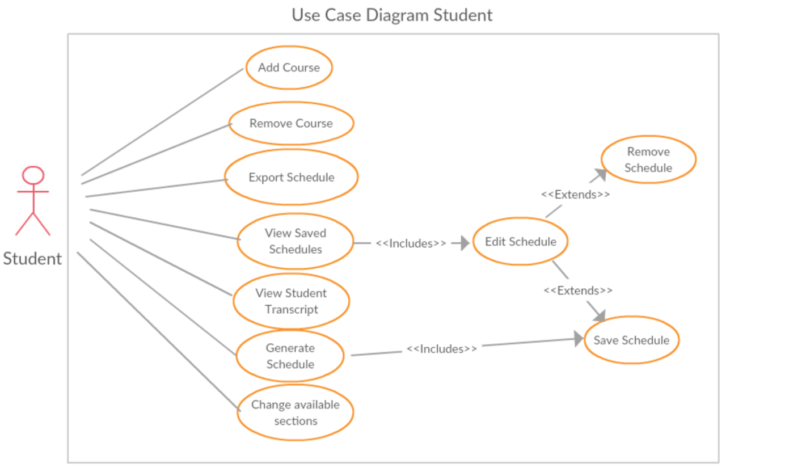Figure: Student UCD

Figure: Administrator UCD

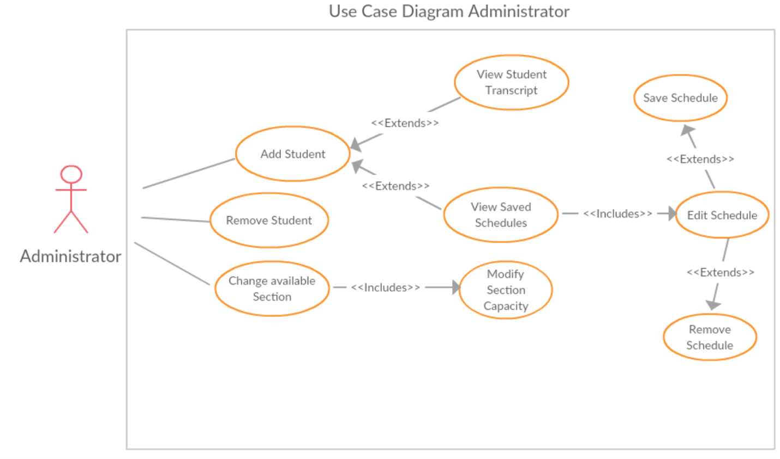

2.1.2 - Use Cases

UC09 (Export Schedule) was phased out due to time constraints.

UC10 (Save Schedule) is now rendered useless because all schedules are saved automatically by the system, eliminating the need for the user to do this.

UC12 (Delete Schedule) was removed, as it was decided that a student will have to individually remove courses from their schedule if they want to make it blank. This will make it easier for the system to identify future courses that require the currently removed course as a prerequisite so they can be removed as well.

UC13 (Modify Section capacity) was phased out due to time constraints.

|  |  |
| --- | --- |
| ID: | UC01 |
| Name: | Login |
| Importance (/5): | 5/5 |
| Difficulty (/5): | 2/5 |
| Risk Assessment: | Low |
| Actors: | Student, Administrator |
| Goals: | * To allow students and administrator access to the site’s home page |
| Summary: | By using this feature, the student and administrator will be able to view their profile information and search through schedules to make changes or create new ones. |
| Preconditions: | The user must be on the login page |
| Basic Flow: | 1. The user provides a valid username and password 2. The system responds by checking the username and password 3. The system redirects the user to another page of the website |
| Post Conditions: | Success: The user will be brought to the home page of the website  Failure: The user will remain on the login page since he/she will be denied access. An error message will be displayed. If the user cannot figure out their password, they must go through the proper procedure to change it. |

|  |  |
| --- | --- |
| ID: | UC02 |
| Name: | Logout |
| Importance (/5): | 5/5 |
| Difficulty (/5): | 2/5 |
| Risk Assessment: | Low |
| Actors: | Student, Administrator |
| Goals: | * To allow students and administrators to log off of their account in the system |
| Summary: | Any user can log out of the system to terminate their session |
| Preconditions: | User must have successfully logged into the system |
| Basic Flow: | 1. User selects “Log Out” 2. The System redirects the User to the Sign In page |
| Post Conditions: | Success: User is brought back to the main page  Failure: User remains on the same page and an error is displayed |

|  |  |
| --- | --- |
| ID: | UC03 |
| Name: | View/ Edit Profile |
| Importance (/5): | 5/5 |
| Difficulty (/5): | 3/5 |
| Risk Assessment: | Low |
| Actors: | Student, Administrator |
| Goals: | * To allow students and administrators to view/edit their profile information |
| Summary: | By using this feature, the student will be able to view their profile information, including ID number, first name, last name, password and email and edit it if necessary. |
| Preconditions: | User must have successfully logged into the system |
| Basic Flow: | 1. User selects the “Account” section 2. System redirects user to their “My Account” page 3. System displays all the user’s account information 4. The user edits one of the displayed fields 5. The user selects “Submit Changes” 6. The system redirects the user to the home page |
| Post Conditions: | Success: System redirects User to home page, changes are saved  Failure: User remains on current page, changes unsaved |

|  |  |
| --- | --- |
| ID: | UC04 |
| Name: | Reset Password |
| Importance (/5): | 5/5 |
| Difficulty (/5): | 3/5 |
| Risk Assessment: | High |
| Actors: | Student, Administrator |
| Goals: | * To allow students and administrators to reset their password if forgotten |
| Summary: | The user can reset his/her password by providing their email address. An email will be automatically sent to the email address with instructions on how to reset the password. |
| Preconditions: | The user must be on the login page |
| Basic Flow: | 1. User selects the “Click here to reset password” 2. System prompts the user for the email address associated to the account 3. User enters the email address 4. System confirms the email address is linked to an account 5. System send email to email address with instructions to change the password |
| Post Conditions: | Success: Email is sent to the user, user remains on current page  Failure: Email is not sent, error message is displayed, user remains on current page |

|  |  |
| --- | --- |
| ID: | UC05 |
| Name: | Add Course |
| Importance (/5): | 5/5 |
| Difficulty (/5): | 3/5 |
| Risk Assessment: | Medium |
| Actors: | Student, Administrator |
| Goals: | * Allow students and administrator to add specified course to a schedule |
| Summary: | Specified courses can be successfully added by the user and to a schedule. |
| Preconditions: | * The user must be logged in and on the home page * The system has access to the course list & schedules * The system has access to previously created schedules * The user must have the pre-requisites (System will check) |
| Basic Flow: | 1. User selects “Modify Schedule” 2. System displays available disciplines to the User 3. User selects the discipline they would like to expand 4. System expands the disciplines to show available courses 5. User selects the course they would like to add 6. User selects “Compute Schedule” 7. System checks the pre-requisites/co-requisites 8. System prompts the user to select a section 9. User selects a section 10. User selects “Commit Changes” 11. System indicates if the add was successful 12. System displays the course & section in the schedule. |
| Post Conditions: | Success: Specified course is added to the schedule  Failure: Process fails, Error is displayed to the user |
| Notes | *****Registration constraints include the following:   * Timeslots for courses cannot overlap (minimum 15 minutes between back-to-back courses). * Students cannot register for the same course twice within the same semester. * Students cannot register for a course which they already completed. * Students cannot register for courses for which they have not fulfilled the pre-requisites/co-requisites |

|  |  |
| --- | --- |
| ID: | UC06 |
| Name: | Change Course Section |
| Importance (/5): | 5/5 |
| Difficulty (/5): | 3/5 |
| Risk Assessment: | Medium |
| Actors: | Student, Administrator |
| Goals: | * To allow students and administrators to change the section of a course in a schedule |
| Summary: | Specified courses can change their sections in a schedule. |
| Preconditions: | * The user must be logged in and on the home page * The system has access to the course list & schedules * The system has access to previously created schedules * The Course must already be on the schedule |
| Basic Flow: | 1. User selects a specified course on the schedule 2. System displays alternate sections available for the course 3. User selects one of the other available sections of the course 4. User selects “Commit Changes” 5. System changes the course to the desired section, then displays it on the schedule. |
| Post Conditions: | Success: Specified course section is changed  Failure: Process fails, Error is displayed to the user |

|  |  |
| --- | --- |
| ID: | UC07 |
| Name: | Remove Course |
| Importance (/5): | 5/5 |
| Difficulty (/5): | 3/5 |
| Risk Assessment: | Medium |
| Actors: | Student, Administrator |
| Goals: | * Allow students and administrators to remove courses from a schedule |
| Summary: | Specified courses can be removed by the user from a schedule. |
| Preconditions: | * The user must be logged in and on the home page * The system has access to the course list & schedules * The system has access to previously created schedules * The Course must already be on the schedule |
| Basic Flow: | 1. User selects specified course 2. System displays the details of the course 3. User selects “Remove Course” 4. System removes the course from the schedule, then displays the updated schedule |
| Post Conditions: | Success: Specified course is removed  Failure: Process fails, Error is displayed to the user |

|  |  |
| --- | --- |
| ID: | UC08 |
| Name: | Generate Schedule |
| Importance (/5): | 5/5 |
| Difficulty (/5): | 5/5 |
| Risk Assessment: | High |
| Actors: | Student |
| Goals: | * To allow students to auto-generate a schedule through the system |
| Summary: | The system will auto-generate a schedule for the user |
| Preconditions: | * The user must have logged in & be on the main page * The system has access to the course list & schedules * System indicates if the add was successful after checking the pre-requisites/co-requisites. |
| Basic Flow: | 1. User selects “Auto Generate Schedule” 2. System creates schedules and displays them |
| Post Conditions: | Success: Schedule is auto-generated  Failure: Process fails, Error is displayed to the user |
| Notes | *****Registration constraints include the following:   * Timeslots for courses cannot overlap (minimum 15 minutes between back-to-back courses). * Students cannot register for the same course twice within the same semester. * Students cannot register for a course which they already completed. * Students cannot register for courses for which they have not fulfilled the pre-requisites/co-requisites |

|  |  |
| --- | --- |
| ~~ID:~~ | ~~UC09~~ |
| ~~Name:~~ | ~~Export Schedule~~ |
| ~~Importance (/5):~~ | ~~3/5~~ |
| ~~Difficulty (/5):~~ | ~~5/5~~ |
| ~~Risk Assessment:~~ | ~~Medium~~ |
| ~~Actors:~~ | ~~Student~~ |
| ~~Goals:~~ | * ~~To allow students to export their schedules and save it on their personal computers~~ |
| ~~Summary:~~ | ~~Students can choose to export their schedules to PDF or as an image and save it to their computer~~ |
| ~~Preconditions:~~ | * ~~The user must have logged in & be on the main page~~ * ~~The user must have a schedule completed~~ |
| ~~Basic Flow:~~ | 1. ~~User selects “Export Schedule”~~ 2. ~~System begins download of the schedule in PDF format on the computer~~ |
| ~~Post Conditions:~~ | ~~Success: Schedule is exported and saved to proper location~~  ~~Failure: Process fails, Error is displayed to the user~~ |

*Omitted due to change in scope of Project

|  |  |
| --- | --- |
| ~~ID:~~ | ~~UC10~~ |
| ~~Name:~~ | ~~Save Schedule~~ |
| ~~Importance (/5):~~ | ~~3/5~~ |
| ~~Difficulty (/5):~~ | ~~3/5~~ |
| ~~Risk Assessment:~~ | ~~Medium~~ |
| ~~Actors:~~ | ~~Student, Administrator~~ |
| ~~Goals:~~ | * ~~To allow students and administrators to save a schedule for future access~~ |
| ~~Summary:~~ | ~~The schedules generated by the system and edited by the user can be saved as a preference~~ |
| ~~Preconditions:~~ | * ~~The user must have logged in & be on the main page~~ * ~~The user must have a schedule completed~~ |
| ~~Basic Flow:~~ | 1. ~~User selects “save schedule”~~ 2. ~~System prompts the user for confirmation~~ 3. ~~User confirms the saving of the schedule~~ 4. ~~System then saves the schedule and displays it~~ |
| ~~Post Conditions:~~ | ~~Success: Schedule is saved and added to database of the Student~~  ~~Failure: Process fails, Error is displayed to the user~~ |

*Omitted due to change in scope of Project

|  |  |
| --- | --- |
| ID: | UC11 |
| Name: | View Saved Schedule |
| Importance (/5): | 2/5 |
| Difficulty (/5): | 3/5 |
| Risk Assessment: | Medium |
| Actors: | Student, Administrator |
| Goals: | * To allow students and administrators to view saved schedules |
| Summary: | The user can load any schedule previously created |
| Preconditions: | * The user must have logged in & be on the My Account page * The user must have access to a schedule saved * The system must have access to all saved schedules |
| Basic Flow: | 1. User selects “Schedule” 2. System redirects user to home page and displays the user’s last updated schedule |
| Post Conditions: | Success: Schedule is displayed from the saved list  Failure: Process fails, Error is displayed to the user |

|  |  |
| --- | --- |
| ~~ID:~~ | ~~UC12~~ |
| ~~Name:~~ | ~~Remove Schedule~~ |
| ~~Importance (/5):~~ | ~~1/5~~ |
| ~~Difficulty (/5):~~ | ~~3/5~~ |
| ~~Risk Assessment:~~ | ~~Medium~~ |
| ~~Actors:~~ | ~~Student~~ |
| ~~Goals:~~ | * ~~To allow students and administrators to remove a saved schedules~~ |
| ~~Summary:~~ | ~~The user can remove any schedule from the list of saved schedules.~~ |
| ~~Preconditions:~~ | * ~~The user must have logged in & be on the main page~~ * ~~The user must have a schedule in the preferred section~~ * ~~The system must have access to all saved schedules~~ |
| ~~Basic Flow:~~ | 1. ~~User selects “View Saved Schedules”~~ 2. ~~System displays the list of the schedules saved~~ 3. ~~User selects a schedule~~ 4. ~~System displays the schedule~~ 5. ~~User selects “remove”~~ 6. ~~System prompts user for confirmation to remove the schedule selected~~ 7. ~~User confirms the selection~~ 8. ~~System removes the schedule, redirects user to home page~~ |
| ~~Post Conditions:~~ | ~~Success: Schedule is removed from the saved list~~  ~~Failure: Process fails, Error is displayed to the user~~ |

*Omitted due to change in scope of Project

|  |  |
| --- | --- |
| ~~ID:~~ | ~~UC13~~ |
| ~~Name:~~ | ~~Modify Section Capacity~~ |
| ~~Importance (/5):~~ | ~~2/5~~ |
| ~~Difficulty (/5):~~ | ~~3/5~~ |
| ~~Risk Assessment:~~ | ~~Medium~~ |
| ~~Actors:~~ | ~~Administrator~~ |
| ~~Goals:~~ | * ~~Allow administrators to change the student capacity of a section~~ |
| ~~Summary:~~ | ~~The administrator can change the capacity of any section specified.~~ |
| ~~Preconditions:~~ | * ~~The Course and specified Section must exist~~ * ~~The system must have access to all courses and sections~~ |
| ~~Basic Flow:~~ | 1. ~~Administrator searches for a specified course~~ 2. ~~System displays the list of available sections~~ 3. ~~Administrator selects a section~~ 4. ~~System displays the section details~~ 5. ~~Administrator selects “Change Capacity”~~ 6. ~~System prompts Administrator for a new capacity~~ 7. ~~Administrator enters new capacity~~ 8. ~~System changes section capacity and redirects Administrator to the home page~~ |
| ~~Post Conditions:~~ | ~~Success: Section Capacity changed~~  ~~Failure: Process fails, Error is displayed to the user~~ |

*Omitted due to change in scope of Project

|  |  |
| --- | --- |
| ID: | UC14 |
| Name: | Add Student |
| Importance (/5): | 5/5 |
| Difficulty (/5): | 3/5 |
| Risk Assessment: | Medium |
| Actors: | Administrator |
| Goals: | * Allow administrators to select student in order to make changes to their schedule |
| Summary: | The administrator can change any specified student’s schedule. |
| Preconditions: | * The Student must have an account. * The Student must have valid schedules completed * The System must have access to the Students schedules * The Student must have the pre-requisites for the courses that the Administrator may add * The Administrator must have an account and be signed in * The Administrator must have access to Students Schedules |
| Basic Flow: | 1. Administrator enters student name in search bar 2. System displays the list of students with the same name 3. Administrator selects the student 4. Administrator selects “View student Schedules” 5. System redirects user to students schedule page and displays the schedules made by the student |
| Post Conditions: | Success: Selected schedule displayed to the Administrator, ready for change  Failure: Process fails, Error is displayed to the user |

|  |  |
| --- | --- |
| ID: | UC15 |
| Name: | Remove Student |
| Importance (/5): | 5/5 |
| Difficulty (/5): | 3/5 |
| Risk Assessment: | Medium |
| Actors: | Administrator |
| Goals: | * Once an administrators has modified a student’s schedule, they remove the student from their queue. |
| Summary: | The administrator removes the selected student from the queue after work was completed. |
| Preconditions: | * The Student must have been selected * The Administrator must have an account and be signed in * The Administrator must have access to Students Schedules |
| Basic Flow: | 1. Administrator selects “Account” 2. System redirect Administrator to their account where they can search for another student if need be. |
| Post Conditions: | Success: Student removed from the queue  Failure: Process fails, Error is displayed to the user |

|  |  |
| --- | --- |
| ID: | UC16 |
| Name: | Request new Account |
| Importance (/5): | 5/5 |
| Difficulty (/5): | 3/5 |
| Risk Assessment: | Low |
| Actors: | Student |
| Goals: | * To allow students the ability to create a new account for the system |
| Summary: | By using this feature, the student will be able to create a new account by providing their first name, last name, password and email to the system. |
| Preconditions: | User does not have an existing account, and is on the login page. |
| Basic Flow: | 1. User selects “Don’t have an account? Create one now” 2. System prompts user to enter account information 3. User enters account information 4. System verifies user email and password combination to be valid and unique 5. System redirects user to main page of website |
| Post Conditions: | Success: System redirects User to home page, account information is saved  Failure: User remains on current page, system displays error |

2.2 - Domain Model

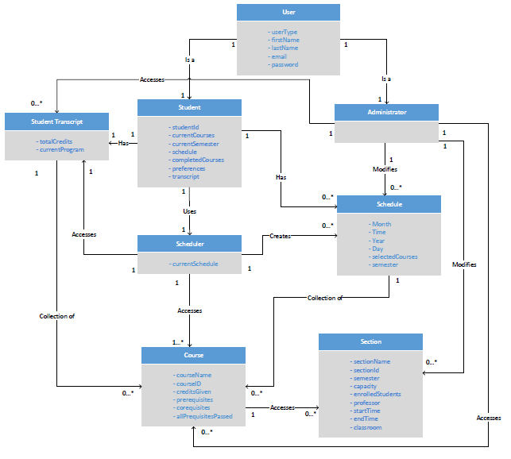

User

* The ‘User’ class is an entity representing a user of the system. This class contains 5 attributes. They are userType, firstName, lastName, email and password. The email and password are used for logging into the website. The userType is what allows the server to distinguish between a Student User and an Administrative user. The firstName and lastName are self-explanatory.
* The ‘User’ class is related to one ‘Student’ class and one ‘Administrator’ class to represent that each user can be either a registered student at Concordia University or an Administrator at Concordia University.

Scheduler

* The ‘Scheduler’ class is an entity representing the key concept of the system, the schedule creation. The class contains 1 attribute; currentSchedule. This encompasses the current schedule generated, while incorporating the user preferences and remaining courses in the course sequence.
* The ‘Scheduler’ class is related to 0 or more ‘Schedule’ objects to represent that the scheduler can create one or more schedules for various semesters and years.
* The ‘Scheduler’ class is related to 1 ‘Student Transcript’ object to represent that the scheduler will consult the transcript of the student who is currently use it to see if they have the course pre-requisites/co-requisites.
* The ‘Scheduler’ class is related to 1 or more ‘Course’ objects to represent that the scheduler will access available courses to see if the scheduler can add them to the current students schedule.

Schedule

* The ‘Schedule’ class is an entity representing the schedule made by a user for a certain semester/year. The class contains 6 attributes: Day, Time, Month, Year, selectedCourses and semester.
* The ‘Schedule’ class is a subset of the scheduler is related to 0 or more ‘Courses’ to represent that a ‘Schedule’ is a collection of courses made by a ‘Student’.

Student

* The ‘Student’ class is a specialized case of the user. The class contains 7 attributes; studentId, currentCourses, currentSemester, schedule, completedCourses, transcript and preferences (All self-explanatory).
* Each 'Student' in the system is associated one 'Student Transcript'. This is the student’s academic history. Also, each ‘Student’ is related with 0 or more ‘Schedule’ which represent the user’s schedules for any academic year.

Administrator

* The ‘Administrator’ class is a specialized case of the user. The class contains no attributes; it only manipulates existing attributes of other classes.
* The ‘Administrator’ can access zero of more ‘Schedules’, ‘Sections’ and ‘Courses’ of a particular 'Student' in the system to change them if necessary.

Student Transcript

* The ‘Student Transcript’ class is an entity representing courses that the ‘Student’ has already taken. The clas contains 3 attributes: totalCredits and currentProgram (All self-explanatory).
* Each ‘Student Transcript’ is related to 0 or more ‘Courses’ to represent the completed courses of a ‘Student’.

Course

* The ‘Course’ class is an entity detailing all the information about courses available to software engineering students during various years/semesters.

Section

* The ‘Section’ class is a subtype of ‘Course’. It contains all the information about availabilities (time slots) of particular courses as well as the professor who will be teacher that section of the course.

2.3 - Constraints and Qualities

Documentation: In order to complete the project in an effective manner, all planning and progress must be documented in an organized manner. This documentation includes both technical and non-technical specifications.

Performance: The generator shall quickly generate the schedules upon pressing the generate button (<10 seconds). Adding, removing, and modifying courses from course list is done instantly.

Usability: Simple, minimalistic interface without clutter. User must know what courses they want to enroll in for generator to be effective. Generator cannot be used

to enroll in courses, but instead to guide students to create an optimal schedule with the course sections.

Reliability: The generator accurately displays all possible schedule options. Issues can

arise where class times are changed, but the generator is synchronized with

the Concordia system for instant changes. Verifying prerequisites and course restrictions is completed using the student's record for accurate results.

Scalability: The generator currently works for Software Engineering students and will

have records for all relevant courses in the program. Additional courses could be added if needed and the application could be modified to apply to other programs as well.

Security: The application could pose some security concerns, but since the tool cannot be used to modify any student records, they are not very significant. The main security risk involves the storing of account passwords, which will be encrypted into hashcode to prevent data mining. Additionally, the the student records should only be available for viewing by the respective user after logging in.

3 - Constraints and Qualities

3.1 – Human Resources

|  |  |
| --- | --- |
| Name: | Stefano Pace |
| Student ID: | 27454716 |
| Sub Team: | Documentation (Sub-Team Leader)/Coordination |
| Knowledge: | Java, HTML, CSS, JavaScript, PHP, XML, SQL, Ajax, Databases, Prolog, Lisp, Ruby, Common Lisp Object System, Visual Basic, Python, Microsoft Office: Word, Excel, PPT, Outlook, Publisher, Eclipse, Notepadd++, Omnicast 4.6 |
| Experience: | 1. IT Telecom Integration 2. Wide Area Network (WAN) design 3. Analyst End User Support |
| Strengths: | * Teamwork * Time Management * Organization * Leadership |
| Time for Project: | 5 hours/week |

|  |  |
| --- | --- |
| Name: | Julian Ippolito |
| Student ID: | 27419112 |
| Sub Team: | Front-End Programming (Sub-Team Leader) |
| Knowledge: | Java, C#, JavaScript, HTML5, CSS, XML, PHP, MySQL, Ruby |
| Experience: | 1. IT Manufacturing Applications 2. Programming in C# |
| Strengths: | * Teamwork * Time Management * Efficiency |
| Time for Project: | 5 hours/week |

|  |  |
| --- | --- |
| Name: | Adam Arcaro |
| Student ID: | 27459157 |
| Sub Team: | Documentation |
| Knowledge: | Java, C#, JavaScript, HTML5, CSS, XML, PHP, MySQL, Ruby |
| Experience: | 1. IT Application Specialist 2. Data Entry for Contract Management 3. Customer Service |
| Strengths: | * Teamwork * Can handle Pressure Situations * Strategy |
| Time for Project: | 5 hours/week |

|  |  |
| --- | --- |
| Name: | Joey Tedeschi |
| Student ID: | 27513062 |
| Sub Team: | Documentation |
| Knowledge: | Java, Ruby (beginner), Python (beginner), PHP, JavaScript, JQuery, HTML, CSS, MYSQL |
| Experience: | 1. Web Development 2. Software Development |
| Strengths: | * Teamwork * Organization * Object Oriented Programming |
| Time for Project: | 5 hours/week |

|  |  |
| --- | --- |
| Name: | Olivier Cameron-Chevrier |
| Student ID: | 27228805 |
| Sub Team: | Server-side Programming |
| Knowledge: | Java, JavaScript, PHP, Html, CSS, SQL, Ruby, Prolog, CLOS |
| Experience: | 1. Customer Service/Support 2. Web Programming |
| Strengths: | * Teamwork * Time Management |
| Time for Project: | 5 hours/week |

|  |  |
| --- | --- |
| Name: | Georges Mathieu |
| Student ID: | 26863477 |
| Sub Team: | Server-side Programming (Sub-Team Leader) |
| Knowledge: | C, C++, Java, C#, VisualBasic, HTML, CSS, Javascript, JQuery, PHP, JSP, COBOL, AS/400, Prolog, LISP |
| Experience: | 1. Junior Data Architecture 2. Web Programming |
| Strengths: | * Organization * Time Management * Strategy |
| Time for Project: | 5 hours/week |

|  |  |
| --- | --- |
| Name: | Hasan Ahmed |
| Student ID: | 27546467 |
| Sub Team: | Front-End Programming |
| Knowledge: | Java, Python (Basic), HTML and CSS, PHP & MySQL |
| Experience: | 1. Customer Service 2. Web Programming |
| Strengths: | * Organization * Time Management * Creative Solutions |
| Time for Project: | 5 hours/week |

|  |  |
| --- | --- |
| Name: | Marc-Andre Dragon |
| Student ID: | 27721579 |
| Sub Team: | Server-side Programming |
| Knowledge: | C# (beginner), Java (intermediate), Python (beginner), PHP (beginner), JavaScript (beginner), Html (beginner), CSS (beginner) |
| Experience: | 1. Platforms (Gaming) 2. Web Programming |
| Strengths: | * Organization * Time Management * Critical Thinking |
| Time for Project: | 5 hours/week |

|  |  |
| --- | --- |
| Name: | Jordan Stern |
| Student ID: | 27400144 |
| Sub Team: | Front - side Programming |
| Knowledge: | Java, Javascript, HTML5, CSS, AJAX, Prolog, Common Lisp, Adobe Creative Suite |
| Experience: | 1. Customer Service 2. Web Programming |
| Strengths: | * Organization * Programming * Team Work |
| Time for Project: | 5 hours/week |

|  |  |
| --- | --- |
| Name: | George Theophanous |
| Student ID: | 27400578 |
| Sub Team: | Quality Assurance (Team Leader) |
| Knowledge: | Java, VBA, Python, LISP, Ruby, LISP Common Object, Assembly, HTML, Prolog, C# |
| Experience: | 1. QA/Software Development 2. Web Programming |
| Strengths: | * Organization * Programming * Critical Thinking |
| Time for Project: | 5 hours/week |

3.2 – Technical Resources

To facilitate communication between developers, Skype, Slack and GitHub are used. Skype is a service provided by Microsoft that allows the use of webcams, microphones and screen sharing for instant messaging and online voice/video conferences.

All files used for this project were sorted and stored using GitHub. All developers were given access to the repository and its content. To make sure that the source code used was maintained properly, the code files were given version numbers. Since Slack has GitHub Integration, it was also used for instant messaging and served as a way to update all developers of changes to the GitHub repository.

The server used to host our system, *The Force*, has the following hardware specifications:

* Windows Server 2012 Operating System (64-bit)
* Quad-Core Processor (i7-4790 CPU @ 3.60GHz)
* 16 GB DDR2 RAM
* 25 Mbps Bandwidth
* 2TB Memory

The Software used on the server will be the following:

* HTML, CSS, PHP, MySQL
* MySQL workbench
* GitHub desktop
* NotePad++
* Eclipse
* Bootstrap

4 – Scoping

All features mentioned in previous sections will be implemented into the system. It was determined that, due to a lack of time and complexity in implementation, the following non-essential features would deemed out of scope and removed:

|  |  |
| --- | --- |
| Feature Removed | Reason |
| Save Schedule | This requirement is now rendered useless because all schedules are saved automatically by the system, eliminating the need for the user to do this |
| Remove Schedule | This requirement was removed, as it was decided that a student will have to individually remove courses from their schedule if they want to make it blank. This will make it easier for the system to identify future courses that require the currently removed course as a prerequisite so they can be removed as well. |
| Export Schedule | This requirement was scoped out due to time constraints |
| Modify Section Capacity | This requirement was phased out due to time constraints. |
| User Account Deactivated After 5 Failed Attempted Logins | This requirement was scoped out due to time constraints |
| Generate course schedule for selection with alternate professor | This can be done by the “changing section” use case, as the section information will include the name of the professor in its information |
| Generate course schedule for user defined course code & sequence | This requirement was considered to be not widely desired as Concordia University suggests all students follow the pre-determine sequence. As well, this feature proved to be too complex to implement and was scoped out due to time constraints. |
| Website Timeout | This requirement was scoped out due to time constraints |
| View Schedule | The team realized that the button would no longer be needed, as schedules created by the user would automatically be displayed after login. |

5 – Solution Sketch

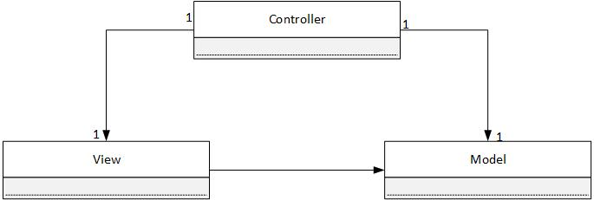5.1 – Architecture

The Force will be following a Model-View-Controller (MVC) software architecture pattern as its high-level architecture. The MVC architecture is ideal for this project as it allows for a clear separation between domain logic, controllers/requests, and user interface into unique classes. By isolating these key components, the MVC architecture enables development and testing of all components without requiring them to interact and possibly interfere with each other. In a team project such as this, independence is key. By allowing the controller, model, and view of a page to be modified simultaneously without worry of possibly affecting other components of the application, greater progress can be made for each portion by the various sub-teams.

In the case of The Force, as it is a web-based application, any request the user makes on a given web page (the view) is handled by the controller. Based on the inputs of said user, the controller then makes a call to the model in order to determine the proper behavior in which the data needs to be treated, and then applies said logic using the domain objects. In most cases, requests for state-specific information are usually presented by the view, while instructions to update states are given by the controller. Once the model has handled the logic required to gather the data necessary for the user’s request, the web page (or view) will be updated using the data acquired by the controller. The end result is a new web page, displayed on the user’s browser, on which the cycle can then repeat as required.

In comparison to MVC structures, Web Enterprise Architecture (WEA) is composed of layers instead of simply components. Separation of concerns is still present in WEA, but high-level layers may need to interact with lower-level layers instead of just those directly below it, increasing the complexity of the task and performance time as a whole. It would also be far more difficult to create clean separations between layers in comparison to simply separating all aspects into 3 classes. It is for these reasons that the Force chose to implement MVC as it’s high-level architecture: The separation of concerns it provides, and the ease at which this separation can be done.

5.2 – Technologies in Use

5.2.1 – Programming Languages:

1. *HTML*

Hyper Text Markup Language (HTML) is a markup language used to describe web documents, and document content. Seeing as HTML is the standard language read by web browsers, and The Force is a web-based application, it stands that HTML would be a requirement for developing the user interface.

1. *CSS*

Cascading Style Sheets (CSS) is a stylesheet language used to describe the layout and appearance of a document written in a markup language (in the case of this application, HTML). CSS is imperative to the development of The Force as it is a simple way to not only to orient information on screen for the user, but do so in an easily reusable manner.

1. *Javascript*

Javascript is a client-side scripting language, considered to be the standard client-side scripting language for web applications. As all modern web browsers support it, Javascript is ideal for development purposes and will be the main language used for client-side programming. The fact that it is a multi-paradigm scripting language also makes it incredibly flexible in use. The inclusion of Javscript not only provides The Force with a complete GUI, but its quick learning curve makes it perfect for those unfamiliar with the language. Javascript will be used in order to design how the various web pages behave based on event occurrence (e.g.: Pressing certain buttons, or typing into certain fields).

1. *PHP*

PHP is a server-side scripting language originally designed for web development, though now serves as a general-purpose programming language. PHP is The Force’s primary server-side programming language due to it being the language the team is most experienced with for interacting with databases. Through the implementation of PHP, The Force will be able to interact with and modify data stored on web servers in an efficient manner, allowing dynamic content to be accessed and displayed.

1. *Python*

Python is an object-oriented programming language normally used for developing web applications. Due to Python’s easy to learn syntax, high-level built in data structures, as well as flexibility and power thanks to its extensive library, it is an extremely valuable tool to have. Python will be used in accompaniment to the other languages discussed whenever it might provide an easier solution to a proposed issue.

5.2.2 – Libraries/Frameworks:

1. *Bootstrap*

Bootstrap is a HTML, CSS, and JavaScript framework used to aid in the development of a proper GUI. Bootstrap contains HTML and CSS based design templates for most necessary components of the GUI, and thus will be used to ease the development of The Force while also creating the visually appealing application possible for its users.

1. *jQuery*

jQuery is a JavaScript library which will be used to simplify many client-side scripting tasks such as document navigation, event handling, and AJAX implementation.

1. *Data Integration*

Data Integration is an Extract-Transform-Load (ETL) framework developed by Pentaho, which will be used to manipulate data into graphical representations. This will not be used for actual website implementation, but will instead be used by the server-side team to simplify the processing of data.

5.2.3 – Relational Database Management Systems:

1. *MySQL Workbench*

MySQL Workbench is a visual database design tool that implements SQL development, database creation, designs, and maintenance into a single IDE for MySQL database systems. The team will use it to create the database, as well as insert all necessary tables, before uploading this information to the server.

5.2.4 – Web Server

The web server used for this application is Internet Information Services (IIS) 6.1, with PHP 7.0 and MySQl 5.6.26 implementation. Created by Microsoft, IIS is an extensible web server that supports HTTP, among other protocols, and can be used to host nearly anything on the Web. For the sake of flexibility and security, it will be used to host The Force.

5.2.5 – Integrated Development Environments (IDE) / Editors:

1. *CodeRunner*

*CodeRunner i*s an IDE and editor released exclusively for Mac, which supports and can run 20 languages of code. With regards to The Force, it will mainly be used for client-side coding (HTML, CSS, Javascript), though PHP and Python are both supported by the program.

1. *Sublime Text*

Sublime Text is a cross platform source code editor, which Python based plugin API should it be required. Due to its “Goto Anything” feature, Sublime Text allows for quick navigation of large files, making it easier for developers to find certain blocks of code. As it also natively supports several programming and markup languages, most notably those required for The Force, it allows for quick changes in larger quantities of code.

1. *Netbeans*

Netbeans is a software development platform written in Java. Though the Netbeans IDE is primarily intended for Java development, it also supports PHP and HTML5. As such, some members of the team will be using it for server-side development, due to previous experience with the platform.

1. *Eclipse*

Eclipse is an IDE that is, once again, written primarily in Java to allow cross-platform compatibility. Despite the fact that it’s mainly used for developing Java applications, plugins enable it to be used for the development of other types of applications as well. With regards to The Force, it will be used for develop PHP scripts, once again due to certain members’ experience with the platform.

5.2.6 – Collaboration Software:

1. *Slack*

Slack is a cloud-based team collaboration tool that allows individuals to join persistent channels (or chat rooms), as well as directly message individuals. Slack is the communication medium of choice for the team as a whole. Due to the simplicity of use, and the fact that people can easily be incorporated into multiple channels, Slack allows for direct, straightforward, and streamlined conversation between members. In addition, each channel includes a search feature, allowing important information to always be accessible without the need to save it somewhere else or scroll indefinitely till it is found.

1. *GitHub*

Github is web-based Git repository hosting service, and offers the same source code management as Git. Unlike Git, however, Github is not strictly a command-line tool, instead providing a web-based GUI, as well as bug tracking, task management, and other collaboration features. Github is used by the team to not only share and incorporate other members’ code segments, but is also used as the main documentation distributer for The Force. Documents can not only be easily uploaded and shared to the entire team, but documentation can also be posted and analyzed by other team members, allowing feedback before beginning proper implementation.

6 – Plan

6.1 – Activities

Activity 1 - Research

Research is described by gathering key information from various relevant sources. This gathered information contains only the necessary details that are pertinent to the project.

Activity 2 - Planning

Before a project begins its development, a plan must be put in effect. This leads to an organized project where all members can track the work they have done and the work they have yet to complete.

Activity 3 - Discussion

In any project that involves multiple members, discussion is key for an optimal development. Sharing ideas and reviewing each other's work can bring out effective ideas with a lower chance of errors.

Activity 4 – Environment Creation

When the technologies required have been decided upon, it is crucial to then set up said technologies to allow the team proper access to everything they need to complete the application.

Activity 5 - Programming

Programming, both client-side and server-side, is key for the development of an application. The planning and ideas can be optimal but will only be valuable through effective programming.

Activity 6 - Testing

It is impossible to truly know if a software is effective until it is properly tested. Many unforeseen errors can be uncovered through testing, and releasing an application before testing it can lead to a very negative experience for the user.

Activity 7 - Debugging

The errors found through testing must be solved, which can be complicated when there is a multitude of code involved. Different segments of code must be analyzed for errors and programming solutions must be found.

Activity 8 - Documentation

In order to be fully aware of the progress of a project, every action and plan of action must be well documented. It is only through organized documentation that a project can effectively be completed and ridden of errors.

6.2 – Artifacts

(1) Deliverable 0

Deliverable 0 is used not only to solidify system information and create a rough draft of the project’s Domain Model, including describing each major portion of said model, but it also serves to solidify each member’s role within the team. This artifact serves to outline what will be accomplished in the final project, as well as introducing the entire team.

(2) Deliverable 1

Deliverable 1 serves to describe, in much greater detail than Deliverable 0, the project as well as its goals, requirements, domain model, constraints, resource allocation, and plan for implementation (among others). As this artifact covers most aspects of the application, including a schedule for the either project, it is incredibly important with regards to the development of said application.

(3) Deliverable 2

Deliverable 2 serves to outline the architecture, class diagrams, and design diagrams in complete detail. The deliverable also incorporates reports on rapid prototypes, and analysis of the risks, scope, and estimates involved. Due to its technicality, this artifact is extremely relevant to the programmers of the team in order to create a proper idea of how the project should function.

(4) Deliverable 3

Deliverable 3 serves as a summary of all testing cases previously reported, as well as what needs to be accomplished prior to the final stage of production. This artifact includes testing reports for all items and cases tested, and documentation for the system (including installation and user manuals), as well as a final cost estimate of the project.

(5) Basic Project Structure

As a result of discussion, a basic foundation for a proper course scheduler was achieved. In addition, methods of communication between members (Slack and Facebook) and team member roles were determined and agreed upon. This artifact served as the beginning of the entire software development process, and created the initial foundation for the final project.

(6) Initial Diagrams

Members of the team constructed various diagrams (including ER, Domain and class) in order to better visualize the relationships of the main sections of the project. The diagrams constructed in this artifact serve as the visual foundation for the programming development to come.

(7) List of Features and Technologies Required

Once a solid foundation for general functionality was created, the team discussed exact features they believed the application should include. Once these features were determined, the technologies required to achieve this goals were discussed and decided upon. This artifact serves not only as a measure for what the team wishes to accomplish, but also as a way to determine which technologies will make accomplishing said goals as easy as possible.

(8) Use Cases

Use cases describes all possible actions performed by a user, or an "actor" in a system. The work done in the backend by the system itself is not indicated through this type of model. This artifact allows the development team to see an overview of the user's experience and optimize it.

(9) User Interface

A functional system can only be brought to its full potential through an optimal user interface. An effective UI is clear, concise, and without clutter. Before any programming begins, the user interface must first be designed in an effective manner. The client-side programming team must always keep this artifact in mind when implementing the layout of the application.

(10) Design of Script to obtain Concordia Class Data

Since a large amount of data is required for the integration of our project, this is an important artifact because it ensures that correct data will be populated in our SQL tables in the database.

(11) ER Diagram

Once the data is obtained using the script and put into the database, the team created ER diagrams to show relationships between objects/tables derived from the domain model. This will help the team in the configuration of the manipulation of the data. This artifact is closely tied with the main functionalities of our system since the data used in the software must be well-represented and easily accessible.

(12) Architecture Programming, Use Cases

The main part of the programming takes place within this artifact because the code is created which makes all the designed architecture and use cases functional. If this artifact did not exist, the system would not exist.

(13) Scope of Project

Since the programming for this system is still ongoing, the scope of the project is subject to change. As the project progresses, the scope will change depending on what the team believes is still feasible to implement or not. This artifact will lead to the final product as element the team deems as nonessential/infeasible will be removed.

(14) Test Cases

As functionality is added by programming, test cases are created to ensure that the newly added operations of the system are fully working. Most importantly, these test case are largely based on the use cases and also will test the functionality of the database as well. This artifact is essential for quality assurance and a working final product.

(15) Performance

The Sub-team members responsible for QA will try out each test case on the system and determine whether or not the system operation is fully functional. This artifact will be the final confirmation that newly added system components are working and before they are put into the final polished product.

(16) Design of UI/Aesthetics of Application

The attractiveness of the product is important for the usability of the product. If users do not find the website esthetically pleasing, they will refrain from visiting it. On the contrary, if they like the aesthetics of the website, the users will appreciate the system more. This artifact ensures the final system is visually pleasing.

(17) Debugging / Bug Fixes

During both technical and user testing, several errors can be uncovered but their source relies unknown. The programming team must discover the errors in the code and find effective solutions to prevent them from repeating.

6.3 - Project Estimates

|  |  |  |  |
| --- | --- | --- | --- |
| **Task Name** | **Duration (Number of Days)** | **Total Cost (Hours)** | **Starting Date** |
| Deliverable 0 | 3 | 10 | 10-Jan |
| Deliverable 1 | 15 | 35 | 22-Jan |
| Deliverable 2 | 15 | 30 | 22-Feb |
| Deliverable 3 | 15 | 30 | 10-Mar |
| Basic Project Structure Discussion | 5 | 6 | 10-Jan |
| Initial Diagrams | 5 | 10 | 11-Jan |
| List of Features and Technologies Required | 10 | 10 | 14-Jan |
| Creation of Proper Programming Environment | 2 | 5 | 10-Jan |
| Implementation Discussion | 10 | 20 | 14-Jan |
| Use Cases | 10 | 15 | 26-Jan |
| User Interface | 10 | 15 | 26-Jan |
| User Testing | 20 | 65 | 28-Feb |
| Design of Script to Obtain Concordia Class Data | 5 | 6 | 02-Feb |
| ER Diagram Creation | 5 | 6 | 06-Feb |
| Architecture Programming, Use Cases | 20 | 90 | 19-Feb |
| Scope of Project | 60 | 20 | 08-Feb |
| Test Cases | 12 | 15 | 28-Feb |
| Performance | 8 | 20 | 08-Mar |
| Design of UI / Aesthetics of Application | 10 | 20 | 12-Mar |
| Debugging | 10 | 20 | 22-Mar |
| **Total** | 90 | 440 | N/A |

**\*\*** Estimates were made based on time required to create, as well as based on each team members’ individual work ethic. Based on the activities assigned to each member (and the artifacts said activities produce), an appropriate amount of time was estimated, taking into consideration the number of people striving to achieve said artifact, and the time they have available for said tasks. For all artifacts not yet created/achieved, re-estimation might occur if it is discovered that the time provided is inefficient for the members responsible to complete their task. In addition, the opposite can be said; re-estimation might occur if the task is easier than expected, thus saving time in that regard and allowing a reallocation of time to another issue. Re-estimation would also be required in the case that additional components not yet listed were designed and implemented. In such as a case, time would need to be allocated to these new tasks and the time provided to our sections might decrease as a result.

6.4 – Activities Assignments

|  |  |  |
| --- | --- | --- |
| Member Name | Main Role within Project | Activities Assigned |
| George Theophanous | Team Leader  Leader of Quality Assurance | Discussion, Planning, Research, Testing, Environment Creation |
| Stefano Pace | Leader of documentation  Assisting in both front and server-side programming | Discussion, Planning, Research, Documentation |
| Julian Ippolito | Leader of client-side programming | Discussion, Research, Programming, Debugging |
| Joey Tedeschi | Documentation  Assisting in both front and server-side programming | Discussion, Research, Documentation |
| Adam Arcaro | Documentation  Assisting in both front and server-side programming | Discussion, Research, Documentation |
| Georges Mathieu | Leader of server-side programming | Discussion, Research, Programming, Debugging,  Environment Creation |
| Olivier Cameron-Chevrier | Server-side Programmer | Discussion, Research, Programming, Debugging |
| Marc-Andre Dragon | Server-side Programmer | Discussion, Research, Programming, Debugging |
| Jordan Stern | Front-end Programmer | Discussion, Research, Programming, Debugging |
| Hasan Ahmed | Front-end Programmer | Discussion, Research, Programming, Debugging |

6.5 – Schedule

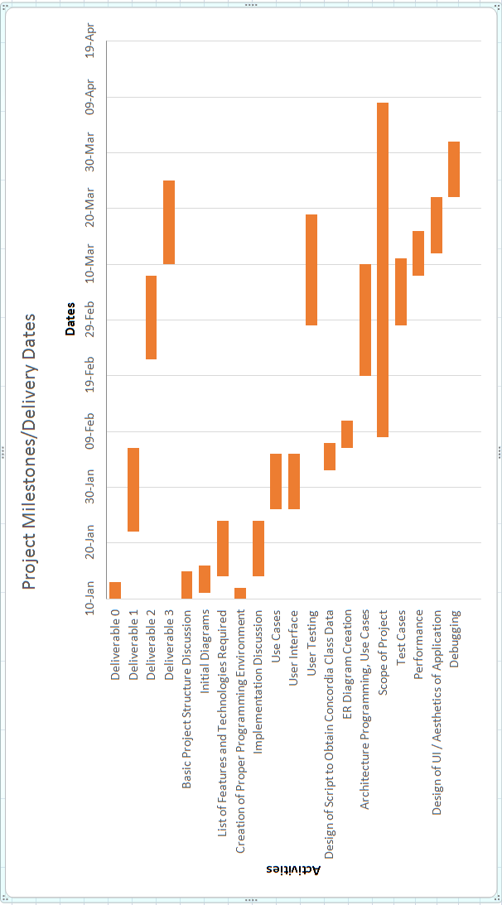

6.6 – Risk

1. *Lack of Communication and Time Allocation*

Seeing as most members of the team have never worked together, some efficiency is lost while trying to establish a proper team dynamic, and effective communication between teammates. All the members of The Force also have requirements outside of the team, including other classes, work, or extracurricular activities. As such, time management is extremely important and it’s possible that some features will need to be left out due to lack of time.

1. *Relearning required languages*

Though most members of The Force have experience, whether basic or advanced, with web development, not everyone has recently been practicing the various languages being used. As such some time was lost at the start of the project in order to allow members to familiarize themselves with the languages being used, as unfamiliarity would lead to lost time in the future when more complicated algorithms and features are required.

1. *Server Side Security*

As the server is being hosted online, it is imperative that proper security protocols be applied. Without proper testing of the server and its limitations, it could eventually be revealed to the team that the server might not be able to store all the data required, or certain requests might not be handled properly. Should errors begin occurring with regards to the server and data management, the entire project would fall apart.

1. *Miscommunication between client and server side*

Should inputs provided by the user not be properly registered, the entire project would cease to function properly. For this reason, risks associated with the GUI (such as buttons not working, or information not being passed to / retrieved from the database) need to be treated with the utmost urgency.

7 - Prototype

The following will describe work undertaken in development of our prototype “The Force”.

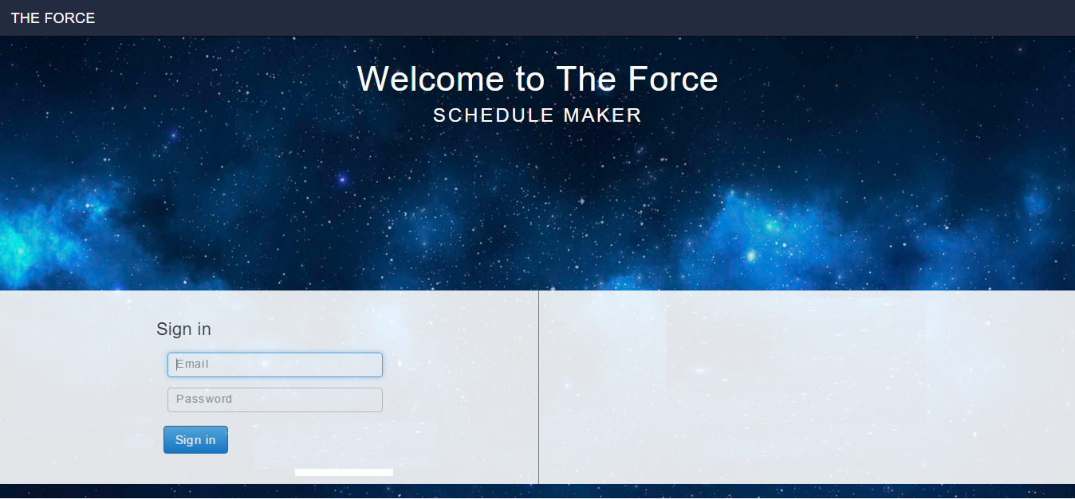

The screenshot above shows the home page of the website. Here, you will be able to sign in with the email associated to your Concordia Student account and your password. There is also a feature to “remember me” this way you can sign in faster every time you open the website. If you do not have an account, this means that Concordia has not created one for you yet. This can be either due to the fact that you are a new Student. If that is the case, you will be able to create an account and Concordia will populate all the necessary information to your profile (i.e: Student Transcript, courses taken etc.)

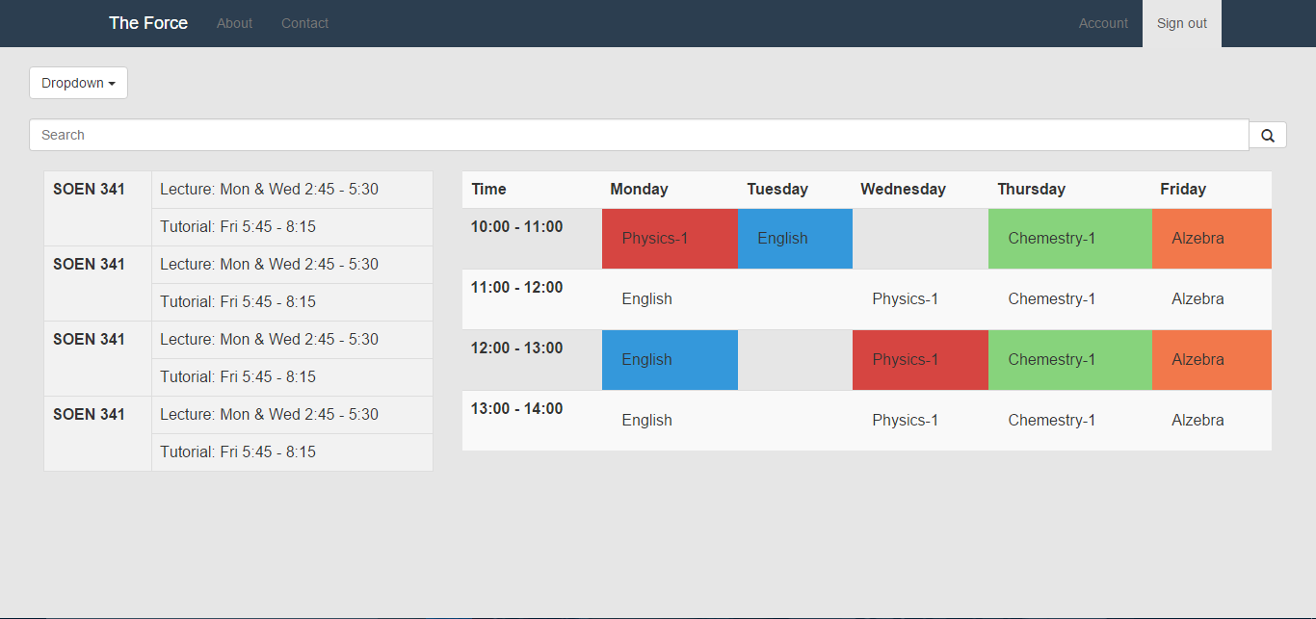

The screenshot above shows the main page of the website. Here, you can search for courses and add them to your schedule. By clicking on courses already added, you can also remove them from your schedule or browse for other sections available at different times. The search bar on top allows a student to manually search for the course they are look for by entering the course code. An autocomplete feature will kick in once they start to type, allowing for fast filtering and searching. The Header will include links to the “About Us” & “Contact Us” section of the site, which have not been developed yet. As well, there is a link to the “Account” section, which will be described below and an option to sign out.

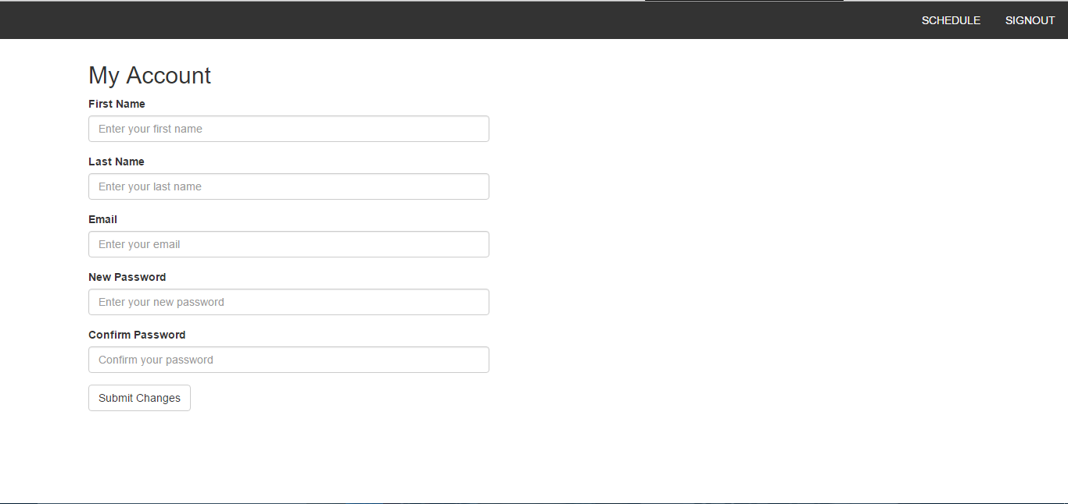

The screenshot above shows the “My Account” portion of the website. Here, any student can view and edit any of the information associated to their account. As of right now, the team has incorporated First Name, Last Name, Email address, and the options to change password. If the password do not match, the user will be informed through a message on the screen. In the future, the team will add more of the student information here such as Student ID, Transcript, courses taken, etc. At the top, the Header has yet to include the section previously mentioned, but it includes a link “Schedule” which navigates the user back to the main page shown in diagram 2.

On top of this, the Server Side Team has created scripts in Python to extract all pertinent data from the data from Concordia’s website related to the course sequence for Software Engineers. They have all created all of the SQL tables for the values specified in each class of the domain model, and incorporated them into the host server. Last they created the following ER diagram to aid in their coordination between SQL tables and PHP scripts.

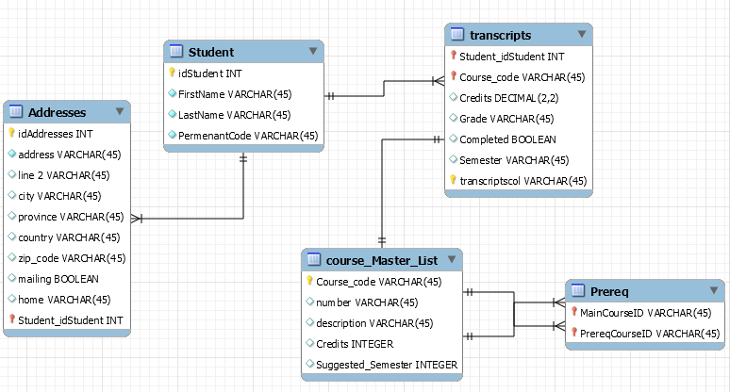

**Part B: Project Design**

8 – Introduction

The following deliverable will present 5 key topics that were essential in the continual development of “The Force” system. They are; Architectural Design, Detailed Design, Dynamic Design Scenario, Estimation and Rapid Prototyping & Risk.

In the Architectural Design section, we provide a high-level description of the system in terms of its modules and their respective purpose as well as exact interfaces. There are 2 subsections to this; Architecture Diagram and Subsystem Interface Specification. The architecture diagram will show the high-level structure of the system and the reasons for this design. The Subsystem Interface Specification will describe the parameters passed in these functions.

In the Detailed Design section, we provide a description of the system design and each subsystem and their purpose. They subsystems are User, Course and Scheduler. Here we also included 2 subsections; Detailed Design Diagram and Unit Descriptions. The detailed design diagram will show the internal working of the subsystems mentioned and describe the reasoning for their design. The unit descriptions list each class from the subsystem mentioned and describe their purpose as well as the attributes, functions and parameters used.

In the Dynamic Design Scenarios, we provide System Sequence Diagrams, Operational Contracts and full Sequence Diagrams of two main uses cases described from previous deliverables. These two uses are Generate Schedule and Add a Course.

In the Estimation section, we revise the estimates for previously identified tasks. We then update the tables describing the cost (man hours), number of days allocated as well as the start date for the tasks. Last, we show an updated schedule (Gantt chart) with the changes incorporated.

The last section is Rapid Prototyping and Risk. In this section we outline the updates made to the prototype of our system “The Force”. Included are screenshots as well as an updated Domain Model, Use Cases and newly found risks. Previous risks are also assessed to see if they are still valid to the scope of the project.

9 – Architecture Design

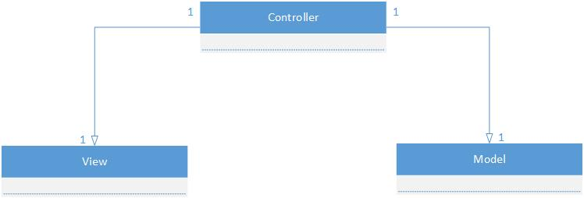

As was discussed in Deliverable 1, The Force’s high-level architecture follows Model-View-Controller (MVC) architecture. Since the MVC architecture allows for a clear separation between domain logic, controllers, and user interfaces into separate entities/components, it is ideal for this project. Any requests for communication will be made through the appropriate controller, and the components designated to be models would not be exclusive to a single controller. Since the same data might be needed over numerous web pages (for example, when displaying a schedule on one page and when displaying student information on another), the controllers would be able to access said data directly. In addition, the separation of concern allows for development without the need for concern over minor interactions leading to unsatisfactory interference between components.

The complete design of The Force will be presented in various forms and contexts using the 4+1 view. This architectural view will break The Force into Logical, Process, Development, and Physical View, as well as include Scenarios for user interaction.

9.1 – Architecture Diagram

9.1.1 – Logical View

Logical views are concerned with presenting the functionality provided by the system to the users. As such, the logical view presented here is a presentation of the subsystems (and their components) of The Force’s model component (Refer to 9.1.2 for a full component diagram).

The actors in the system are denoted as Student and Administrator, both inheriting general characteristics of a standard “User”, but with their own unique functions as well. Students are given the ability to use the Scheduler to generate a possible combination of Courses he/she has yet to take, as well as view said Schedule once it’s been made. Each Student also possesses a studentTranscript (which cannot exist without said student), which is used to track his or her academic progress. The Scheduler creates Schedules through the use of Courses and Sections, these being available options that the Student still has remaining in their academic careers. The Student can make modifications to their Schedule, assuming the necessary requirements are met (e.g.: Prerequisites for a particular class), and can also export said Schedule for ease of access. The Administrator, though lacking in the ability to use the Scheduler, can modify the contents of all Courses, Sections, and Schedules, as well as view any studentTranscript he or she might want to see.

Through the use of the following class diagram, it can be seen that concerns are well separated through the use of multiple different classes. Unlike in a system where design dictates that a single class holds a large majority of the functionality, The Force ensures to the best of its abilities that concerns are separated appropriately. As such, changes can more easily be made without affecting a majority of the system, thus allowing for faster progress and implementation.

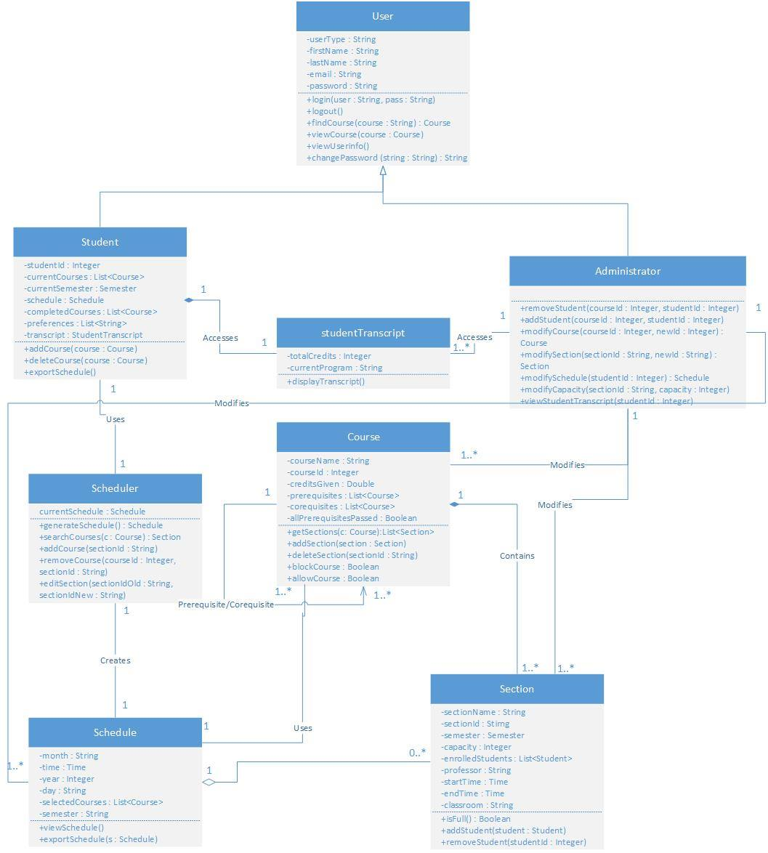

9.1.2 – Development View

Development views, or implementation views, are concerned with software management. They aim to present a system from a programmer’s perspective.

The Force, as was previously mentioned, is designed using the MVC architecture and as such will be broken down into three components: Model, View, and Controller. All logic, for both the model and controller), is being implemented using PHP and is being handled by a single server. On said server, Windows Server 2012 Operating System is being used as the Operating System, and MySQL 5.6.26 is used for all database needs. The view is being rendered through the user’s browser using HTML, CSS and JavaScript, which the application is generating.

The client side of the application relies strictly on multi-platform browsers such as Google Chrome. As such, The Force will work on all clients but support is mainly given to current versions of most popular browsers currently being used. Through the use of HTTP requests and responses, communication is made possible between the user’s browser and the server.

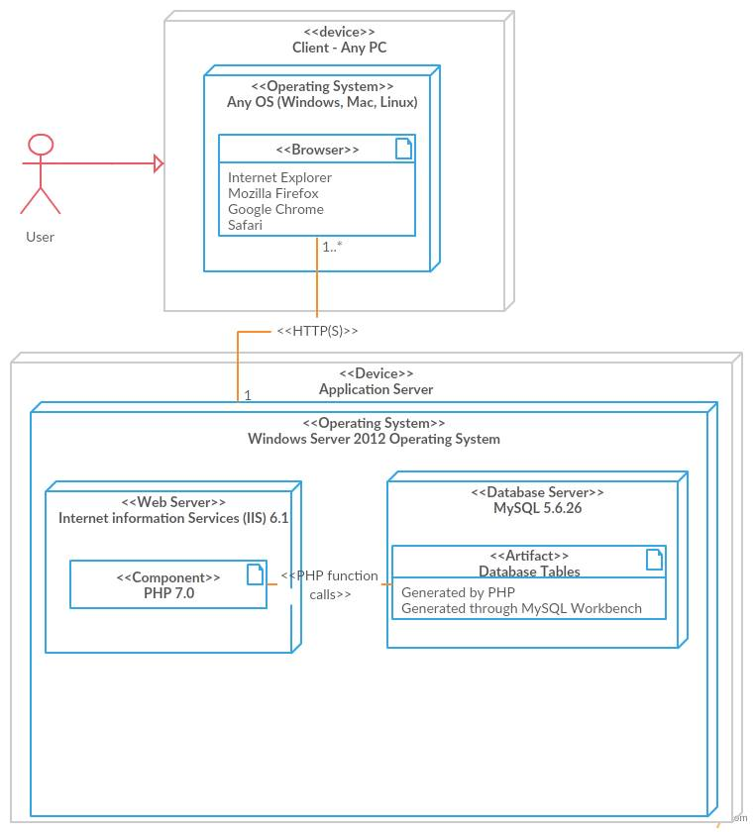In addition, a database model is provided in order to present the interactions between tables currently being stored on the server. This database is manipulated through the use of PHP (and MySQLi queries), and MySQL workbench.

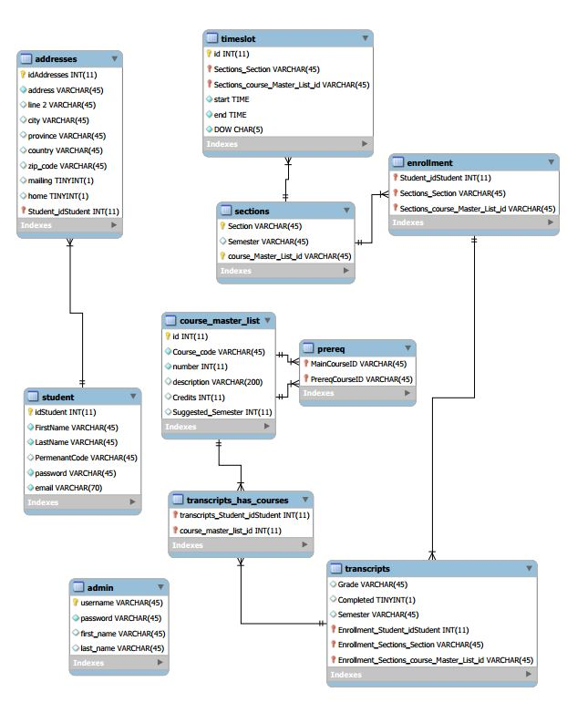

9.1.3 – Physical View

Physical views are concerned with the software components of a given system, as well as how they communicate between each other. As The Force follows MVC architecture, it is broken down into three major components: Model, View, and Controller.

The Views component is composed of all the user interfaces a user would need to interact with while using The Force. It is used to connect information found within the Models to HTML templates, thus allowing a user to understand and interact with them. Each Views component is paired with a controller from the Controllers component, as it is to manipulate the Models based on user input and changes the Views accordingly.

The largest component is the Models component, which is made up of 3 distinct components representing the major subsystems of the application. The User subsystem is comprised of classes used to represent the various types of users who might be using The Force. In addition, they deal with all attributes and services unique to just the User classes, such as viewing student transcripts. Classes within the User subsystem not only provide information to other subsystems (namely the Scheduler subsystem, allowing it to compose schedules based on the appropriate student information), but it also requires methods from both subsystems in order to manipulate the schedule by modifying the courses being taken by said Student (or by a Student, in the Administrators case). The Scheduler subsystem, in addition to representing all classes relating to one’s schedule and schedule-making, also requires information from the Course subsystem in order to create proper representations of a Student’s academic semester. The schedules it houses are the used by the User subsystem, namely when exporting or viewing schedules. Finally, the Course subsystem encompasses all courses and sections provided by the university. It provides services to both other subsystems in order to generate, display, and modify appropriate configurations of courses.

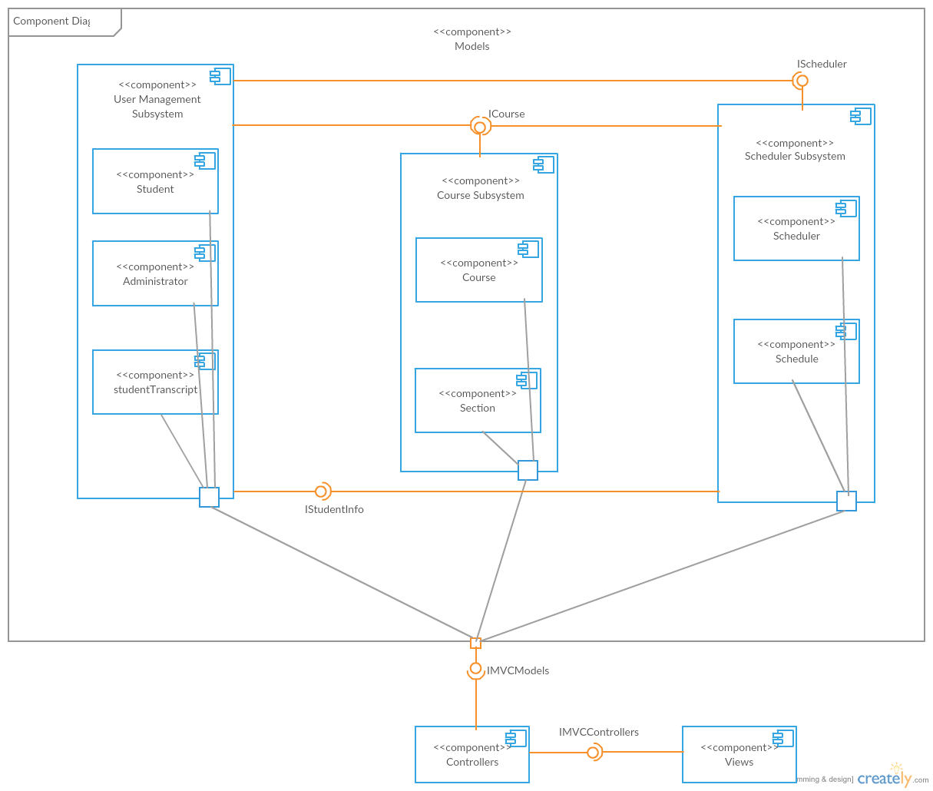

9.1.4 – Process View

Process views deal with how a system’s processes communicate, as well as focusing on the runtime behavior of the system. One activity diagram (Figure 9.1.4.1) is used in order to denote the main purpose of The Force (the generation of a schedule), and two more activity diagrams are used to go into greater detail on how schedules would be auto generated (Figure 9.1.4.2) or manually generated (Figure 9.1.4.3) during the runtime of the application.

Figure 9.1.4.1 describes the general runtime behavior of the complete schedule generation process. Once a student logins in (as an administrator doesn’t possess this feature), they are greeted with a main page consisting of their current semester’s schedule and courses. From here they may either exit the program, access their account page in order to change their personal information (and be redirected to the main page), or remain on the same page. From the main page, the student’s semester could be changed (allowing them to view past or future semesters) thus updating the displayed schedule and course list, or a schedule could be generated. Generation could be done in one of two ways, auto generation (Figure 9.1.4.2) or manual generation (Figure 9.1.4.2), both of which will be explained in more detailed shortly. Once a schedule’s been made, the student can either quit the application, or modify their schedule manually (perhaps they are unhappy with an automatically generated course they were given, or they failed to notice an error while manually creating their schedule). Attempting to modify the current schedule will result in a display of the student’s current courses with modification options now present. Removing a course will simply update the schedule, however requesting to add or change a courses section will result in a list of alternatives (found similarly to what is seen in Figure 9.1.4.3), and once a new option is chosen the complete schedule will be displayed. Once modifications are complete, the student can make different modifications, or simply quit the application.

Figure 9.1.4.2 describes the auto generation process of creating a schedule. Once access to a student’s transcript and preferences are achieved, their current total credits within their program are analyzed. Should it be that they already have the maximum possible amount of credits they can achieve, they would have no courses left to complete and thus would be done, generating an empty schedule. Should their credits be lower than this arbitrary total amount, access is given to the student’s current program and course sequence, and the courseId for the next course in their sequence is acquired. Should the number of courses ever reach the max they are allowed per semester (e.g.: Perhaps 5 or 6), the schedule will stop adding courses and update itself. Otherwise, the next course will be selected and examined. If the student is still taking less than the recommended amount of classes, and the classroom still has rom in it, the course will be added to a list. So long as another course exists in the sequence, this cycle will continue until the maximum amount of courses is being taken, or there are no courses left (credits would equal the maximum amount), thus updating the schedule and ending the generation.

Figure 9.1.4.3 describes the process by which a schedule is generated manually by a student. Upon selecting the option, the student is told to enter their unavailability, or preferences (e.g.: No school on Friday, no class after 4:00pm), and they are then able to enter the name of the course they wish to add. If the course doesn’t exist, an error message appears and they can try again, otherwise the course information is displayed. Before searching for possible sections based on the students unavailability, room availability (whether there’s space in the class), and whether the necessary prerequisites are met, the student could decide against the current choice and change their mind. Once all checks have been performed, the student could cancel their selections (exiting the generation), or should a proper timeslot have been found, they may select their preferred section within the course. This will lead to their schedule being updated, and they may either stop choosing courses, or repeat the process again. It should be noted that the process used to check for a course availability is the same process used to determine the list of alternative sections proposed in Figure 9.1.4.1, thus it was omitted there to reduce redundancy.

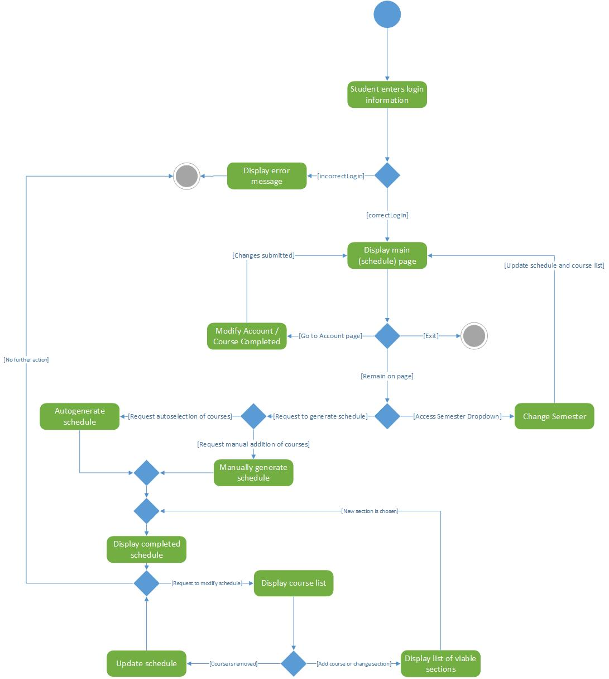

Figure 9.1.4.1: Main Schedule Generation

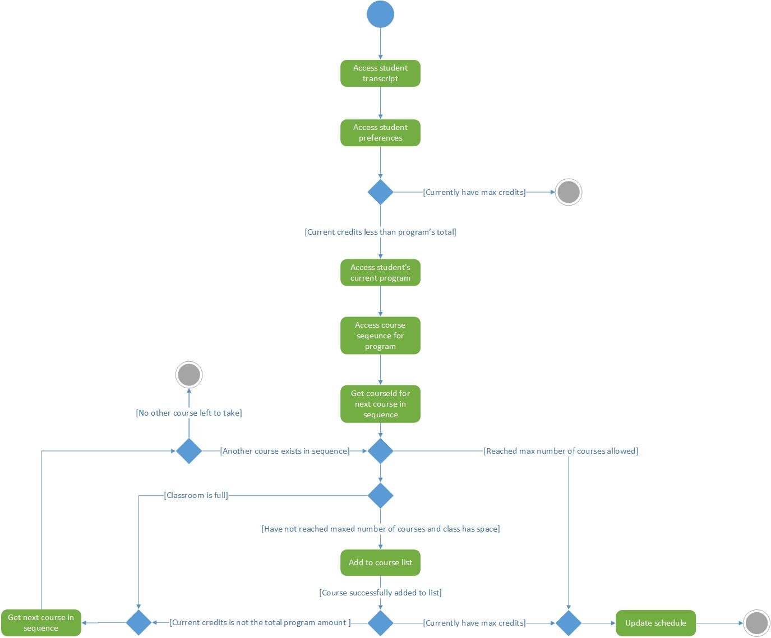

Figure 9.1.4.2: Auto Generated Schedule

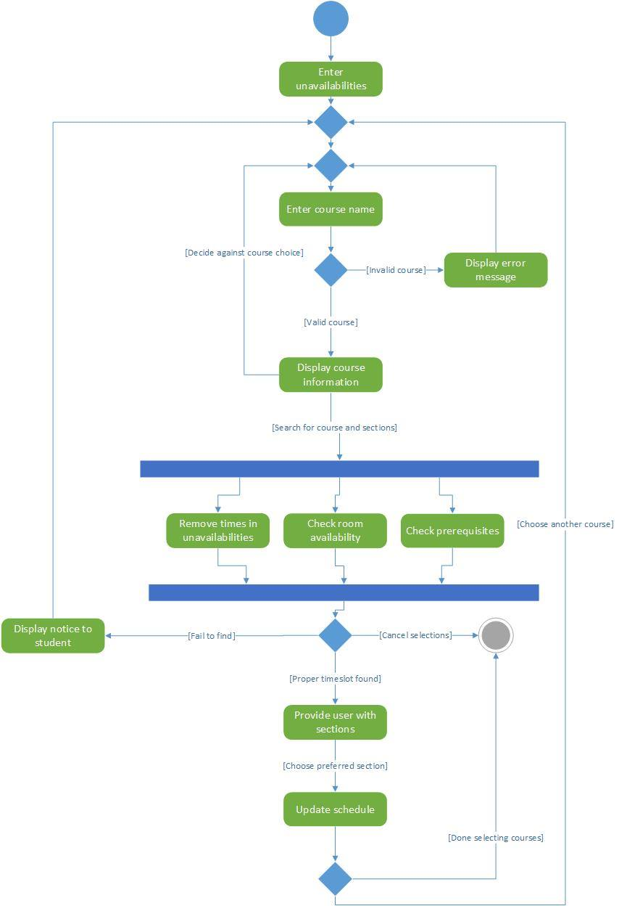Figure 9.1.4.3: User Generated Schedule

9.1.5 – Scenarios

Scenarios are used to interactions between objects and between processes, as such Use Case Diagrams will be used to denote the way the various types of users can interact with The Force.

It should be noted that, by comparison to the original Use Case Diagram made, quite a bit has changed. First and foremost, the UCD was strictly for one situation, most notably assuming that the only type of user would be a student. Since then, the addition of the administrator user type not only required a separate diagram (Figure 9.1.5.4), but also allowed for the creation of a general User diagram (Figure 9.1.5.2). This use case diagram denotes interactions which both Students and Administrators have access too, and helped not only reduce redundancy within each unique diagram, but also allowed a clear distinction to be made between the roles each type of user is allowed to play, and the access each type of user is given. As before, a Use Case Diagram is still present for Students (Figure 9.1.5.3), but it now includes new interactions which were added to The Force between Deliverable 1 and 2, and allows for a clearer view of its unique interactions in comparison to the Administrators.

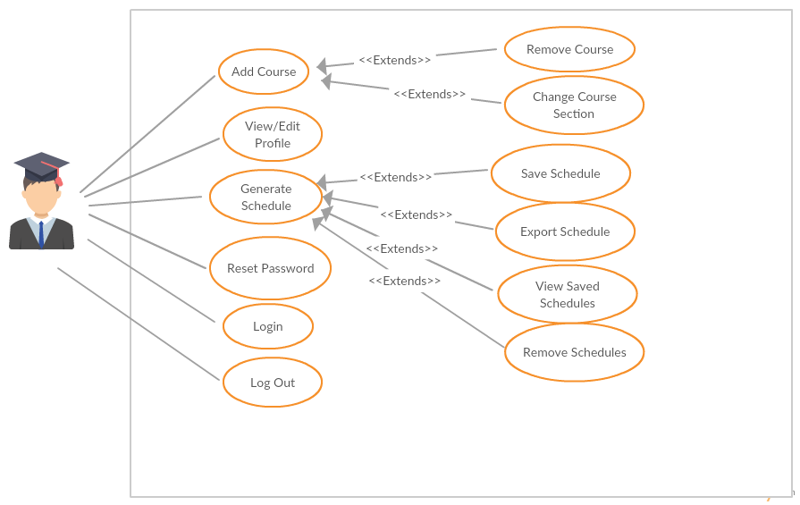

Figure 9.1.5.1. : Original General UCD



Figure 9.1.5.2. : General User UCD

Figure 9.1.5.3. : Student UCD



Figure 9.1.5.4. : Administrator UCD

9.2 – Subsystem Interfaces Specifications

The system will be broken down into three separate subsystems in order to not only facilitate separation of concerns, but also to facilitate public interfacing. All methods referenced below will be those found in the class diagram used to represent Logical View (refer to section 9.1.1.). All constructors, as well as all getter and setter methods, are assumed whenever necessary (as all variables as private), but won’t be included in order to reduce redundancy. Another important note is that some methods, such as the inherited login and logout, are not particularly relevant to one interface or another, nor are they used by subsystems they’re not a part of. These methods will also be removed from the specifications to reduce clutter and increase cohesion.

9.2.1 – IstudentInfo

|  |  |
| --- | --- |
| Class | Student |
| Methods: | * addCourse(Course course) * Add a given course to the current student’s course list. * Parameters: * course – The course to be added to the current semester’s course list. * Invalid values: NULL * Returns: void |
|  | * deleteCourse(Course course) * Remove a given course from the current student’s course list. * Parameters: * course – The course to be removed from the course list. * Invalid values: NULL * Returns: void |
|  | * exportSchedule() (Phased Out) * Export the current student’s schedule. * Parameters: * None * Returns: void |

|  |  |
| --- | --- |
| Class | studentTranscript |
| Methods: | * displayTranscript() * Display current student’s transcript to be seen by the user. * Parameters: * None * Returns: void |

|  |  |
| --- | --- |
| Class | Administrator |
| Methods: | * removeStudent(Integer courseId, Integer studentId) * Remove the given student from the given course. Student’s course list is updated as well. * Parameters: * courseId – The course the student will be removed from * Invalid values: NULL. Student must be enrolled to be removed. * StudentId – The student to be removed * Invalid values: NULL * Returns: void |
|  | * addStudent(Integer courseId, Integer studentId) * Add the given student to the given course. Student’s course list is updated as well. * Parameters: * courseId – The course the student will be added to * Invalid values: NULL. Student must not be enrolled already. * StudentId – The student to be removed * Invalid values: NULL * Returns: void |
|  | * modifyCourse(Integer courseId, Integer newId) * Modify a given course’s courseId to a new value. * Parameters: * courseId – The course to be modified * Invalid values: NULL * newId – The new courseId * Invalid values: NULL * Returns: Course. Returns the updated Course |
|  | * modifySection(String sectionId, String newId) * Modify a given section’s sectionId to a new value. * Parameters: * sectionId – The section to be modified * Invalid values: NULL * newId – The new sectionId * Invalid values: NULL * Returns: Section. Returns the updated Section |
|  | * modifySchedule(Integer studentId) * Gain access to a given student’s schedule for future modifications. * Parameters: * studentId – The student whose schedule will be accessed. * Invalid values: NULL * Returns: Schedule. Returns the Schedule to be modified at a later time. |
|  | * modifyCapacity(String sectionId, Integer capacity) (Phased Out) * Modify a given section’s maximum capacity. * Parameters: * sectionId – The section to be modified * Invalid values: NULL * capacity – The new capacity of the section * Invalid values: NULL, capacity < 0. Capacity must be defined, and can’t be a negative number. * Returns: void |
|  | * viewStudentTranscript(Integer studentId) * View a given student’s official transcript * Parameters: * studentId – The student whose transcript will be accessed. * Invalid values: NULL * Returns: void |

9.2.2 – IScheduler

|  |  |
| --- | --- |
| Class | Scheduler |
| Methods: | * generateSchedule() * Generates a schedule for a student. * Parameters: * None * Returns: Schedule |
|  | * searchCourses(Course c) * Retrieves a section within Course c. * Parameters: * c – The course whose section is being identified * Invalid values: NULL * Returns: Section |
|  | * addCourse(String sectionId) * Add course with the given section, and sectionId, to the schedule. Eliminates the need to pass a course as well as a section. * Parameters: * sectionId – The id of the section found within the course to be added. * Invalid values: NULL * Returns: void |
|  | * RemoveCourse(Integer courseId, String sectionId) * Removes the course and section whose ids were passed, from the schedule. * Parameters: * courseId – The id of the course to be removed. * Invalid value: NULL * sectionId – The id of the section to be removed. * Invalid value: NULL * Returns: void |
|  | * editSection(String sectionOld, String sectionNew) * Find the section whose id is sectionOld, replace the id by sectionNew. * Parameters: * sectionOld – The section to be found. * Invalid value: NULL * sectionNew – The new id of the section. * Invalid value: NULL * Returns: void |

|  |  |
| --- | --- |
| Class | Schedule |
| Methods: | * viewSchedule() * Display current schedule for user to see. * Parameters: * None * Returns: void |
|  | * exportSchedule(Schedule s) (Phased Out) * Export a given schedule to PDF format. * Parameters: * s – The schedule to be exported * Invalid value: NULL * Returns: void. |

9.2.3 – ICourse

|  |  |
| --- | --- |
| Class | Course |
| Methods: | * getSections(Course c) * Retrieves all sections associated with a given course c. * Parameters: * c – The course which contains the sections required. * Returns: List<Schedule> |
|  | * addSection(Section section) * Add a section to the course calling the method. * Parameters: * section – The section to be added. * Invalid values: NULL * Returns: void |
|  | * deleteSection(String sectionId) * Deletes the section associated with the provided id. * Parameters: * sectionId – The id of the section to be removed. * Invalid values: NULL * Returns: void |
|  | * blockCourse() * Blocks the course from being registered to. * Parameters: * N/A * Returns: Boolean. Returns true if course is now blocked, false otherwise. |
|  | * allowCourse() * Allows the course to be registered to. * Parameters: * N/A * Returns: Boolean. Returns true if course is now allowed, false otherwise. |

|  |  |
| --- | --- |
| Class | Section |
| Methods: | * isFull() * Checks if the calling section is full. * Parameters: * N/A * Returns: Boolean. Returns true if the section is full, false otherwise. |
|  | * addStudent(Student student) * Add a student to the calling section * Parameters: * student – The student to be added * Invalid values: NULL * Returns: void |
|  | * removeStudent(Integer studentId) * Remove the student with the id being passed from the calling section. * Parameters: * studentId – The id of the student to be removed. * Invalid values: NULL * Returns: void |

10 – Detailed Design

10.1 – Detailed Design Diagram

10.1.1 – User Subsystem

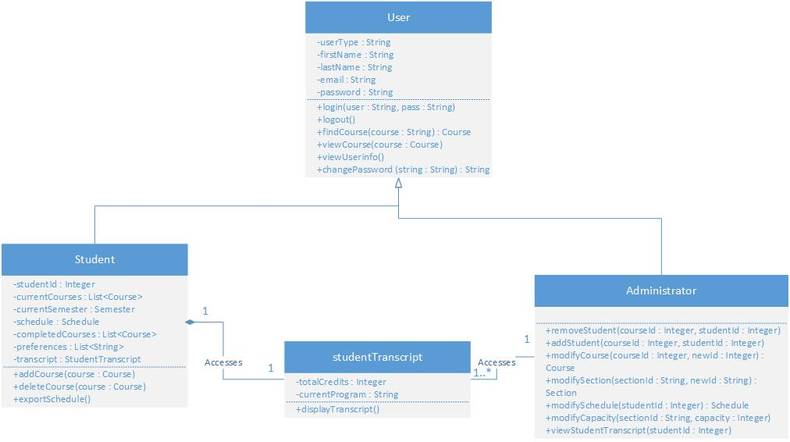

The user subsystem’s role is to store any relevant information regarding a user. While all users share certain base characteristics, such as “First Names” and “Passwords”, they will always either be an Administrator or a Student. This system allows for the creation of a Student account, after which that student may login to their profile using their credentials. Regardless of the type of account, there will always be a link to the “StudentTranscript” class. This means that the user subsystem, while secure, is not isolated from the rest of the system, and may communicate any necessary information to, for example, the Administrator of the system. This transcript information is vital to maintain a proper profile, since it is the most important information regarding academic progress. The Student class contains other classes as its attributes. To see these, refer to section “Unit Descriptions”.

10.1.2 – Course Subsystem

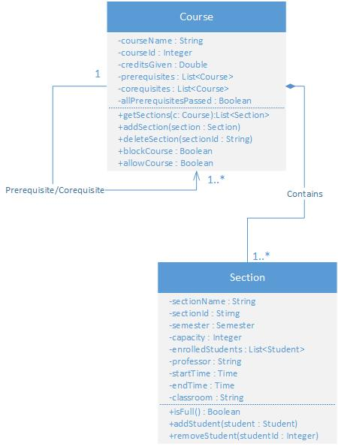

The course subsystem contains all information regarding course offered in ENCS at Concordia. It is composed of all Course object instances. Every Course contains 1 to n Section objects. Furthermore, it is possible for a course to also have prerequisites or co requisites. A prerequisite is a course that a Student must complete before signing up for the course in question, and a co requisite is a course that must be taken simultaneously as the one in question.

10.1.3 – Scheduler Subsystem

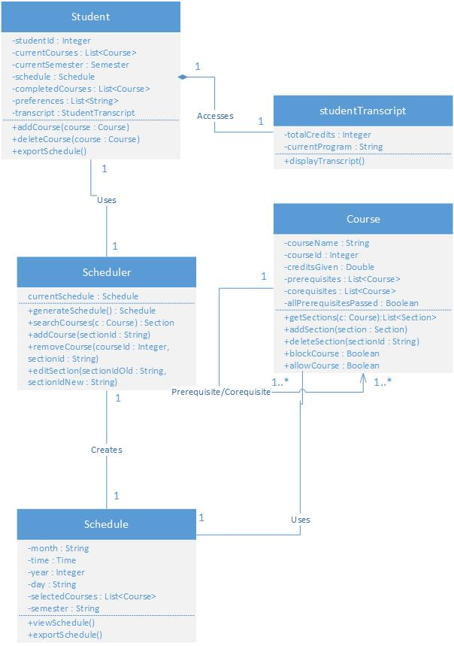

The Scheduler subsystem encompasses aspects of the other subsystems and packages them in order to add real functionality. In essence, its goal is to create a Schedule, which makes it the most important subsystem of all, because the end goal of “The Force” is to provide a scheduling service to all of its users. The Scheduler class provides the service to the Student, whereas the Schedule class itself accesses Course information.

10.2 – Unit Descriptions

10.2.1 – User Subsystem Unit Descriptions

**User Class**

Description: Abstract class which is a template for any user in the system (Student or Administrator). A student or administrator contain the “User” attributes and methods on top of their own.

Attributes:

* userType: String
* firstName: String
* lastName: String
* email: String
* password: String

Methods:

* login(user: String, pass: String): logs the user into the system. The user parameter represents the account’s name, and the pass parameter is the password. This method does not have a return value.
* logout(): Logs the user off of the system. Does not require any parameters, and does not return any value.
* findCourse(course: String): Course: This method searches for a course in the database using the course name as the input string. The return value of this method is a Course object whose courseName attribute matches with the input value for the method.
* viewCourse(course: Course): This method takes in a course object as input value, and does not return anything. However, this method displays the course in a way that the user may understand.
* viewUserinfo(): This method does not return any value, however it displays all the information of the account using the method.
* changePassword(string: String): String: This method takes in a new password as a parameter in the form of a string, and returns it if the method is successful.

**Student Class**

Description: This class is a specialized version of User. The Student class contains the same information as the User along with its own special attributes and methods. This user is granted no special privileges.

Attributes:

* studentID: Integer
* currentCourses: List<Course>
* currentSemester: Semester
* schedule: Schedule
* completedCourses: List<Course>
* preferences: List<String>
* transcript: StudentTranscript

Methods:

* addCourse(course: Course) : This method takes in a Course object as input, and adds it to the Student’s currentCourses attribute, which is a list of Course objects. This method returns no value.
* deleteCourse(course: Course): This method takes in a Course object as input, and removes it from the Student’s currentCourses attribute, which is a list of Course objects. This method returns no value.
* exportSchedule(): This method exports the Schedule object of the account using the method so that the actual user may view it on their own as a file. (Phased Out)

**Administrator Class**

Description: This class is a specialized version of User. While it contains no additional attributes from the User class, it does have additional methods and elevated privileges within the system.

Attributes:

* N/A

Methods:

* removeStudent(courseId: Integer, studentId: Integer): This method takes in a course ID and a student ID as parameters, and does not return any value. The student with that given student ID is removed from the course in question.
* addStudent(courseId: Integer, studentId: Integer): This method takes in a course ID and a student ID as parameters, and does not return any value. The student with that given student ID is added to the course in question.
* modifyCourse(courseId: Integer, newId: Integer): Course: This method takes in two course IDs as parameters and returns a Course object. The course with the associated courseId has its ID changed to newId. The returned Course object has the newId as an attribute.
* modifySchedule(studentId: Integer): Schedule: This method takes a student ID as a parameter and returns a Schedule object. This method allows the Administrator to modify the schedule of the given student, and once changes are made, returns that new Schedule.
* modifyCapacity(sectionId: String, capacity: Integer): This method takes in a string parameter called sectionId and an Integer called capacity. It does not return any value. This method modifies the allowable number of students in a given section with the associated section ID to the new capacity parameter. (Phased Out)
* viewStudentTranscript(studentId: Integer): This method takes in a student ID as a parameter and returns no value. This method displays the schedule of the student in question for the administrator to see.

**StudentTranscript Class**

Description: This class represents the academic progress for a Student. It holds relevant information regarding program and credits.

Attributes:

* totalCredits: Integer
* currentProgram: String

Methods:

* displayTranscript(): This method takes no parameters and does not return any value. This method displays the student’s transcript to whoever is accessing it. This method is not only available to the student in question, but also to administrators.

10.2.2 – Course Subsystem Unit Descriptions

**Course Class**

Description: The Course class represents a course offered at the university. Its most important attributes are the collection of Sections that compose it.

Attributes:

* courseName: String
* courseId: Integer
* creditsGiven: Double
* prerequisites: List<Course>
* corequisites: List<Course>
* allPrerequisitesPassed: Boolean

Methods:

* getSections(C: Course): List<Section>: This method takes in a Course as parameter and returns all the associated Section objects as a list. The sections returned are only the ones within the course in question.
* addSection(section: Section): This method takes in a Section object as parameter and returns nothing. This method adds a Section to the List of Sections within a course. The Course that gets the extra Section is the one using the method.
* deleteSection(sectionId: String): This method takes in a String representing a SectionId as a parameter and returns nothing. This method deletes the section with the associated section ID from the course that it is contained in.
* blockCourse(): Boolean: This method takes in no parameters and returns a true/false value. True means that the Student is blocked from taking the course, false means that the Student is allowed to do so.
* allowCourse(): Boolean: This method takes in no parameters and returns a true/false value. True means the Student is allowed to take the course in question, and false means otherwise.

**Section Class**

Description: This class represents a specific course section at Concordia. Section objects are important because a student signs up to a section instead of a course itself.

Attributes:

* sectionName: String
* sectionId: String
* semester: Semester
* capacity: Integer
* enrolledStudents: List<Student>
* professor: String
* startTime: Time
* endTime: Time
* classroom: String

Methods:

* isFull(): Boolean: This method takes in no parameters and returns a true/false value. It checks to see if the length of the List of Students enrolled in a section (enrolledStudents) is equal to the capacity of the section. A return value of true means that there is no more room in a section, and false means that there is still room.
* addStudent(student: Student): This method take sin a student as a parameter and returns no value. The Student object inputted into the method is added to the section using the method if and only if the isFull() method returns false.
* removeStudent(studentId: Integer): This method takes in an integer as a parameter representing a student ID and returns nothing. It checks the enrolledStudents list and removes the student with the associated student ID.

10.2.3 – Scheduler Subsystem Unit Descriptions

**Student Class**

See section 10.2.1

**Student Transcript Class**

See section 10.2.1

**Course Class**

See section 10.2.2

**Scheduler Class**

Description: The Scheduler class effectively serves as a kind of interface for a student to interact with which provides the student with their desired schedule. In order to achieve this, the scheduler has access to both the Student class and the Schedule class.

Attributes:

* currentSchedule: Schedule

Methods:

* generateSchedule(): Schedule: This method takes in no parameters and returns a Schedule. This is the method that provides the Student with the end product.
* searchCourses(c: Course): Section: This method takes in a Course as a parameter and returns a Section. This method searches the database for a Course (input parameter) and returns the best fit of a section to the Student’s preferences and schedule.
* addCourse(sectionId:String): This method takes a section ID String as a parameter and returns nothing. It adds a section to the student’s schedule.
* removeCourse(courseId: Integer, sectionId: String): This method takes a courseId Integer and a sectionId String as parameters. It removes the section with the associated ID from the Course with the associated course ID from the Student’s schedule.
* editSection(sectionIdOld: String, sectionIdNew: String): This method takes in two section ID strings as parameters and returns nothing. This method swaps sections for a student in their schedule. The section with the associated sectionIdOld is replaced with the section with the associated sectionIdNew.

**Schedule Class**

Description: This class is the end product provided to the user. It is effectively the goal of the entire system.

Attributes:

* month: String
* time: Time
* year: Integer
* day: String
* selectedCourses: List<Course>
* semester: String

Methods:

* viewSchedule(): This method has no parameters and no return values. It displays the schedule using the method to the user.
* exportSchedule(): This method has no parameters and no return values. It exports the Schedule as a file that the user can then use in whatever way they see fit. (Phased Out)

11 – Dynamic Design Scenarios

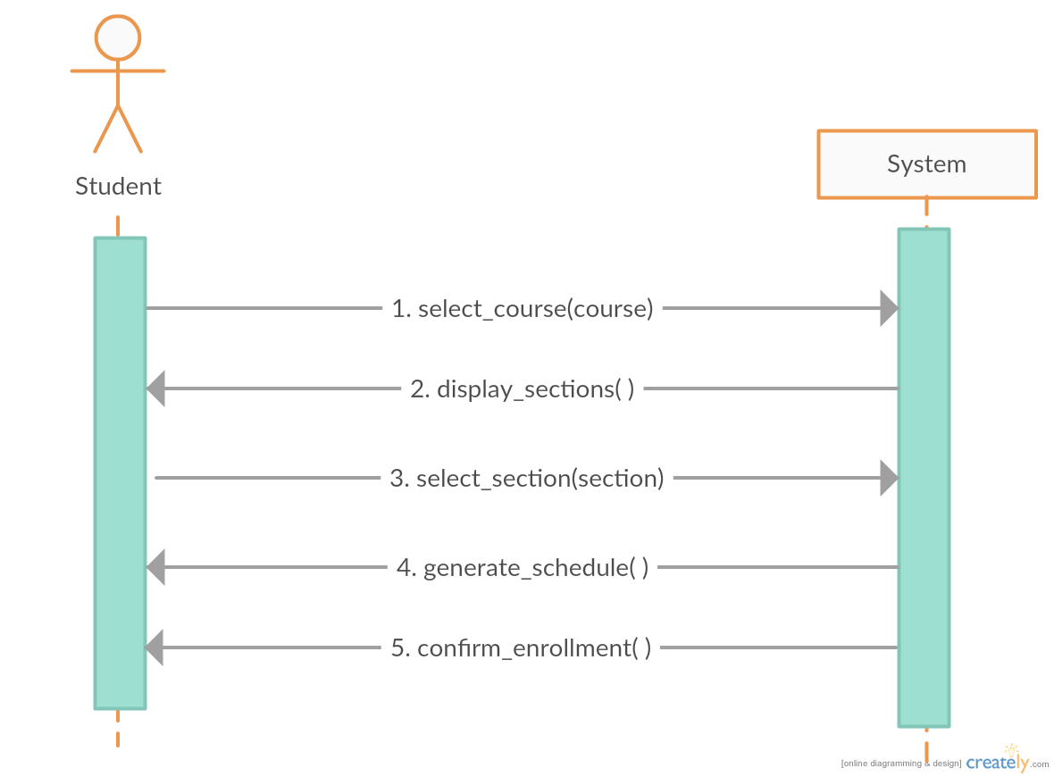

*Manually Registering a Course – System Sequence Diagram*

This system sequence diagram shown above demonstrates the interaction between the actor (student) and the system (course generator). This simplified model omits any technical functions performed by the system itself, and focused on the student’s perspective.

Once the student initially accesses the application, they must select the course they desire to be enrolled in. Afterwards, the system will return the selected course’s sections. Then, the student will select their preferred section. Last, the system returns an updated schedule and confirmation message to the student when the process is completed.

**Operational Contracts:**

|  |  |
| --- | --- |
| Name: | Manually Adding a Course |
| Operation(s): | select_course(course) |
| Cross Reference: | UC05 Add Course |
| Preconditions: | * User is logged into the system * At least one search result displayed after course search and filter |
| Postconditions: | * Course is associated to student record * Course is associated to schedule |

|  |  |
| --- | --- |
| Name: | Select Course Section |
| Operation(s): | select_section(section) |
| Cross Reference: | UC06 Change Course Section |
| Preconditions: | * User is logged into the system * At least one search result displayed after section search and filter |
| Postconditions: | * Section is associated to student record * Section is associated to schedule generator |

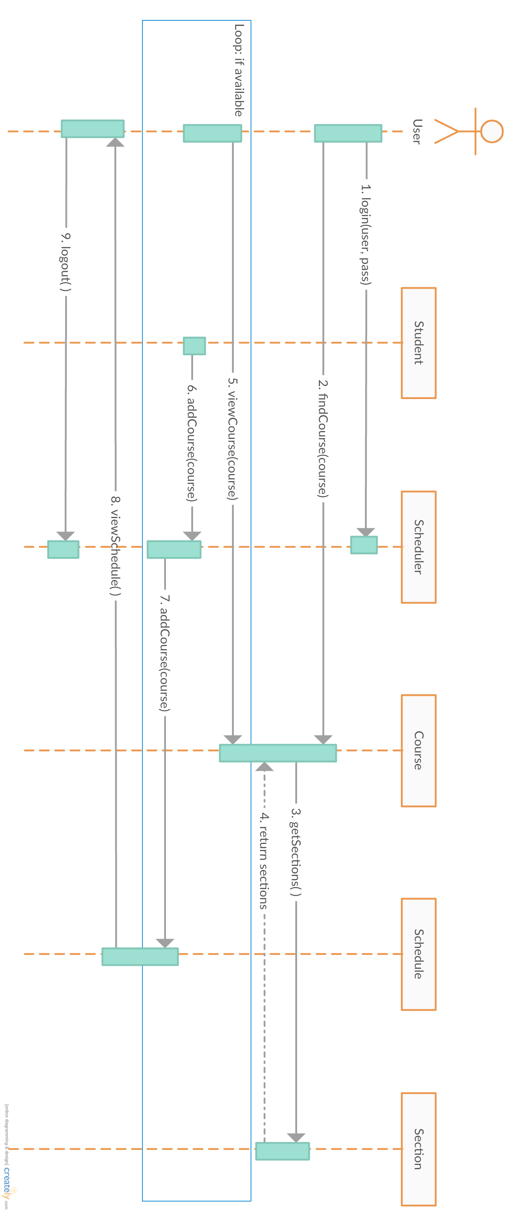

*Manually Registering a Course – Full Sequence Diagram*

This full sequence diagram shown demonstrates the detailed interaction between every component involved in the system when manually adding a course.

The student first initiates the system, after which the student searches for the desired course for enrollment. The course is found and its respective sections are obtained and displayed to the user. The user can then select a section and attempt to add it to their current schedule using the scheduler. The scheduler will check the students’ attributes to see if they have the prerequisites or co-requisites for the course to be added. If the chosen section could not be added, the user is sent back to select another section. If the course has been successfully added, the updated schedule is displayed to the user. The user can loop through this manual registration for as many courses as desired (up to a maximum of 5 courses per semester), and once they are satisfied with their schedule, they may then logout from the system.

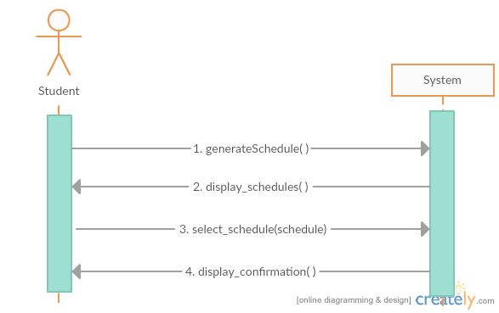

*Auto-Generating Schedules – System Sequence Diagram*

This system sequence diagram demonstrates the interaction between the student and the system when automatically generating schedules. The user initializes the program, and then the system displays the possible schedules that satisfy the course sequence. The user then picks their preferred schedule, after which the system confirms enrollment in the selected courses.

There are not many steps involved in this process from the user’s perspective, which is why the diagram appears very simple. This is due to the fact that the majority of the functions involved in this process are within the system, which can only be demonstrated through the use of a full sequence diagram, as shown below.

**Operational Contracts:**

|  |  |
| --- | --- |
| Name: | Generate Schedule |
| Operation(s): | generateSchedule() |
| Cross Reference: | UC08 Generate Schedule |
| Preconditions: | * The user must be logged in * The system has access to the course list and schedules * System checks the pre-requisites/co-requisites for all relevant courses |
| Postconditions: | * Schedule is associated to student |

|  |  |
| --- | --- |
| Name: | Display Schedule |
| Operation(s): | select_schedule() |
| Cross Reference: | UC05 Add Course |
| Preconditions: | * The user must be logged in * The system has access all created schedules |
| Postconditions: | * Schedule is associated to student record |

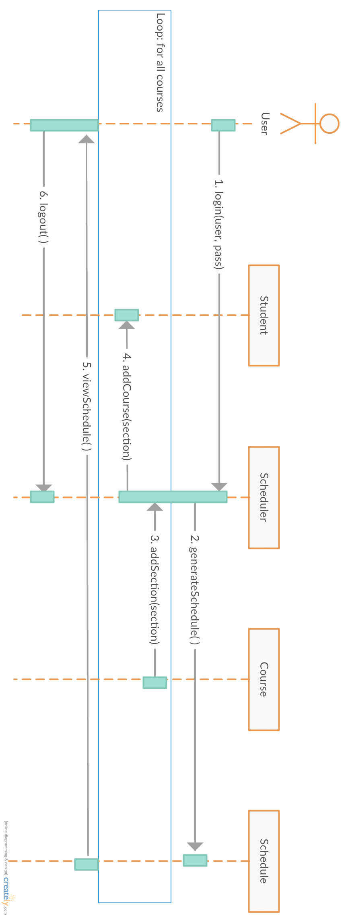

*Auto-Generating Schedules – Full Sequence Diagram*

This full sequence diagram shown above demonstrates the detailed interaction between every component in the system when generating schedules automatically.

The user first logs into the scheduler. Next, their schedule is generated using their student information. During this process, the courses and sections are obtained. These courses are then individually added to the student’s schedule, along with the appropriate sections. The scheduler will check the students’ attributes to see if they have the prerequisites or co-requisites for the course to be added. If the chosen section could not be added, the system will add another course. If the course has been successfully added, it proceeds until the schedule is full. When all the courses have been added, the resulting schedule is then displayed to the user. The user may then logout from the system.

12 – Estimation

12.1 – Revised Project Estimates

This is a copy of the original Project Estimates table.

|  |  |  |  |
| --- | --- | --- | --- |
| Task Name | Duration (Number of Days) | Total Cost (Hours) | Starting Date |
| Deliverable 0 | 3 | 10 | 10-Jan |
| Deliverable 1 | 15 | 35 | 22-Jan |
| Deliverable 2 | 15 | 30 | 22-Feb |
| Deliverable 3 | 15 | 30 | 10-Mar |
| Basic Project Structure Discussion | 5 | 6 | 10-Jan |
| Initial Diagrams | 5 | 10 | 11-Jan |
| List of Features and Technologies Required | 10 | 10 | 14-Jan |
| Creation of Proper Programming Environment | 2 | 5 | 10-Jan |
| Implementation Discussion | 10 | 20 | 14-Jan |
| Use Cases | 10 | 15 | 26-Jan |
| User Interface | 10 | 15 | 26-Jan |
| User Testing | 20 | 65 | 28-Feb |
| Design of Script to Obtain Concordia Class Data | 5 | 6 | 02-Feb |
| ER Diagram Creation | 5 | 6 | 06-Feb |
| Architecture Programming, Use Cases | 20 | 90 | 19-Feb |
| Scope of Project | 60 | 20 | 08-Feb |
| Test Cases | 12 | 15 | 28-Feb |
| Performance | 8 | 20 | 08-Mar |
| Design of UI / Aesthetics of Application | 10 | 20 | 12-Mar |
| Debugging | 10 | 20 | 22-Mar |
| Total | 90 | 440 | N/A |

The following is a revised cost estimate for the project. Upon review of what has been completed by the Project team so far as well as challenges/risks encountered, the cost estimates have changed. In some cases, they have risen and in others they have dropped.

*Numbers in Blue signify costs that have dropped, Numbers in Red signify costs that have risen

***Highlighted Dates signify changes in start Dates

|  |  |  |  |
| --- | --- | --- | --- |
| Task Name | Duration (Number of Days) | Total Cost (Hours) | Starting Date |
| Deliverable 0 (Documentation) | 3 | 10 | 10-Jan |
| Deliverable 1 (Documentation) | 15 | 35 | 22-Jan |
| Deliverable 2 (Documentation) | 10 | 25 | 22-Feb |
| Deliverable 3 (Documentation) | 15 | 30 | 10-Mar |
| Basic Project Structure | 5 | 6 | 10-Jan |
| Initial Diagrams | 5 | 10 | 11-Jan |
| List of Features and Technologies Required | 10 | 10 | 14-Jan |
| Proper Programming Environment | 2 | 5 | 10-Jan |
| Implementation | 15 | 35 | 14-Jan |
| Use Cases | 10 | 15 | 26-Jan |
| User Interface | 10 | 15 | 26-Jan |
| User Testing | 15 | 55 | 28-Feb |
| Design of Script to Obtain Concordia Class Data | 1 | 3 | 02-Feb |
| ER Diagram | 1 | 3 | 06-Feb |
| Architecture Programming, Use Cases | 20 | 90 | 19-Feb |
| Scope of Project | 60 | 15 | 08-Feb |
| Test Cases | 12 | 15 | 28-Feb |
| Performance | 8 | 20 | 08-Mar |
| Design of UI / Aesthetics of Application | 10 | 15 | 12-Mar |
| Debugging | 10 | 30 | 22-Mar |
| Deliverable 4 : Final Report (Documentation) | 10 | 30 | 4-Apr |
| Total | 95 | 472 | N/A |

The changes to the Project Estimates table were made for the following reasons:

Deliverable 2 (Reduced from 15 days, 30 hours 🡺 10 days, 25 hours)

* The deliverable was completed in a shorter time period than expected by the team.
* This allows more time allocation to different tasks in the project

Implementation (Increased from 15 days, 20 hours 🡺 15 days, 35 hours)

* The implementation proved to be more complicated than previously expected, so more time was allocated to the implementation to allow the team to properly implement all functionalities.

User Testing (Reduced from 20 days, 65 hours 🡺 15 days, 55 hours)

* It was determined that since the user testing would only be started after the completion of all underlying functionalities (i.e course generator etc.), it leaves the team with less time to complete testing, since implementation will now take longer.
* This was not something the team wanted to do, but as we had no choice, the team will need to be very efficient and incorporate a thorough plan while completing the testing.

Design of Script to Obtain Concordia Class Data (Reduced from 5 days 🡺 1 day)

* The script was completed in a shorter time period than expected by the team.

ER Diagram (Reduced from 5 days 🡺 1 day)

* The script was completed in a shorter time period than expected by the team.

Scope Project (Reduced from 20 hours 🡺 15 hours)

* The team determined a thorough scope of the system fairly early within the project, so as time progressed not many changes were needed. The team would still periodically check over the course of the project.

Design of UI / Aesthetics of Application (Reduced from 20 hours 🡺 15)

* Through the use of bootstrap, the Design of the UI was completed in a shorter time period than expected by the team

Debugging (Increased from 20 hours 🡺 30)

* Because of time saved in the other tasks, more time was allocated to the debugging of the system. This was decided by the team we can make our system as efficient and easy to use as possible for the Actors (Administrator and Student)

Deliverable 4 : Final Report (Not previously Included 🡺 10 days, 30 hours)

* This part of the project was thought to be straight forward and just a combination of all previous Deliverables, but after contemplation it was decided that a lot of editing and re-structuring would need to be done in order to present the final product.

**** Estimates were made based on time required to create, as well as based on each team members’ individual work ethic. Based on the activities assigned to each member (and the artifacts said activities produce), an appropriate amount of time was estimated, taking into consideration the number of people striving to achieve said artifact, and the time they have available for said tasks. For all artifacts not yet created/achieved, re-estimation might occur if it is discovered that the time provided is inefficient for the members responsible to complete their task. In addition, the opposite can be said; re-estimation might occur if the task is easier than expected, thus saving time in that regard and allowing a reallocation of time to another issue. Re-estimation would also be required in the case that additional components not yet listed were designed and implemented. In such as a case, time would need to be allocated to these new tasks and the time provided to our sections might decrease as a result.

12.2 – Revised Schedule & Gantt Chart

This is a copy of the original Schedule & Gantt Chart. A pie chart was also included to show the initial distribution of hours for each task in comparison to the project as a whole.



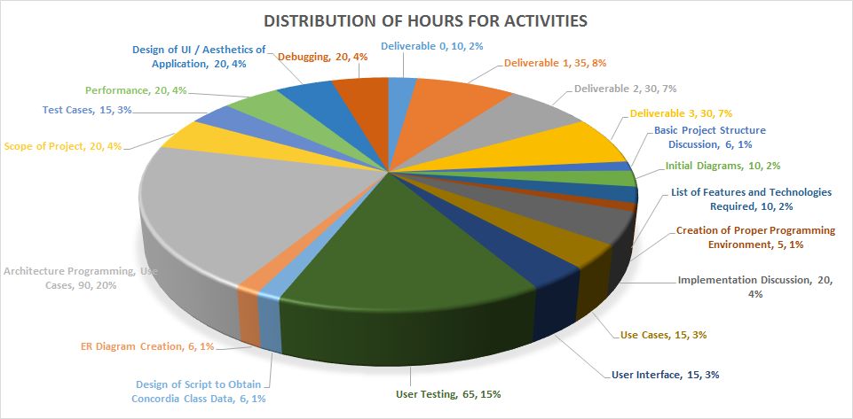

The initial Overall Man-hours for the project was 440. The revised Overall Man-hours for the project is now 472. This is an increase of roughly 7.2%. As a result of the changes mentioned previously, the team has updated the schedule to the following:

*Bars in Blue signify time allocation that has decreased

**Bars in Red signify time allocation that has increased

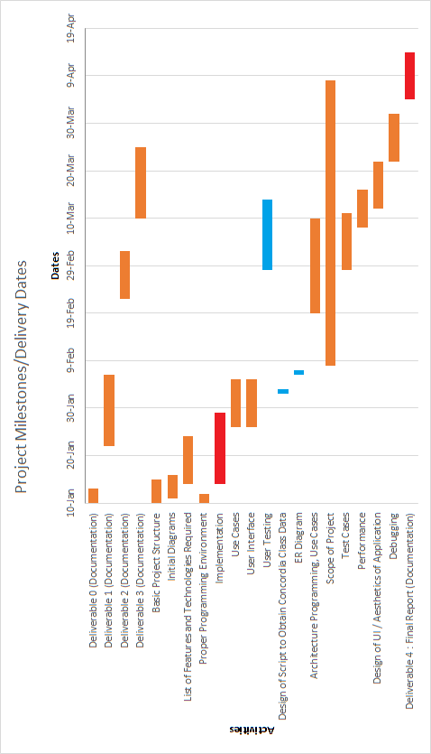

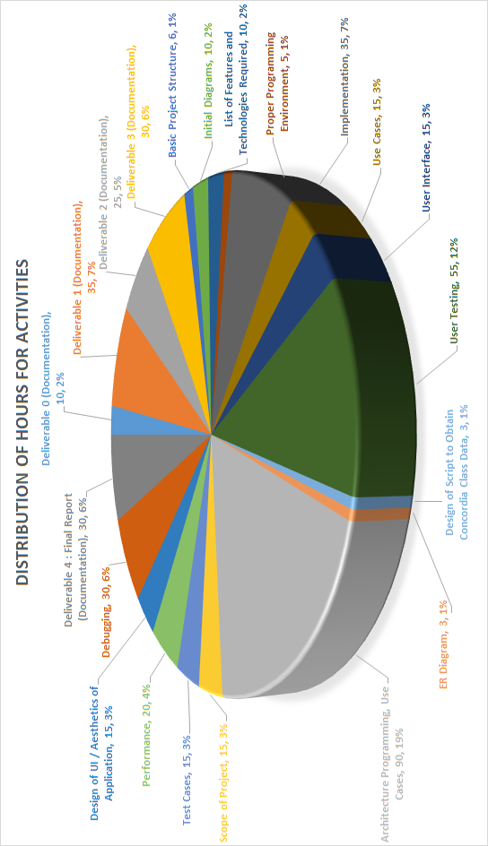

13 – Rapid Prototyping and Risk

13.1 – Prototype

In order to accelerate the development of the project, continuous prototypes will be produced.

The rapid prototyping method will allow the programmers and designers to adapt and implement new ideas faster, as well as to accelerate the learning curve of the programming language (if any).

The following describes work undertaken in development of our second prototype “The Force”.

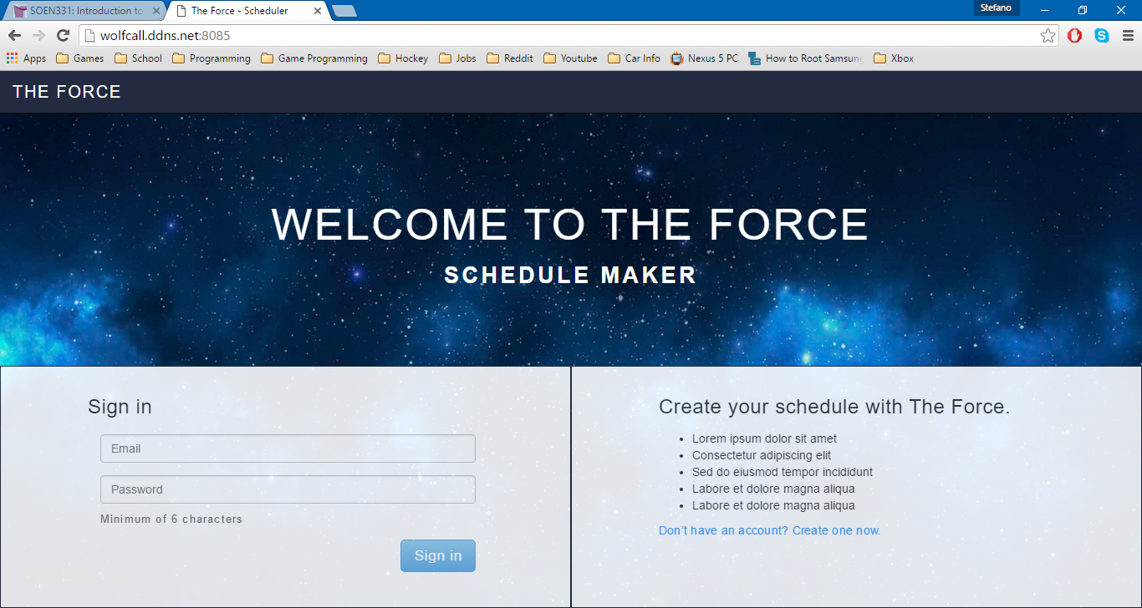

The screenshot above shows the updated home page of the website. Here, you will be able to sign in with the email you used when you created the account. If the information you entered does not match anything in the database, then you will not be able to sign in. It is suggested that you use the email that is associated to your Concordia Student account. If you do not have an account, you can create a new account.

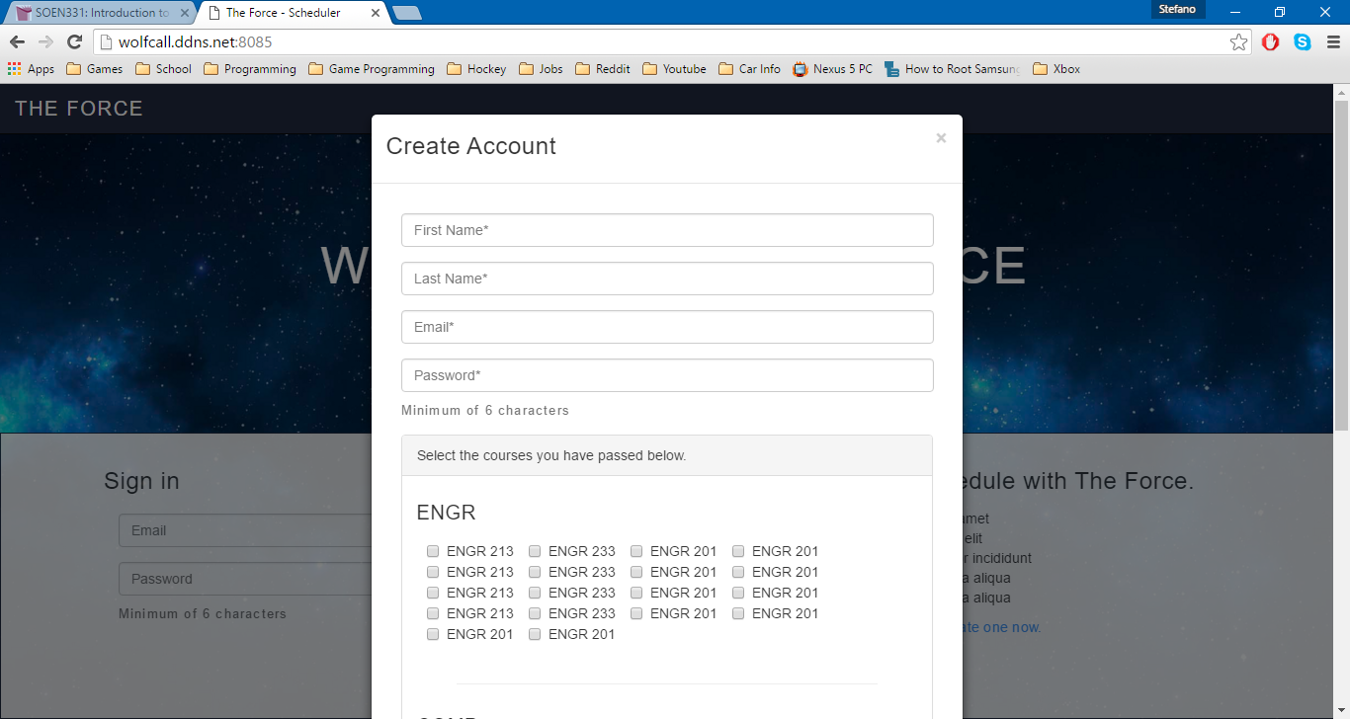

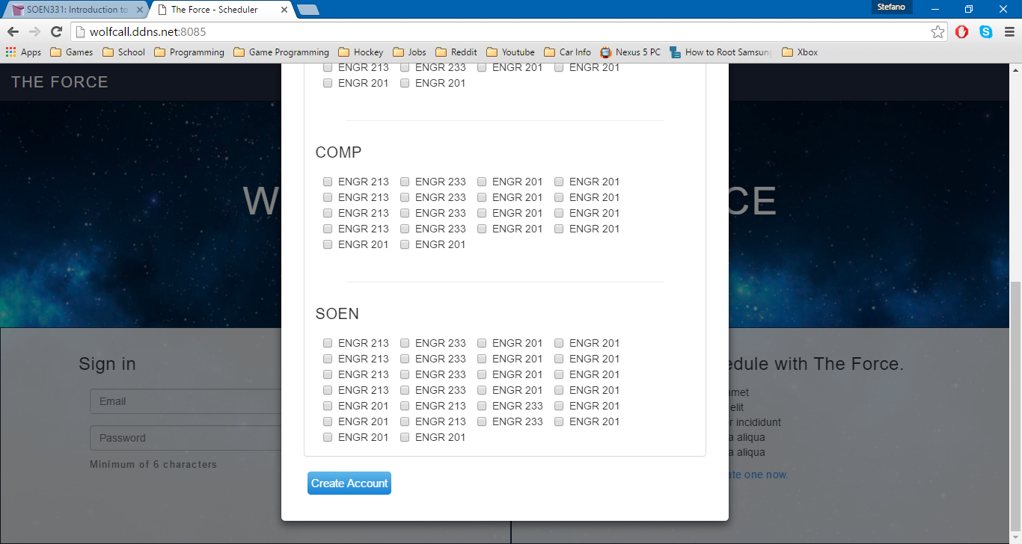

If you select the “create an account” option, a dynamic window will appear. It will prompt the user to enter all pertinent information such as Name, Email, Password and Courses taken. To specify the courses they have taken and passed, they will need to check the boxes corresponding to the course. This way, they can be saved to the database and associated to the current student (see information on ID mentioned below). Once all information is entered, it will be saved to the database and the user will be redirected to the main page of the website.

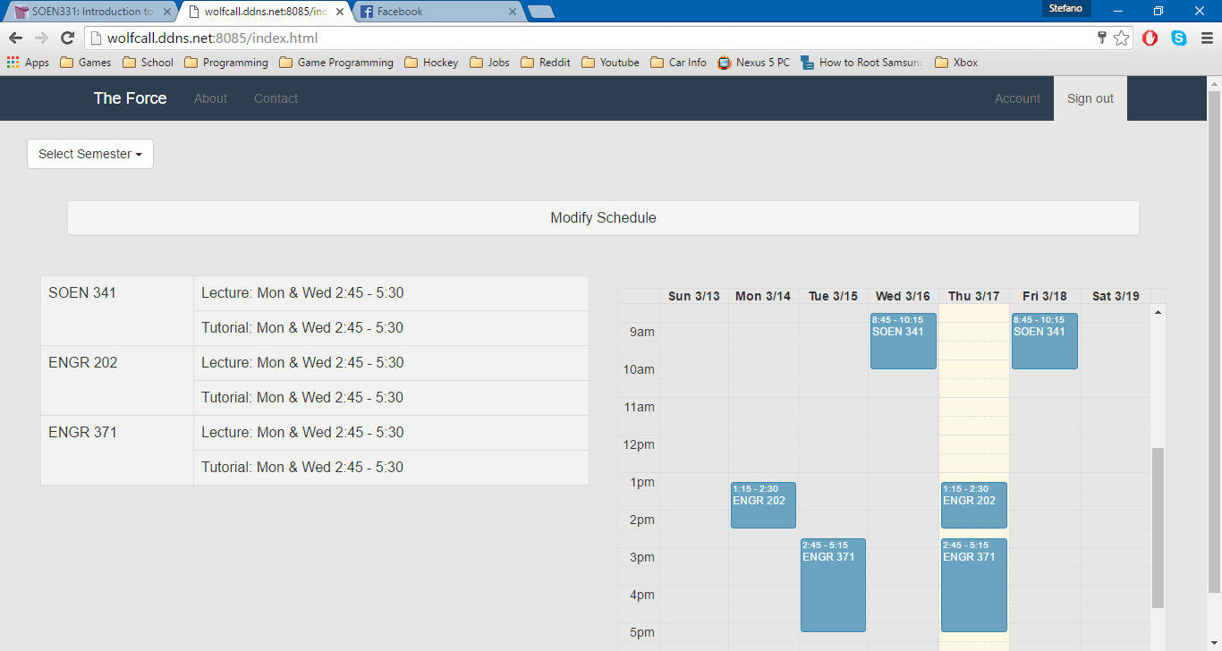

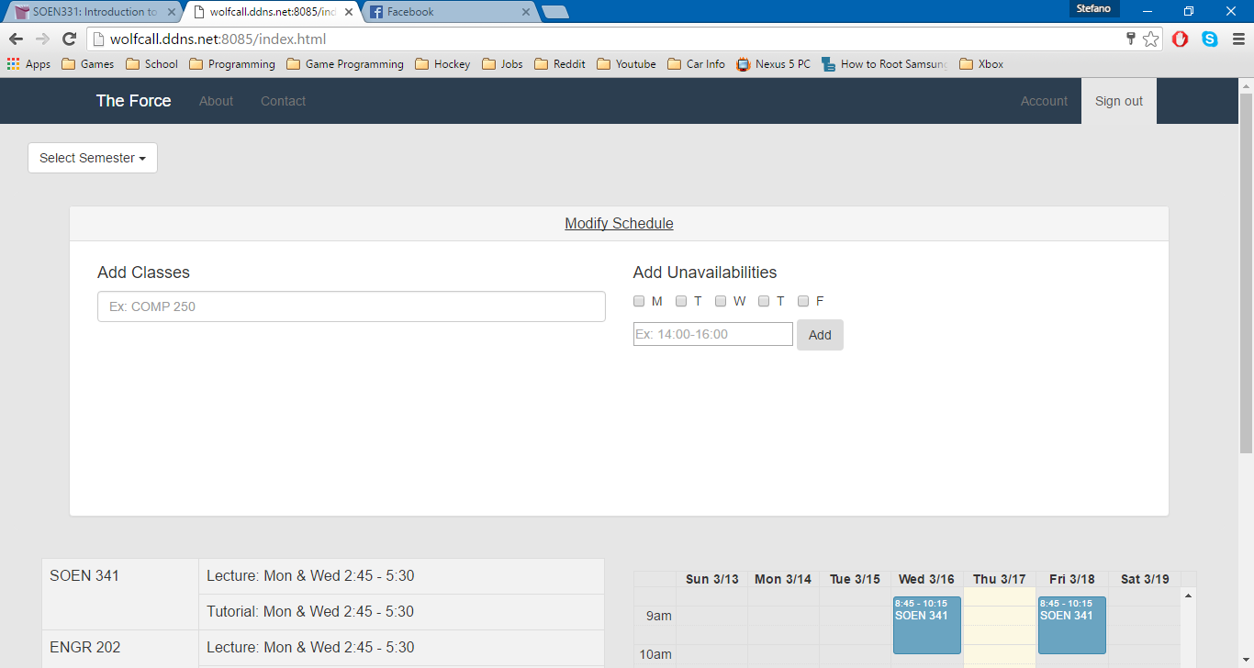

The screenshot above shows the main page of the website. Here, you can search for courses by entering the course code and add them to your schedule. You can specify the time and date constraints to your search so it will provide you with filtered search results. An autocomplete feature will kick in once the user begins to type a course code, allowing for fast filtering and searching.

The courses added by the user are added to database and are associated using an ID. Every user on the website is given a unique ID, so there is no way to display the wrong data.

By clicking on courses already added, you can also remove them from your schedule or browse for other sections available at different times. If the user tries to add a course that a student already has in their schedule, they will be prompted if they want to overwrite the course. If they select yes, the data will overwrite in the database. If they select no, then the data will stay the same.

The Header includes links to the “About Us” & “Contact Us” section of the site, which have not been developed yet. As well, there is a link to the “Account” section, which will be described below and an option to sign out.

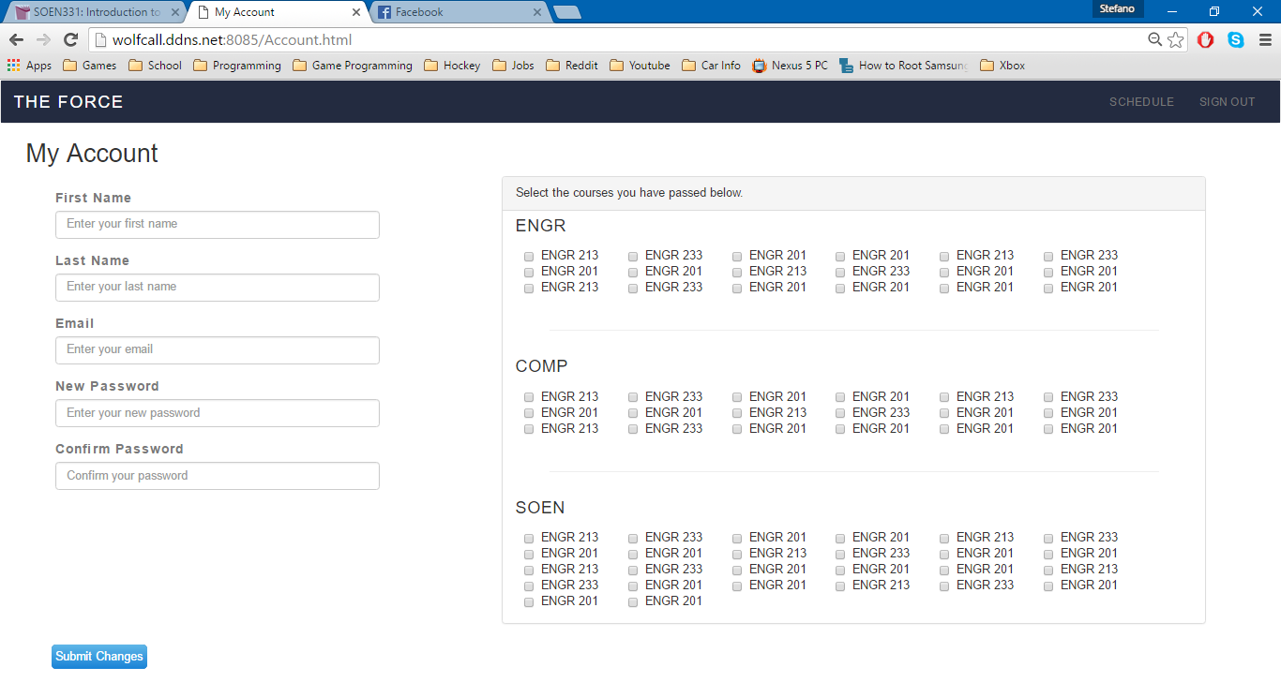

The screenshot above shows the “My Account” portion of the website. Here, any student can view and edit any of the information associated to their account (mentioned above). If the password does not match, the user will be informed through a message on the screen. When the user changes any information here, it will be overwritten in the database.

13.2 – Previously Identified Risks

Four risks were initially identified within the scope of this project.

The first was the Lack of Communication and Time Allocation. The concern was that since most of the members of the team have never worked together before, the overall efficiency would be slow at the beginning of the project while a proper team dynamic was formed. This proved to be a non-issue, as the team gelled quickly and it allowed the completion of the early tasks in shorter times than expected. As a result, the team decided to allocate more time to tasks deemed more challenging than initially expected (i.e. Implementation, Relearning required Languages). Time management remains extremely important to our team and it’s possible that some features will need to be left out due to lack of time.

The second risk was relearning required programming languages. The concern was that members of The Force, whether they had basic or advanced knowledge of web programming, were not practicing recently so they had to take some time to re-familiarize themselves. As mentioned above, since the early tasks were completed quickly, more time was allocated for this and it allowed everyone to regain a good understanding of web programming in the early goings of the project.

The third risk was the security of the server. The concern was that proper security protocols had to be applied. Without proper testing of its limitations, there was a fear it could eventually be revealed that the server did not store all the data required, or that certain requests might not be handled correctly. This would lead to the collapse of data management and as a result, of the entire project. With the work done so far, we have taken extra caution in ensuring that this does not happen, so there is no change with regard to this risk on the scope of the project.

The fourth and final initial risk was the miscommunication between the client and server side. The concern was that if the user would not properly register, then the entire system would stop functioning properly. Therefore all aspects of the system associated to the GUI’s (button’s not working, or information not being passed/retrieved from the database) need to be top priority. With the work done so far, the team has not encountered any problems with the communication between the client and server side, so there is no change with regard to this risk on the scope of the project.

13.3 – Newly Identified Risks

As we have continued our work on “The Force System”, the team has discovered three new risks that could potentially affect the final implementation of system.

The first new risk is the reduction of time allocated for User Testing. As mentioned previously, since the time allocated for User Testing was reduced from 20 days and 65 hours, to 15 days and 55 hours, there is a risk that the team might not complete all necessary testing before the final implementation of the system. This is due to the fact that underlying functionalities have taken longer than expected to incorporate into the system. To combat this risk, the team has prepared a thorough plan to ensure efficiency when completing the testing of the system.

The second new risk is the addition of an Administrator to the system. The Administrator would have the power to search through any registered students schedule and make changes (i.e. course section). They would also have the power to change the details of the Students account (i.e. password, classes taken & pre-requisites).

The risk associated to the creation of this new Administrative user was ensuring that changes are not made to a student’s schedule which lead to time conflicts or errors due to lack of pre-requisites for course. To prevent this from happening, the team decided that they will give the Administrative user access to the see the Students list of all courses they previously took as well as create a function to see if an added course has a time conflict with any course already in the schedule.

The third new risk was the differentiation between the Student account and the Administrative account. We did not want the users to be able to create a new Administrative account from the log in page, so the team decided to that the administrator would be a protected account (By protected, it is meant that only system administrators would be aware of this account and it would be hidden from the students). This means that when the user “Clicks on Create an Account”, the only option to appear would remain Student account. However, although this is true if an Administrative user is signed, they can create more administrative accounts for others to use (if necessary). As a result, this no change with regard to this risk on the scope of the project.

**Part C: Project Testing and Delivery**

14 – Introduction

Before delivering an application to a customer, one should make sure that a thorough testing report has been completed. This document provides explanation of all tested items as well as untested items of interest. These items of interest will require more testing in the future. Details of all the test cases current finished are also included. They are unit testing, requirements testing, stress testing and last but most importantly security testing.

When delivering an application to a customer, clear instructions must also be provided. The instructions provided in this document should cover both installation and use of the system. The Installation Manual describes the steps to set up necessary hardware and software for the system before use. Next, the User Manual details the features of the system and provides instructions on how they work. Both of these manuals contain screenshots of the steps to help visualize and facilitate the process for the user and administrator.

The third part of this document includes the final cost estimate of the system. It breaks down further changes to the project Estimates table as well as the reasoning behind all changes. Another updated Gantt chart is provided, and pie-charts are used to show a change in the distribution of the number of hours per activity. Last but not least, an extra section is included, showing further changes to the use case tables after continued implementation of core functionality.

15 – Testing Report

15.1 – Test Coverage

15.1.1 – Tested Items

**Tested Units**

With regards to item testing, all requirements were grouped into appropriate units/classes based on similarity and interdependence of function (E.g.: Login and Logout). Each requirement is, in actuality, a use case previously outlined in Deliverable 1 and improved upon in Deliverable 2. In addition, a unit was created consisting of a new feature/use case: “Create Student Account”. This unit consists of the use case “Create Student Account.

All requirements below are considered to be part of the core functionality of The Force, and thus are given a higher priority in comparison to something such as admin access and features (refer to 15.1.2 for further information). All units, and the core features/requirements they represent, can be seen in the table below. The test cases associated with each unit and requirement is numbered, and can be seen in further detail under section 15.2.2.

|  |  |  |
| --- | --- | --- |
| Unit/Classes | Related Requirements | Test Case(s) |
| Login | UC01, UC04 | 1.1 – 1.3, 4.1 – 4.2 |
| Logout | UC02 | 2.1 – 2.2 |
| Edit Student Information | UC03 | 3.1 – 3.8 |
| Edit Courses | UC05, UC06, UC07 | 5.1 – 5.8, 6.1 – 6.4, 7.1 – 7.3 |
| Schedule Generation | UC08, UC11 | 8.1 – 8.3, 11.1 |
| Administrator Features | UC14, UC15 | 14.1 – 14.3, 15.1 |
| Create Student Account | UC16 | 16.1 – 16.8 |

Login

The login procedure is incredibly important with regards to The Force as a whole. In order to access the scheduler, student information, or administrative access, a proper email and password combination is required. The login will only be successful if the combination of this email and password previously existed in the database (associated to a single user). Should this combination not exist, access to any further functions would be denied and the email and password fields would be cleared. The reset feature allows a student to change the password associated to their account by sending a temporary password to their email. Login is a unit that would be used several times, incredibly often, by every user of The Force. As such it requires extensive testing, as it contains the requirement that allows all other features to be accessed effectively.

Logout

Logging out is needed in order to allow a student or administrator to exit their account once they’ve completed their actions. Logging out ensures safety and security for the user’s account should they be sharing the device they used The Force on with others. Without logging in and logging out, all functionalities provided by The Force become irrelevant, thus it is a very high priority. In addition, all users will heavily use the logout feature, just as they use the login feature. As such, the logout unit must be tested in order to ensure the safety of all users, otherwise it runs the risk of massive security breaches across multiple users.

Create Student Account

In the case that a student wishes to create a schedule, it is required they have an account in place. For this reason, the creation of student accounts is another incredibly important requirement for The Force. Anytime a student without an account already in place would like to use The Force, they would need to make an account. This unit will be tested by following the instructions provided upon requesting to create an account, and then confirming whether or not a new entry was created in the databases with all the appropriate information. In the case that an account is made properly, the student will be redirected to the main page with their current schedule and courses.

Edit Student Information

Based on the student currently using The Force, the appropriate account information will be displayed on the Accounts page. From this page, the student will be given the option to change their password should they like. This will be tested through a mock-account, and the new password can be checked through accessing the database after the change, or simply attempting to re-enter the application after logout using the new password. This feature is more so a novelty for the student/administrator using it, but it is important due to the comfort it can provide a user as well as the added security provided thanks to the option to change one’s password.

Edit Courses

Course addition is an incredibly vital part of the entire schedule generation process. Without the option to manually add courses, students would be left without any true control over the courses they take. Every student using The Force needs to add courses, and thus it is considered extremely important with regards to the application. Courses added would need to ensure no conflicting time slots, as well as ensuring that the course is not allowed should the necessary co- and prerequisites not be present. In addition to choosing a course, students are expected to choose an appropriate section as well, which will also be tested for time slot conflicts before being added to their schedule. Should these two options misbehave, students will be unable to add courses to their schedule, nor edit the sections they are in, thus invalidating the entire schedule generation process, and the application as a result.

Deleting a course is of an equal importance. Should a student wish to remove a course they had entered in their schedule during the registration period (possibly due to a new, more important course conflicting with the time), or during the semester for some other reason, it is imperative that the option function perfectly. This option will once again be used by all students, and can be tested by simply removing a course from a schedule and ensuring that the necessary updates take place

Schedule Generation

Schedule generation is, in fact, the primary purpose of The Force, and as such may very well be the most important unit present (aside from login/logout). Once courses have been added or removed according to the student’s wishes, their schedule will be generated and saved. This can be tested by simply observing whether the schedule is still present for a given semester upon refresh of the main page. Seeing as it is the entire purpose of the application, extra precautions must be taken.

Assuming no courses were manually added/removed, or if a student doesn’t care for the courses they have already added, a schedule can also be auto generated based on the courses said student needs to take next in their sequence. Though this may not result in a student’s ideal schedule, the option to edit sections and remove courses will still be present after the generated schedule has been accepted. Auto generation of a schedule is far more complicated than manual generation, as a student will normally know what courses they need to take next and can physically see and avoid time conflicts. As this is not the case for auto generation, extra precautions are placed and need to be tested (e.g.: Overlapping timeslots, registering for previously completed courses, registering for courses without the pre- or co-requisites required). This can be tested through observation of the generated schedules, and addressing any issues that may arise. Both methods of schedule generation, should they not be implemented properly, could jeopardize the entire purpose of the application, and thus are of the utmost importance.

Once a schedule has been generated, a student may give his or her approval and save it to the semester they are currently creating it for. Once saved, the schedule, as well as the courses they are currently enrolled in, will be visible upon login and on the main student page. All students will have access to this saved schedule, and without properly implementing the save feature, a student would never be able to store their schedule for later use (effectively removing the need for one). Though the program would function without this feature, it would serve no real purpose, as students need to be able to see the classes and sections they are currently, and will be, enrolled in.

Administrator Features

Admins would be a separate type of user from a student: An admin would be given the ability to not only modify a section’s capacity, but also view and edit any student’s current course list. Admins are given the ability to change any student’s current schedule. This is required as an administrator must be able to move students between courses and sections should the student come to them for help, or if they’re required to move certain individual due to classroom size limitations. This is done by adding a given student to a queue; a queue that may only contain one individual at a time. Once added, the administrator will be given the ability to view said students schedule, course list, and account information. From there, the process of adding and removing courses, as well as changing sections, is identical to the process used by the student. Once the necessary changes have been made, the student will be removed from the queue, allowing the admin to modify a different student. This can be tested, similarly to the previous step, with black box testing. By providing certain inputs to the administrative features, the results can be observed and the necessary modifications can be made. All administrative features are important due to the differentiation it provides between user types, and the unique role it plays in comparison to a normal student. Should they not be tested properly, students may be given administrative access, or administrators may be given none at all, thus ruining the differentiation created.

Tested Requirements

The requirements displayed above were tested for one of 2 reasons:

1. They are considered integral to the development of web application project as a whole, and thus were tested in order to gain an understanding of the progress being made as a whole (e.g.: Login, add course).
2. They were lesser features, which were ready for testing (e.g.: View / Edit Profile).

Any explanation for the necessity of testing of these requirements can be found below, as well as an indication of their level of importance in comparison to the other requirements being tested

* Login (Use Case 1)
  + This requirement is considered to be of a **high importance** level, as should the login feature fail, further access to the application would be restricted. Not only would further testing be impossible, but any use of the program would be as well.
* Logout (Use Case 2)
  + This requirement is considered to be of a **high importance** level, as without the option to logout, other unique users would not be able to utilize the application from a shared device. In addition, overall security for each user would diminish due to the fact that their accounts would, in a sense, always be available to anyone who managed to get the device said individual used.
* View / Edit Information (Use Case 3)
  + This requirement is considered to be of a **high** **importance** level, as the ability to view ones account information can be important (e.g.: Seeing which courses have already been taken), as well as editing something such as a password in the case of security risks. In addition, it is important to be able to view any errors in a student’s personal or academic information, thus allowing the proper help to be notified.
* Reset Password (Use Case 4)
  + This requirement is considered to be of a **high importance**, as it serves as the backup for the login. Without the ability to reset your password, any user that forgets their password would lose access to their account. The reset will be done upon the entering the email of a valid account, at which point they will be sent a temporary password.
* Add Course (Use Case 5)
  + This requirement is considered to be of a **high importance**, as it serves as the backbone for manual schedule generation. Without the ability to manually add a course to one’s schedule, students would be forced into only auto-generating their schedule without the ability to then add one which they would prefer (as manual generation simply would not exist).
* Change Course Section (Use Case 6)
  + This requirement is considered to be of a **high importance** level, as without it a student would be restricted to the section either provided to them by the auto-generator, or which they themselves chose while initially creating their schedule. Should a situation arise where a student wanted to switch their section, perhaps into a better-timed one, or in order to avoid a conflict with another course, this feature is required.
* Remove Course (Use Case 7)
  + This requirement is considered to be of a **high importance** level, as without it students would be unable to remove course automatically assigned to them, or which they lost interest in. This feature is required when editing one’s schedule, as without it new courses could never be added (assuming the student has reached a “maximum” number of courses, or they’ve decided to no longer take a particular course).
* Generate Schedule (Use Case 8)
  + This requirement is considered to be of a **high importance** level, as it represents the entirety of the auto-generated schedule feature. Without this feature, students would be restricted to only creating schedules manually, even though they may be indifferent to the outcome of their schedule; they may simply wish to follow their sequence (and perhaps make changes after auto-generation takes place).
* View Saved Schedule (Use Case 11)
  + This requirement is considered to be of a **medium importance** level, as it doesn’t represent a core functionality of the application, nor does it provide additional user security. Even so, the entire purpose of creating a schedule, aside from enrolling in classes, is to be given the option to refer to said schedule at a later date (perhaps to check course times, or locations). Thus though it is not a main pillar of The Force, it is relevant nonetheless.
* Add Student (Use Case 14)
  + This requirement is considered to be of a **high importance**, as it serves as an Administrator for the entire system. Without the Administrator, there would be no way for the University to regulate classes that a user can take or not.
* Remove Student (Use Case 15)
  + This requirement is considered to be of a **high importance**, as if an administrator cannot remove a student from their queue, they cannot move on to another student to continue their work. This would limit the University to regulate classes for only one student.
* Request New Account (Use Case 16)
  + This requirement is considered to be of a **high importance** level, as every student is required to make an account before access to The Force’s features are provided. This is equally as important as the ability to login, as it serves as the precursor to it. Without the ability to create an account, a student would never be able to eventually login and begin creating their schedule.

15.1.2 - Untested Items of Interest

Four main units were not tested. They are Export Saved Schedule, Saved Schedule, Delete Schedule and Modify Section Capacity. Export Saved schedule and Modify Section Capacity were deemed out of scope by the team due to time constraints leading to the inability to implement the features. Both these features would have improved with regards to the end goal of the application: Proving an easy to use experience, and a distinction between different types of users and their unique features. Save Schedule was rendered useless because all schedules are saved automatically by the system, eliminating the need for the user to do this. Delete Schedule was removed as it was decided that a student will have to individually remove courses from their schedule if they want to make it blank. This will make it easier for the system to identify future courses that require the currently removed course as a prerequisite so they can be removed as well.

Export Saved Schedule

This feature is relevant due to the convenience it provides the students using The Force. By allowing their schedules to be exported, students are given the option to easily access their schedule without needing to go through the application (as well as print said schedule, providing them with a physical copy). As it is another requirement, this too would be tested through a black box, and should a properly exported file/image be created on request, the feature will be deemed successful. It is important to test due to the fact that, should it fail to work properly, user satisfaction would decrease as a result, and ease of access for the student’s schedule would be reduced. As the entire purpose of The Force is to create student schedules (primarily), it stands that once created, these schedules should be made easily accessible to those who made them.

Modify Section Capacity

Upon selecting a given course from their administrative list, admins would be given the option to change said courses (as well its sections’) size capacity. This could be tested through trial (i.e.: Black-box testing) and by inputting various values in the section’s capacity is observing not only whether a change takes place, but also whether the value entered is a legal one (i.e.: No negative values). This is important to test to due to fact that courses and sections will natural change capacity from time to time, thus having the ability to manually do so is imperative.

However, as previously mentioned, this was phased out due to time constraints.

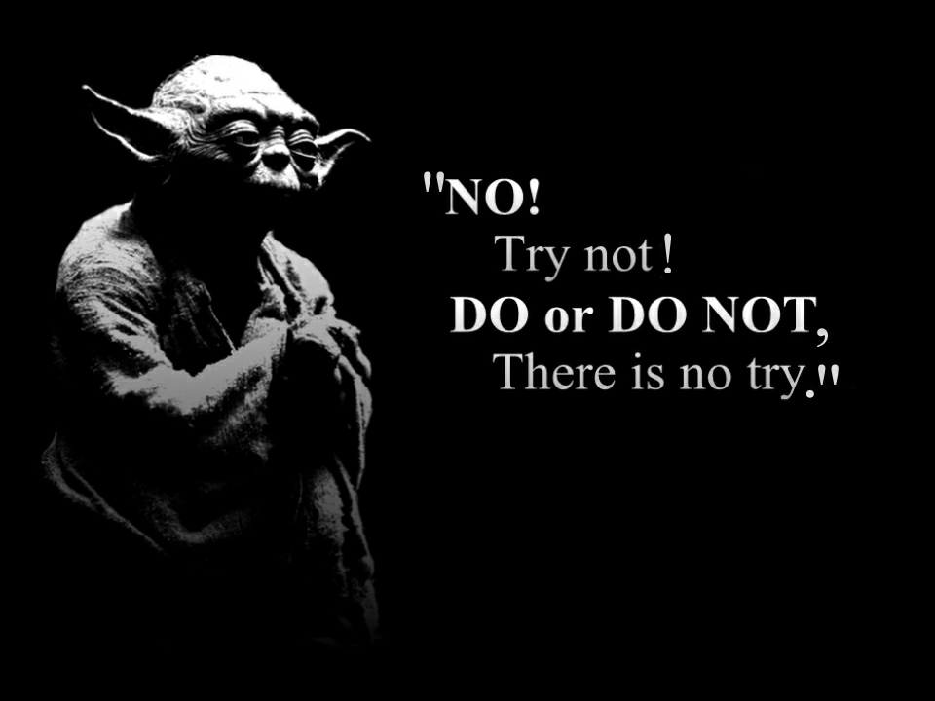

15.2 - Test Cases

15.2.1 - Unit Testing

PHPUnit unit is a tool which exists to make unit testing easier and more precise for PHP.

The tools included are in the form of Test stubs and mocks. These 2 object have some of their components replace by fake ones. For example, an interior method can be replace with a fake method. In general, the stubs are allow us to write and run repeatable unit tests so that they last until the end of the life cycle of the system. The following tests presented used a branch and input/output analysis at the design phase of the unit tests.

In Unit Test 1 – Login, Mocks and Stubs are used. Authenticate creates a mock from UserID and creates a stub for the login method derived from UserID

Unit Case 1 - Login

With respect to the unit “Login”, two test cases were analyzed:

|  |  |  |  |  |
| --- | --- | --- | --- | --- |
|  | *Login* Test Cases | |  |  |
| Test Case | | **Description** | **Input provided** | **Expected Output** |
| 1 | | Email and password combination provided is invalid | Email = “test.com”  Password = “passw” | User would be notified of the error, and the account would not signed in |
| 2 | | Email and password combination provided are valid | Email = “test@case.com”  Password = “password” | User would be signed in and redirected to main page |

For a detailed list of all possible test cases related to the requirements of “Login” (i.e.: The requirement that makes up this unit), refer to section 15.2.2. The results of the testing can be seen below. These two test cases were derived through grouping, and stubs were used in order to create mock student account (and other testing components), while a driver was created to simulate a new completed account and authentication of its values was allowed as a result. In order to simplify these two test cases, only two test functions were made: Login1 and Login2. Login1 would always return false (signifying an invalid email/password combination), while Login2 would always return true. In this way, though several different inputs could realistically be used, the results were simplified to two categories: Valid and Invalid. This simplified the act of testing and allowed the unit to be easily tested as a whole

<?php

require_once('/../protected/layout/createAccount.php');

class LoginFormTest extends PHPUnit_Framework_TestCase

{

protected $driver;

//Set up the test driver

protected function setUp()

{

driver = new LoginForm;

driver->email = "test@case.com";

driver->password = "password";

}

Protected function tearDown()

{

}

public function Rules()

{

//Define the rules for the test stubs

$stub = array(array('username, password', 'required'),

array('password', 'authenticate'));

$results = driver->rules();

assertEquals($stub,$results);

}

public function Authenticate()

{

$stub = getMockBuilder('UserID')->getMock();

$stub->expects(any())

->method('authenticate')

->will(returnValue('true'));

assertTrue(driver->authenticate());

}

public function Login1()

{

$stub = getMockBuilder('LoginForm')->getMock();;

$stub->expects(any())

->method('login')

->will(returnValue('false'));

$this->assertEquals('false', $stub->login());

}

public function Login2()

{

$stub = getMock('LoginForm');

$stub->expects(any())

->method('login')

->will(returnValue('true'));

assertEquals('true', $stub->login());

} }?>

Unit Case 1 Results

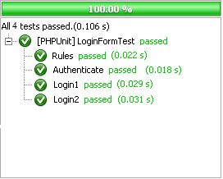

Unit Case 2 – Create Student Account

With respect to the unit “Create Student Account”, two test cases were analyzed:

|  |  |  |  |  |
| --- | --- | --- | --- | --- |
|  | Create Student Account Test Cases | |  |  |
| Test Case | | **Description** | **Input provided** | **Expected Output** |
| 1 | | Email and password combination provided is invalid | Email = “test.com”  Password = “passw” | User would be notified of their error, and the account would not be created |
| 2 | | Email and password combination provided are valid | Email = “test@case.com”  Password = “password” | Account would be created, user would be redirected to main page |

For a detailed list of all possible test cases related to the requirements of “Requesting a New Account” (i.e.: The requirement that makes up this unit), refer to section 15.2.2. It is important to note that a test case was not created for when first or last names are not provided. As both fields are required, the result will never stray from simply asking for both again should they not be present (seen in the test stubs/driver code, as both fields are required). The results of the testing can be seen below. These two test cases were derived through grouping, and stubs were used in order to create mock student account (and other testing components), while a driver was created to simulate a new completed account and authentication of its values was allowed as a result. In order to simplify these two test cases, only two test functions were made: Create1 and Create2. Create1 would always return false (signifying an invalid email/password combination), while Create2 would always return true. In this way, though several different inputs could realistically be used, the results were simplified to two categories: Valid and Invalid. This simplified the act of testing and allowed the unit to be easily tested as a whole

<?php

require_once('/../protected/layout/createAccount.php');

class createAccountTest extends PHPUNIT_Framework_TestCase

{

protected $driver;

//Set up the test driver

protected function setUp()

{

$driver = new createAccount;

$driver->firstName = "test";

$driver->lastName = "case";

$driver->email = "test@case.com";

$driver->password = "password";

}

protected function tearDown()

{

}

public function RulesT()

{

//Define the rules for the test stubs

$stub = array(array('firstName, lastName', 'required'),

array('email', 'authenticate'),

array('password','authenticate'));

$actual = $driver->createRules();

assertEquals($stub, $actual, "Values are not equal");

}

public function AuthenticateT()

{

$stub = getMockBuilder('studentAccount')->getMock();

$stub->expects(any())

->method('authenticate')

->will(returnValue('true'));

assertTrue($driver->authenticate());

}

public function Create1()

{

$stub = getMockBuilder('createAccount')->getMock();

$stub->expects(any())

->method('create')

->will(returnValue('false'));

//If not equal, print valid

assertEquals('false', $stub->create(), "Valid");

}

public function Create2()

{

$stub = getMockBuilder('createAccount')->getMock();

$stub->expects(any())

->method('create')

->will(returnValue('true'));

//If not equal, print invalid

assertEquals('true', $stub->create(), "Invalid");

}

} ?>

Unit Case 2 Results

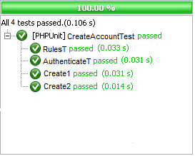

15.2.2 - Requirements Testing

The test cases for all tested requirements presented in section 1.1.1. can be found below. These requirements are based upon the use cases highlighted in deliverable 1 and 2. Each requirement includes numbered test cases, a description of each test case, an example of possible input which could be provided (as not every situation can be addressed for most requirements, thus partition testing is applied and test values are used to represent larger groups of examples) for said test case, the expected output, and whether each output was actually achieved. It is important to note that all test cases with failures are considered to be top priorities, and thus are primary focuses with regards to the end product of the application.

|  |  |  |  |  |
| --- | --- | --- | --- | --- |
| UC01 | Login |  |  |  |
| Test Case | **Description** | **Input provided** | **Expected Output** | **Result** |
| 1.1 | User inputs valid email and password combination | Email = “test@case.com”  Password = “password” | User is redirected to main page | PASS |
| 1.2 | User inputs an invalid email and password combination | Email = “test@case.com”  Password = “password1” | Empty email and password fields. User is not redirected | PASS |
| 1.3 | User leaves the fields blank | Email = “”  Password “” | User will not be able to press the sign in button | PASS |

|  |  |  |  |  |
| --- | --- | --- | --- | --- |
| UC02 | Logout |  |  |  |
| Test Case | **Description** | **Input provided** | **Expected Output** | **Result** |
| 2.1 | User is not logged in and attempts to log out | User attempts to press Logout button | User is on login page, and thus no logout feature is provided | PASS |
| 2.2 | User is logged in and attempts to logout | User presses Logout button in navigation bar | User is redirected to login page, without access to any other feature | PASS |

|  |  |  |  |  |
| --- | --- | --- | --- | --- |
| UC03 | View / Edit Information |  |  |  |
| Test Case | **Description** | **Input provided** | **Expected Output** | **Result** |
| 3.1 | Student wishes to view their account | “Account” button is pressed | User is redirected from schedule/main page to Account page | PASS |
| 3.2 | User enters a new password and confirms their request | newPass = “password1”  confirm = “password1” | Message appears confirming user’s actions | PASS |
| 3.3 | Administrator views a student’s schedule | Student name is provided.  Example: “Joey” | Administrator is redirected to student’s Schedule page | PASS |
| 3.4 | Administrator wishes to view their account | Administrator signs in to their account | Administrator is redirected to their account page | PASS |
| 3.5 | Users password and confirm password fields do not match | newPass = “password1”  confirm = “password2” | User is alerted that the passwords do not match | PASS |
| 3.6 | Users new password does not meet requirements | newPass = “ks” | User is alerted that the new password does not meet requirements (minimum 6 characters) | PASS |
| 3.7 | Users new name is invalid | First name = “@*#*$”  Last name = “329(()$” | User is alerted that the name contains invalid characters | PASS |
| 3.8 | Users new email does not meet requirements | Email = “#((#(($” | User is alerted that the email does not meet requirements (not properly formatted) | PASS |

**Note that when adding a course (UC05), the case of have “co-requisites” completed but not prerequisites does not exist, as all courses in software engineering that require a prerequisite also allows the course to be completed concurrently. As such, this situation is not relevant.**

|  |  |  |  |  |
| --- | --- | --- | --- | --- |
| UC04 | Reset Password |  |  |  |
| Test Case | **Description** | **Input provided** | **Expected Output** | **Result** |
| 4.1 | User inputs valid email | Email = “stefano.pace12@gmail.com » | User is sent an email with a temporary password | PASS |
| 4.2 | User inputs an invalid email | Email = “blan@nothing.com” | No email is sent | PASS |

|  |  |  |  |  |
| --- | --- | --- | --- | --- |
| UC05 | Add Course |  |  |  |
| Test Case | **Description** | **Input provided** | **Expected Output** | **Result** |
| 5.1 | Student adds a course they already have in their schedule | Student selects “COMP 232”, while COMP 232 is already in their schedule | No changes should occur | PASS |
| 5.2 | User adds a course they do not have the prerequisites, nor co-requisites, for | Student adds “SOEN 287” before completing “COMP 248” | Inform user of error (lack of pre/co-requisite) and do not add course to schedule | PASS |
| 5.3 | User adds a course they have completed the necessary prerequisites for, but not co-requisites | Student has not yet added “SOEN 343”, but adds “SOEN 345” to their schedule and generates | Inform user of error (lack of co-requisite) and do not add course to schedule | PASS |
| 5.4 | User adds a course they have previously completed (no need to retake the course) | Previously completed “COMP 248”, add to schedule once again | Inform user of error (course completed) and do not add to schedule | PASS |
| 5.5 | User adds a course which conflicts with a course already in the schedule | “COMP 248” times overlap with “SOEN 228”, but the student adds “COMP 248” to their schedule anyways | Inform user of error (time conflict between courses) and do not add course to schedule | PASS |
| 5.6 | User adds a course which is currently full (either a course or section) | “COMP 248” is already full, but is added to the schedule anyways | Inform user of error (course/section is full) and do not add course to schedule | OUT OF SCOPE |
| 5.7 | User adds a course with all the necessary prerequisites completed, no time conflicts, and space in the class remaining | “COMP 248” is added to the schedule, and all conditions are satisfied | Course and section is added to the student’s current schedule | PASS |
| 5.8 | Student adds a course after indicating preferred personal constraints (days off, between two times, etc…), assuming no other conflicts | Student selects “COMP 248” after indicating they would like no courses between 8:00 AM and 10:00 AM | Course and section would be added to the student’s current schedule | FAIL |

|  |  |  |  |  |
| --- | --- | --- | --- | --- |
| UC06 | Change Course Section |  |  |  |
| Test Case | **Description** | **Input provided** | **Expected Output** | **Result** |
| 6.1 | Student selects a course or section from within their schedule | Student clicks on “COMP 248” from within their schedule | Popup window appears containing alternate sections and their times | FAIL |
| 6.2 | Student selects a new section from the popup, but this conflicts with another course in the schedule | Student selects section “AA” for “COMP 248”, but this conflicts with “COMP 232” | Inform user of error (time conflict) and section change does not occur | FAIL |
| 6.3 | Student selects a new section from popup, but this section is full | Student selects section “AA” for “COMP 248”, but section “AA” is full | Inform user of error (section size full) and section change does not occur | FAIL |
| 6.4 | Student selects a new section from popup, and no issues are associated with this section | Student selects section “AA” for “COMP 248” | Section change occurs. Both course list and the student’s schedule are updated | FAIL |

|  |  |  |  |  |
| --- | --- | --- | --- | --- |
| UC07 | Remove Course |  |  |  |
| Test Case | **Description** | **Input provided** | **Expected Output** | **Result** |
| 7.1 | Student tries to remove course when no courses are saved | Student presses “Trash” Icon | No ““Trash” Icon is present | PASS |
| 7.2 | Student chooses to drop a course, and confirms their decision | Student presses “Trash” Icon | The course is removed from the course list, as well as from the saved schedule | PASS |
| 7.3 | Student chooses to drop a course that is a prerequisite/corequisite for a future semester | Student presses “Trash” Icon | The user is warned that removing the course will remove all courses that require prerequisite/corequisite | PASS |

|  |  |  |  |  |
| --- | --- | --- | --- | --- |
| UC08 | Generate Schedule |  |  |  |
| Test Case | **Description** | **Input provided** | **Expected Output** | **Result** |
| 8.1 | Student auto generates a schedule for the current semester | Student presses “Auto Generate Schedule” button | A popup will appear containing an auto generate schedule, based on the next courses in said student’s sequence | PASS |
| 8.2 | Student dismisses the option created automatically | “Cancel” button is pressed on popup window | Schedule will not be saved and user will remain on main page | OUT OF SCOPE |
| 8.3 | Student auto generates schedule with unavailability’s | Student presses “Auto Generate Schedule” button and provides unavailability’s | Schedule will be saved and will now be featured on the main page, next to a course list | FAIL |

|  |  |  |  |  |
| --- | --- | --- | --- | --- |
| UC11 | View Saved Schedule |  |  |  |
| Test Case | **Description** | **Input provided** | **Expected Output** | **Result** |
| 11.1 | Student views their schedule | Student signs in, makes an account, or presses “Schedule” from the “Accounts” page. | Student is redirected to the main / schedule page and their current saved schedule is displayed. | PASS |

|  |  |  |  |  |
| --- | --- | --- | --- | --- |
| UC14 | Add Student |  |  |  |
| Test Case | **Description** | **Input(s) provided** | **Expected Output** | **Result** |
| 14.1 | Administrator searches for a valid student name | User enters an existing student’s name | User is redirected to the student’s schedule page | PASS |
| 14.2 | Administrator searches for an invalid student name | User enters a non-existing student’s name | User is not redirected, and a message is displayed alerting the Administrator that the student does not exist | PASS |
| 14.3 | Administrator leaves the field blank and tries to search for a student | Field Blank | No redirection occurs | PASS |

|  |  |  |  |  |
| --- | --- | --- | --- | --- |
| UC15 | Remove Student |  |  |  |
| Test Case | **Description** | **Input(s) provided** | **Expected Output** | **Result** |
| 15.1 | Administrator clicks on “Account” page to return to their account so they can search for a new student | No input provided | Administrator is redirected to their account page | PASS |

|  |  |  |  |  |
| --- | --- | --- | --- | --- |
| UC16 | Request New Account |  |  |  |
| Test Case | **Description** | **Input(s) provided** | **Expected Output** | **Result** |
| 16.1 | Create Account option is chosen | User presses “Create Account” button | Popup page with all required fields appears | PASS |
| 16.2 | User leaves any of the 4 fields blank (First name, Last name, Email, Password) | Any blank field will result in the same expected output.  First = “Test”  Last = “Case”  Email = “”  Password = “password” | Popup window remains open. Field with error is highlighted in red in order to notify user. | PASS |
| 16.3 | Email does not follow the format “xxx@yyy.zzz” | 1. @test.com 2. testcase.com 3. test@case | Popup window remains open. Email field is highlighted in red. Message appears below field notifying user of invalid entry | FAIL |
| 16.4 | Email follows the format “xxx@yyy.zzz” | Email = “test@case.com” | No error message displayed. Assuming other fields are valid on submission, registration is completed | PASS |
| 16.5 | Password is less than 6 characters | Password = “passw” | Popup window remains open. Password field is highlighted in red. Message appears below field notifying user of invalid entry | PASS |
| 16.6 | Password length is equal to or greater than 6 characters | Password = “password” | No error message displayed. Assuming other fields are valid on submission, registration is completed | PASS |
| 16.7 | Previously completed courses are marked (checkboxes) | Checkbox indicating “COMP232” is checked | Assuming successful registration, marked courses can be seen in “Accounts” page | PASS |
| 16.8 | All fields are filled with valid entries | First = “test”  Last = “case”  Email = “test@case.com”  Password = “password” | Upon submission, user is redirected to main schedule page. | PASS |

15.2.3 - Stress Testing

In the case of extreme situations that are beyond our control, the system might encounter decline in performance with regards to software. This may be related to the ability of the server to handle heavy networking loads due the cap on capacity.

Under conditions such as high latency and a large number of simultaneous website connections, we would experience clear degradation of service. The system would no longer be able to meet outlined requirements such as response time, uptime, and scalability. Testing all of the conditions would be possible if and only if the system was put onto a live environment.

Based on experience and through knowledge obtained by observing other systems, we have concluded that time periods where the system could face the conditions mentioned are during the scheduling periods of the academic year. Since these periods are known and occur around the same time every year, it would be possible to act accordingly and prevent the issues.

One possibility would be to dedicate extra bandwidth to the site during the scheduling period of the academic year. This could be done by purchasing or renting additional servers, or by changing TCP/IP protocol to better manage bandwidth used by an individual person.

To test for performance and reliability under conditions of extreme load, it is possible to setup a testing environment where a script can be run that was designed to bombard the system with a variety of simultaneous function calls. These function calls could include login/logout, register course, and/or any of the other implemented features outlined above. The script could also be run on multiple computers at once to test for higher traffic.

15.2.4 - Security Testing

**SQL Injection**

SQL injection is a technique by which malicious SQL statements are inserted into an entry field in order to trick the system into giving more information than would be normally available. By exploiting wording used in SQL statements, security vulnerabilities can be exploited and incredible damage can be done to an application, thus it is imperative that this threat be tested against.

In order to test for these vulnerabilities, a FireFox Extenstion called SQL Inject-Me was used. By submitting HTML forms with substituted values (i.e.: Strings representing what would be used during an SQL Injection attack), the tool allows for the inspection of said vulnerabilities. Once escape strings have been sent to the database through the form fields, the extension then looks for database error messages that have been outputted into the rendered HTML of the page. Despite all this, the tool does not compromise the security of the application, as it simply looks for entry points to attack through (no actual attacks are done).

The SQL Injection tool was run on 3 of The Force’s pages: It’s login page (including both logging in and creating an account), the main / schedule page, and the user account page. Below are the results. As the results (when errors were found) and number of form fields can be quite extensive at times, only the overall results are shown. To mitigate this, explanations for failures are provided when they occur.

1. Login Page

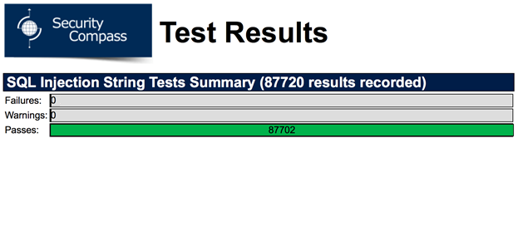

No failures or warnings were detected on the login page, thus it can safely be considered secure from SQL Injection attacks.

1. Main Page

No failures or warnings were detected on the main page, thus it can safely be considered secure from SQL Injection attacks.

1. Account Page

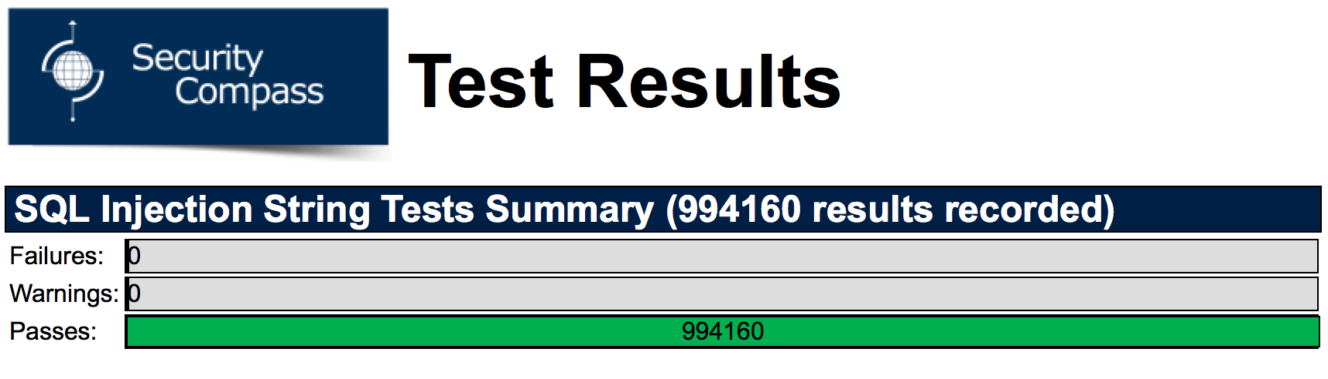

No failures or warnings were detected on the accounts page, thus it can safely be considered secure from SQL Injection attacks.

**Nikto**

Nikto is an open source web server scanner, used to perform comprehensive tests against web servers from multiple items (e.g.: potentially dangerous files/programs, outdated server versions, and version specific server issues). As web server security is an ever-increasing issue, namely since Web Server vulnerabilities can be easily taken advantage of, it is imperative that the server used for The Force be tested for security. The Force is hosted on an IIS (Internet Information Services), which is a Microsoft-made extensible web server, and the results of running Nikto on our server can be found below.

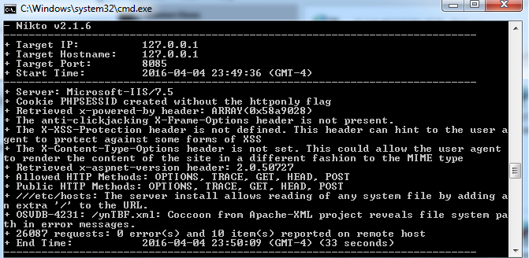

The security tool failed to find any particularly dangerous errors, and thus the server security can be considered to be quite high.

**NMap**

NMap (or Network Mapper) is a security scanner used to discover hosts and services on a computer network. In addition, NMap can be used as a port scanner, to determine whether network ports are open, closed, filtered (i.e.: NMap can’t determine if the port is opened, making it frustrating for attackers), etc.… The main result of this scan can be seen below:

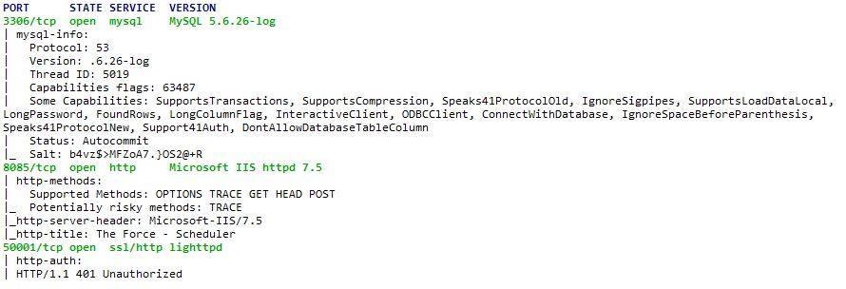

As can be seen above, several ports are currently open. While this makes accessibility higher (i.e.: For the team), open ports are simply paths to be attacked through. Since possible attackers wish to exploit open ports, it would be ideal to close (or at the very least filter) these ports once work on the project has completed. In doing so, the legitimate users (the team) will not be reprimanded, but possible attackers will no longer be able to utilize these open ports to target the network (as ports present an endpoint of communication in an operating system).

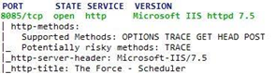

After running the test again, we have successfully shutdown the 3306 and 50001 TCP ports so possible attackers will no longer be able to utilize these open ports to target the network. The 8085 port was the only one left open to allow for external access to the website.



16 - System Delivery

16.1 - Installation Manual

The following will explain how you can go about installing a web-application service tool on your hosting server. *Note: This will only function on a Windows device. Ensure that all site files provided are stored in a specific folder (ex: C:\Websites\Generator) so they are easier to access.*

1. Open the Control Panel on your Windows device.

2. Select *Programs.*

3. Under *Programs and Features*, select *Turn Windows Features On or Off*.

4. Under *Internet Information Services*, check *Web Management Tools* and *World Wide Web Services*.

* This will install required files and the IIS manager application needed to host a website.

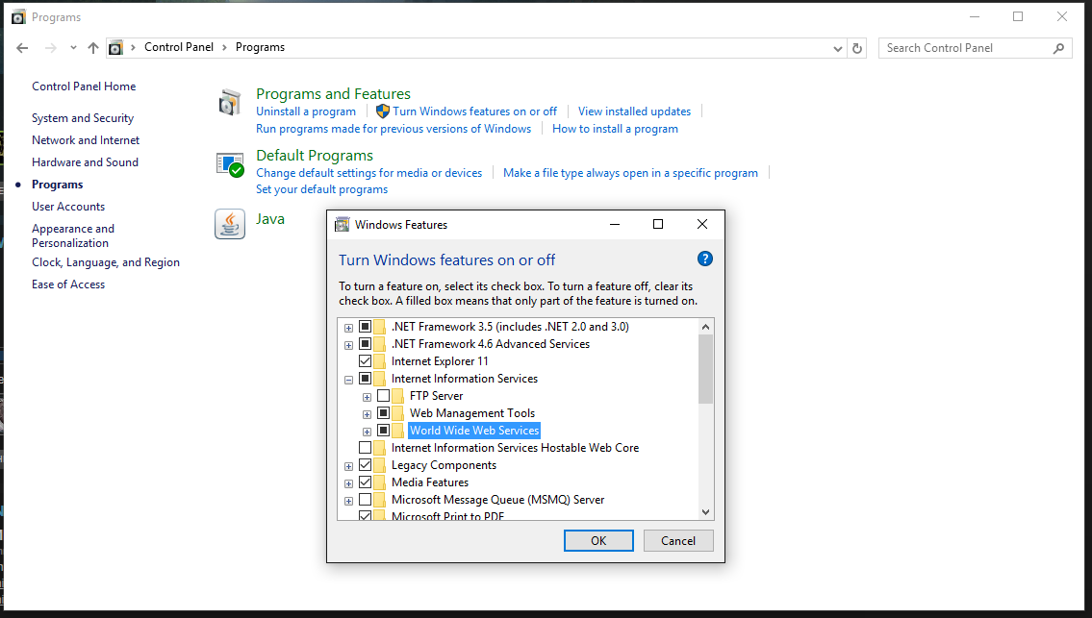

*Control Panel*

5. Download and install PHP for IIS from the following website: <https://php.iis.net/>

* This is what will allow you to run the PHP scripts from the websites

6. Open the IIS manager application installed in step 4.

7. Open *Web Platform Installer*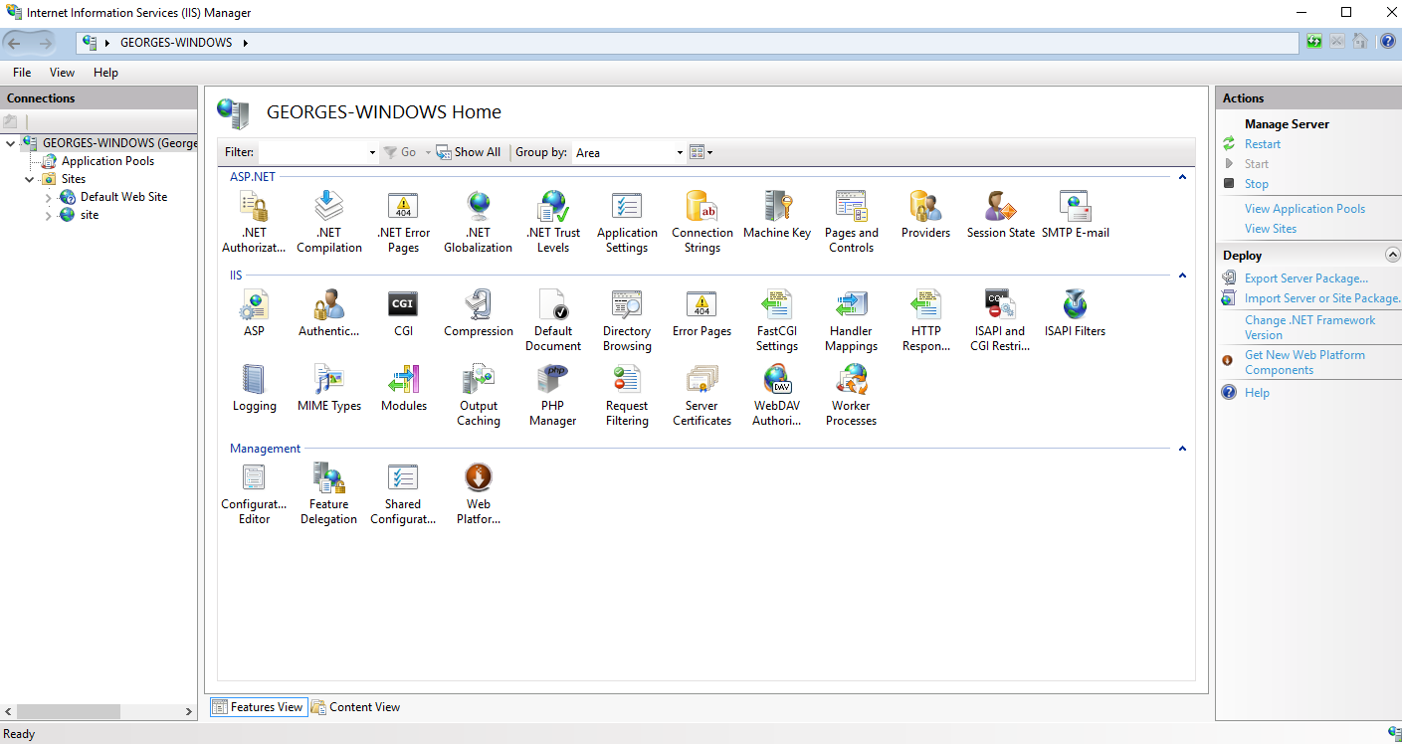

*IIS Manager*

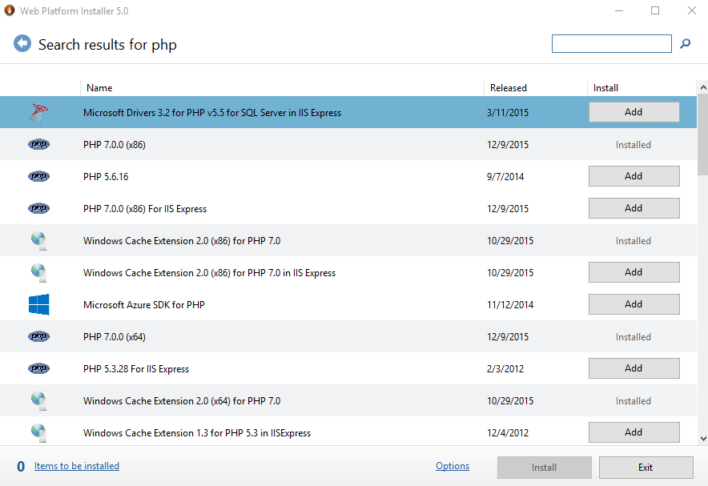8. Search *php* in the search bar. Find the version of PHP that was just installed and is now being used (likely PHP 7.0), and click *add* to install it to the IIS Manager Application.

*Installing PHP for IIS manager*

9. Return to the IIS manager default page. On the left hand side, right click your computer

name. Select *Add Website*.

10. In the *Site name* field, enter your desired name for the website.

11. In the *Physical path* field, select the folder that contains your website files.

12. In the *Binding* section, leave *Port* as default. This value should be 80; if it is not, set it to

80 manually.

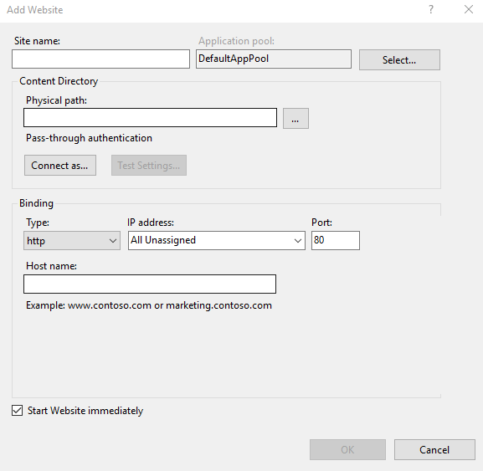

*Add Website*

13. Select *Default Document* and change it to *signin.php*.

* This will be the sign in page of the website you would like to host

14. Select *Authenticator* and ensure that *Application pool identity* is selected.

* 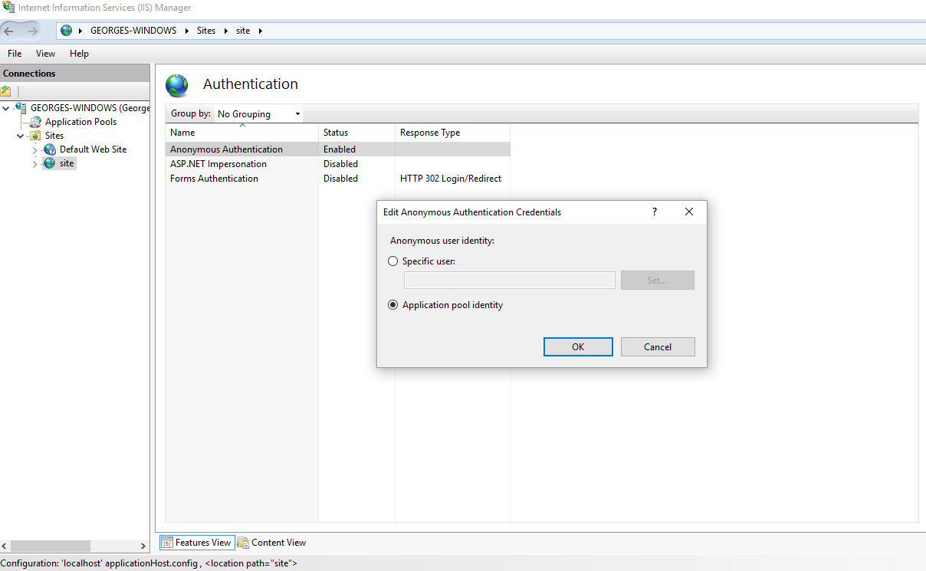This ensures you are given the sole administrator access to the system.

15. Download and install MySQL at the following link: <https://www.mysql.com/downloads/>

16. Select the scripts located in *dbscripts* in MySQL workbench and run them.

* This allows all SQL scripts to store information on the database of the server

17. Execute dbsetup.php from files provided through MySQL Workbench

* This will populate the database with the necessary tables to store information from the website.

Congratulations! Your website should now be up and running.

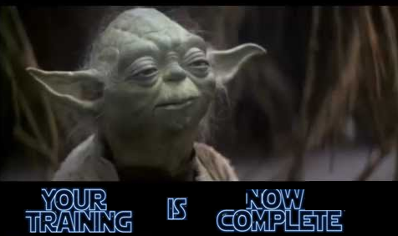

16.2 - User’s Manual

16.2.1 - Getting Started

The application is web based. Open your web browser of choice and navigate to the following:

<http://wolfcall.ddns.net:8085>

You will be directed to the following Sign In page:

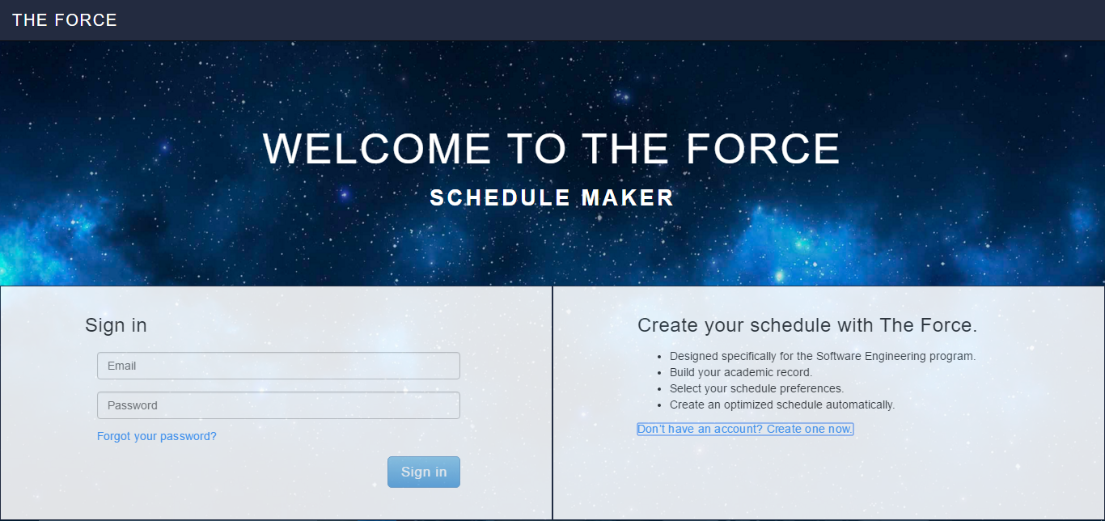

16.2.2 - Creating an Account

If you do not have an account, you can select the “Don’t have an account? Create one now” located by the red box.



Once selected, you will then be prompted to enter your personal information. This includes first name, last name, email and desired password (minimum 6 characters):

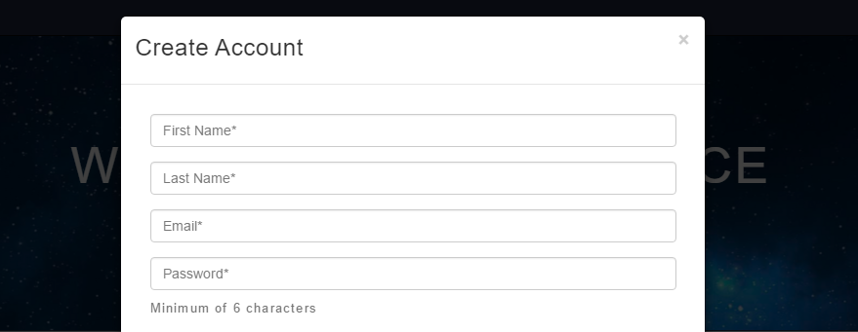

As well, you will need to check off the classes you have previously completed during your studies, so they can be saved as prerequisites for your account.

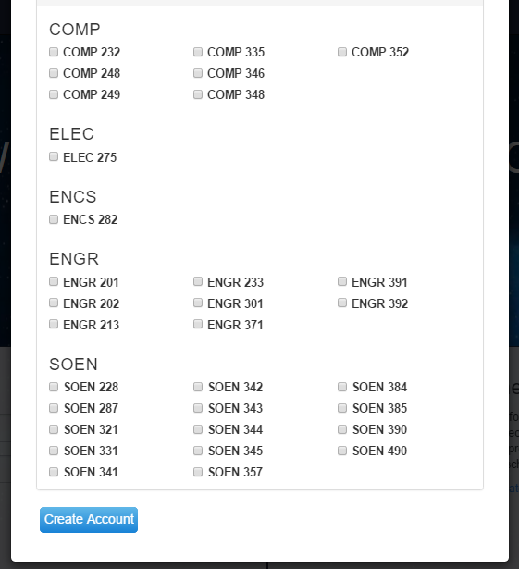

Once you select “Create Account”, your account information will be saved. Upon successful creation of your account, you will be redirected to the main page of the website (see later). If your account creation was not successful, verify if all fields are valid. Invalid fields will be highlighted in red.

16.2.3 - Login

If you wish to log into your account, you will be required to fill in your email address and password information (shown by the red box).



Once the email and password combination is verified, you will be redirected to the main page of the website (see later). If your sign in was not successful, verify that all fields are valid. Invalid fields will be highlighted in red.

16.2.4 - Logout

If you wish to log out of your account, you may select the “Sign Out” option in the top right corner of the screen that is shown by the red box.

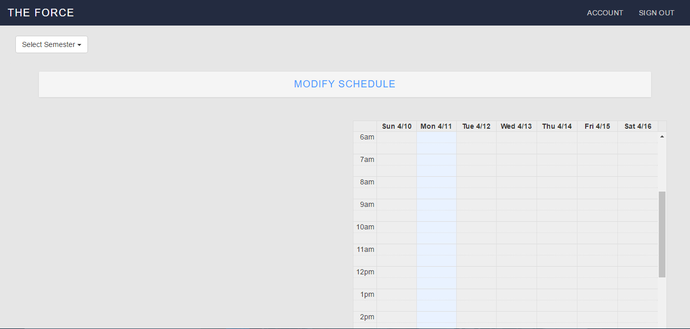

Once signed out, you will be redirected to the Sign In page.

16.2.5 - View/Edit Profile

If you wish to edit your account information, you can select “Account” on the top right corner of the website.



You will then be redirected to the My Account page. Here you will be able edit any of the information you previously entered such as first name, last name, email and courses previously taken. You also have the option to create a new password shown by the red box. You can always go back to the schedule page to view saved schedule by selected “Schedule” (shown in yellow).

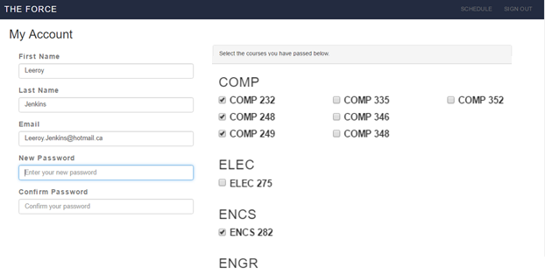

Once you select “Submit Changes” located lower on the page (not shown in the photo), these changes will be saved.

16.2.6 - Reset Password

If you wish to reset the password of your account, then you may select “Click here to Reset your password” as shown by the red box.



You will then be prompted to enter the email associated to your account. Once the email has been verified, a temporary password will be sent to you. You must then log in and change your password by going to the “Account” section described earlier.

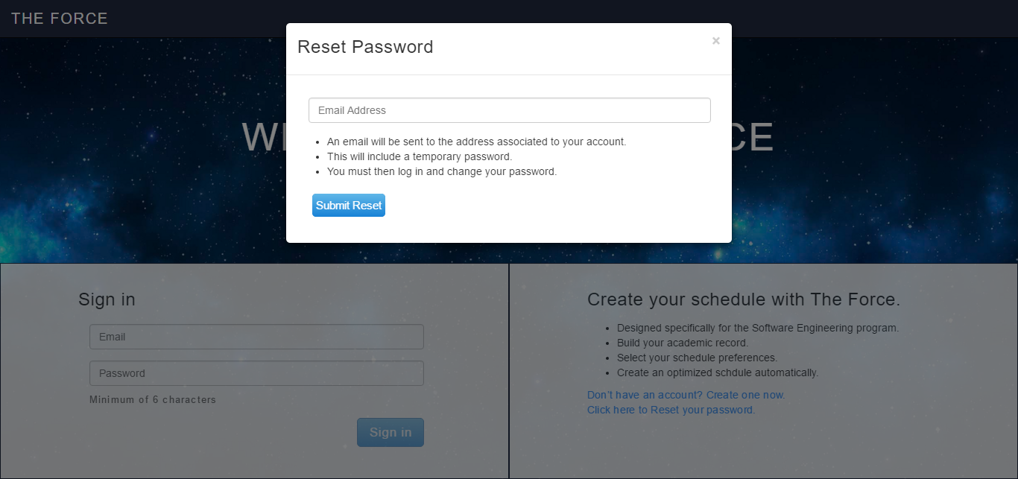

16.2.7 - Add Course Manually

If you wish to add a course to your schedule, then you may select “Modify Schedule”

You will then see the following options. You can select the “COMP”, “ELEC”, “ENGR” or “SOEN” disciplines to expand a list of course (shown by the red box). Once a course is selected, you can specify unavailable times or days and a section.

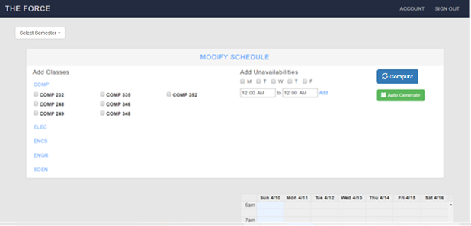

Last, when you select “Compute Schedule” (shown by the yellow box), the sections will be verified if they conform to the unavailability’s and then added to the schedule.

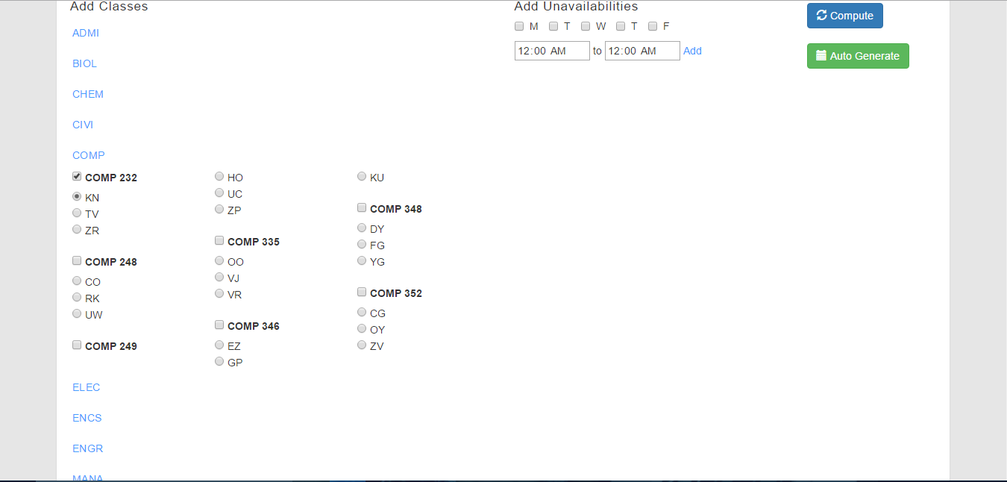

As an example, COMP 232 KN will then be displayed as follows:

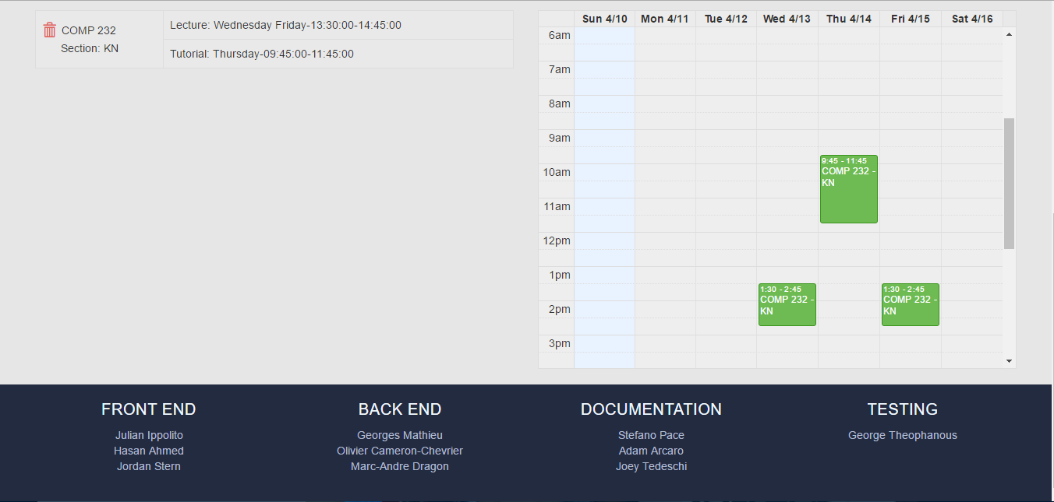

If there are any conflicts between the course you are trying to add and the courses already in your schedule, then an error message will be displayed. You must either choose another section for one of the classes in the conflict, or choose one for removal.

16.2.8 - Change Course Section

If you wish to change a section of a course you are currently enrolled in, you can pick another section from the drop down menu. For this example, we will use the same course as mentioned in the last section: COMP 232. Once you select another section, the sections will be verified if they conform to the unavailability’s and then added to the schedule.



If there are any conflicts between the course you are trying to add and the courses already in your schedule, then an error message will be displayed. You must either choose another section for one of the classes in the conflict, or choose one for removal.

16.2.9 - Remove Course

If you wish to remove a course from your schedule that you are currently enrolled in, you must select the trash bin icon located next to the course code (shown by the red box). For this example, we will again use the same course as mentioned in the last section: COMP 232. Once the trash bin next to COMP 232 is selected, it will remove this course from the schedule.



16.2.10 - Schedule Generation

If you wish to automatically generate your schedules for the remaining courses in your sequence, then you must first specify the semester to do so (shown by the yellow box).



Then you select “auto generate” (as shown by the red box) and the schedule will be automatically populated based on your remaining courses and unavailability’s.

If there are any conflicts between the courses auto-generated, then an error message will be displayed. If this is the case, you will need to contact your administrator, as your remaining courses conflict and prevent you from completing your sequence.

16.2.11 - Add Student (Administrator)

Another Administrator privilege is the ability to edit any existing student’s schedule. To do this, as an Administrator you must first add the student to your queue by searching for their name (shown by the red box). Once a name is found, select “View Saved Schedules”.

******Please note you can only have 1 student at a time in the queue. 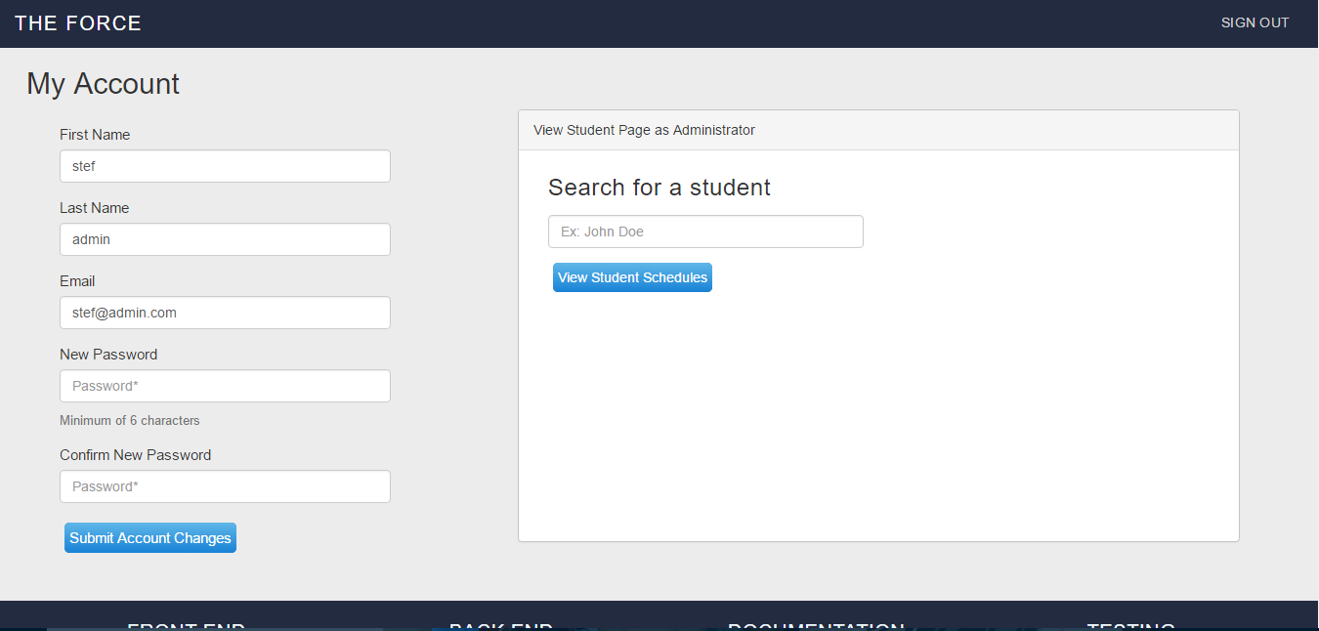

The system will then redirect you to their “Schedule” page. Now that you can view any of the student’s schedules, you are free to modify them in any way you please, using features that were mentioned in previous sections (add course, remove course). These features are shared between regular user and Administrators. Any change in the schedule will result in the system displaying the new schedules.

16.2.12 - Remove Student

As an administrator, once you are done editing a specified students’ schedule, you may remove him from your queue by selecting “Account”. Once this is selected, you will be re-directed back to your account page, and you can search for another student or sign out if you wish.

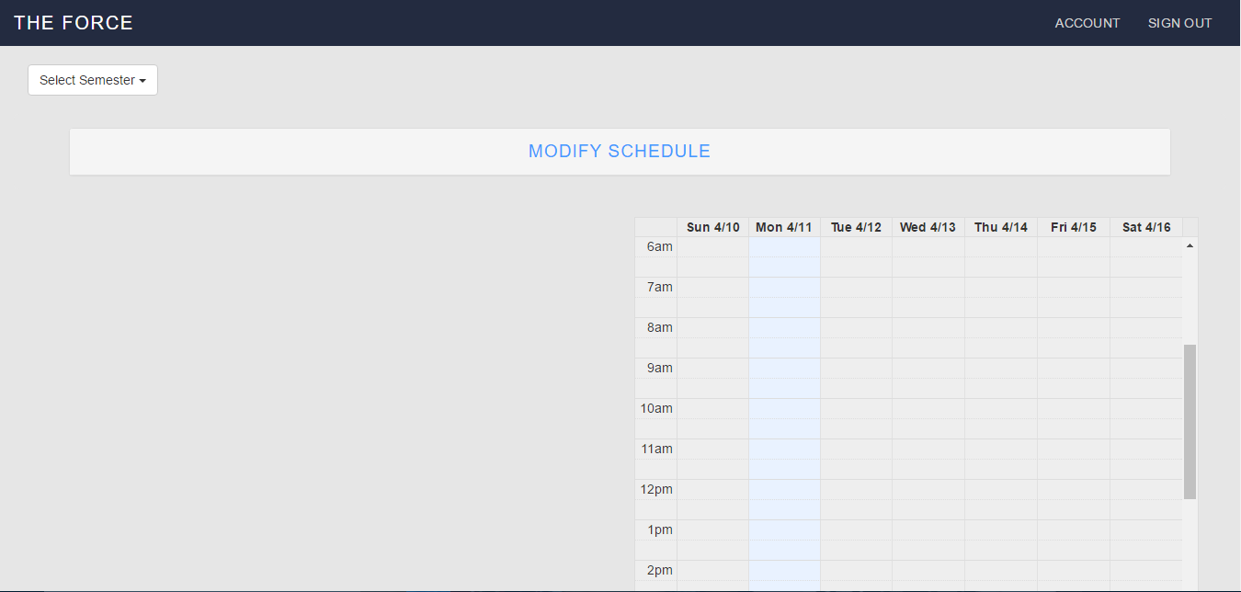

# 17 - Final Cost Estimate

## 17.1 - Revised Project Estimate

This is a copy of the Project Estimates table from Deliverable 2

|  |  |  |  |
| --- | --- | --- | --- |
| Task Name | Duration (Number of Days) | Total Cost (Hours) | Starting Date |
| Deliverable 0 (Documentation) | 3 | 10 | 10-Jan |
| Deliverable 1 (Documentation) | 15 | 35 | 22-Jan |
| Deliverable 2 (Documentation) | 10 | 25 | 22-Feb |
| Deliverable 3 (Documentation) | 15 | 30 | 10-Mar |
| Basic Project Structure | 5 | 6 | 10-Jan |
| Initial Diagrams | 5 | 10 | 11-Jan |
| List of Features and Technologies Required | 10 | 10 | 14-Jan |
| Proper Programming Environment | 2 | 5 | 10-Jan |
| Implementation | 15 | 35 | 14-Jan |
| Use Cases | 10 | 15 | 26-Jan |
| User Interface | 10 | 15 | 26-Jan |
| User Testing | 15 | 55 | 28-Feb |
| Design of Script to Obtain Concordia Class Data | 1 | 3 | 02-Feb |
| ER Diagram | 1 | 3 | 06-Feb |
| Architecture Programming | 20 | 90 | 19-Feb |
| Scope of Project | 60 | 15 | 08-Feb |
| Test Cases | 12 | 15 | 28-Feb |
| Performance | 8 | 20 | 08-Mar |
| Design of UI / Aesthetics of Application | 10 | 15 | 12-Mar |
| Debugging | 10 | 30 | 22-Mar |
| Deliverable 4 : Final Report (Documentation) | 10 | 30 | 4-Apr |
| Total | 95 | 472 | N/A |

The following is a revised cost estimate for the project. Upon review of what has been completed by the Project team so far as well as challenges/risks encountered, the cost estimates have changed. In some cases, they have risen and in others they have dropped.

*Numbers in Blue signify costs that have dropped

**Numbers in Red signify costs that have risen

***Highlighted Dates signify changes in start Dates

|  |  |  |  |
| --- | --- | --- | --- |
| Task Name | Duration (Number of Days) | Total Cost (Hours) | Starting Date |
| Deliverable 0 (Documentation) | 3 | 10 | 10-Jan |
| Deliverable 1 (Documentation) | 15 | 35 | 22-Jan |
| Deliverable 2 (Documentation) | 10 | 25 | 22-Feb |
| Deliverable 3 (Documentation) | 15 | 40 | 10-Mar |
| Basic Project Structure | 5 | 6 | 10-Jan |
| Initial Diagrams | 5 | 10 | 11-Jan |
| List of Features and Technologies Required | 10 | 10 | 14-Jan |
| Proper Programming Environment | 2 | 5 | 10-Jan |
| Implementation | 20 | 75 | 14-Jan |
| Use Cases | 10 | 15 | 26-Jan |
| User Interface | 10 | 15 | 26-Jan |
| User Testing | 15 | 55 | 28-Feb |
| Design of Script to Obtain Concordia Class Data | 1 | 3 | 02-Feb |
| ER Diagram | 1 | 3 | 06-Feb |
| Architecture Programming | 20 | 60 | 19-Feb |
| Scope of Project | 60 | 15 | 08-Feb |
| Test Cases | 12 | 25 | 28-Feb |
| Performance | 8 | 20 | 08-Mar |
| Design of UI / Aesthetics of Application | 10 | 15 | 12-Mar |
| Debugging | 10 | 45 | 22-Mar |
| Deliverable 4 : Final Report (Documentation) | 5 | 25 | 6-Apr |
| Total | 95 | 512 | N/A |

The changes to the Project Estimates table were made for the following reasons:

Deliverable 3 (Increased from 15 days, 30 hours 🡺 15 days, 40 hours)

* This deliverable proved to be more difficult than originally expected and was completed in a longer time frame.
* As a result we had to get more members to help complete the activities.

Implementation (Increased from 15 days, 35 hours 🡺 20 days, 75 hours)

* This task became very complex very quickly. A considerable amount of extra hours had to be allocated to this task because the team encountered serious configuration issues with the server hosting the website.

Architecture Programming (Decreased from 20 days, 90 hours 🡺 20 days, 60 hours)

* After the complications with the servers, we determined that we needed to work efficiently to complete this task. Again, with all the members of the team working, we were able to complete the task early.

Test Cases (Increased from 12 days, 15 hours 🡺 12 days, 25 hours)

* After starting the testing cases, we felt like we were not being thorough enough so we allocated more time for more tests.

Debugging (Increased from 10 days, 30 hours 🡺 10 days, 45 hours)

* Since more tests were done, more bugs were found so more time was taken in order to fix the errors.

Deliverable 4 (Decreased from 10 days, 30 hours 🡺 5 days, 25 hours)

* Since editing was done as feedback was given for all the deliverables, the editing process for the Final Report is expected to be completed in less time than originally thought.

**** Estimates were made based on time required to create, as well as based on each team members’ individual work ethic. Based on the activities assigned to each member (and the artifacts said activities produce), an appropriate amount of time was estimated, taking into consideration the number of people striving to achieve said artifact, and the time they have available for said tasks. For all artifacts not yet created/achieved, re-estimation might occur if it is discovered that the time provided is inefficient for the members responsible to complete their task. In addition, the opposite can be said; re-estimation might occur if the task is easier than expected, thus saving time in that regard and allowing a reallocation of time to another issue. Re-estimation would also be required in the case that additional components not yet listed were designed and implemented. In such as a case, time would need to be allocated to these new tasks and the time provided to our sections might decrease as a result.

## 17.2 - Final Schedule & Gantt Chart

This is a copy of the previously updated Schedule & Gantt Chart. A pie chart was also included to show the last distribution of hours for each task in comparison to the project as a whole.

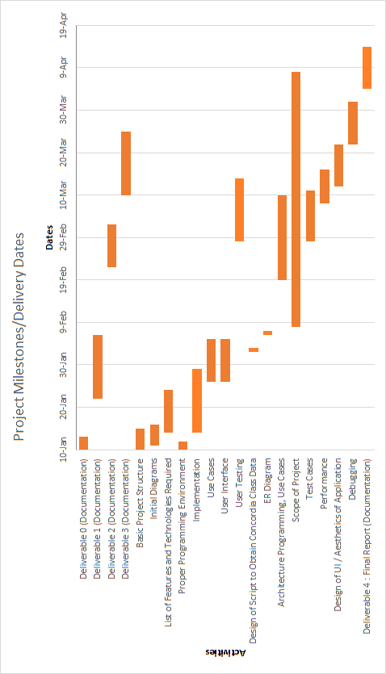



The initial Overall Man-hours for the project after deliverable 2 was 472. The final Overall Man-hours for the project is 512. This is an increase of roughly 8.5%. As a result of the changes mentioned previously, the team has updated the schedule and pie chart to the following:

*Bars in Blue signify time allocation that has decreased

**Bars in Red signify time allocation that has increased

